A hybrid recycling process for mixed plastics

Original article by Jamie Durrani. Adapted by Nina Notman.

Two-step approach eliminates the need to sort plastics before they are recycled

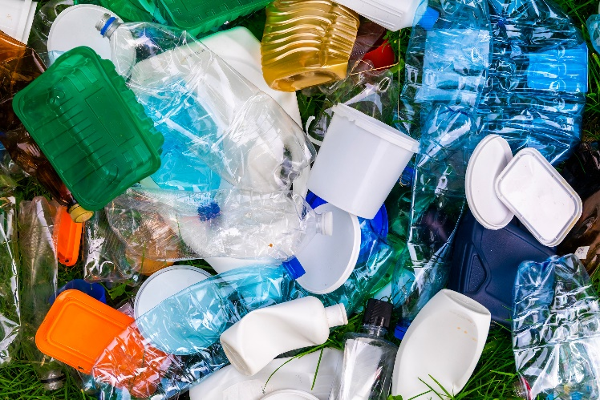
Scientists have developed a process for converting mixed plastic waste into two distinct, useful chemicals. Their method uses a combination of chemical and biological techniques to upcycle mixtures of three common plastics. It could offer a way to streamline recycling processes by eliminating the need to first sort the plastics.

Source: Anton Petrus/Getty Images

Processing mixed plastics eliminates the need for time-consuming sorting and creates useful chemical products

Sorting is not required

Currently, mixed plastic waste, such as what goes into household recycling bins, must be sorted by type before it can be recycled. ‘The motivation was to avoid the expensive and quite tedious sorting of mixed plastic waste,’ says Gregg Beckham from the National Renewable Energy Laboratory in Colorado, US, who led this research. The process is also suitable for plastic waste containing different polymers bonded together, such as multilayer packaging and some textiles.

The three polymers this process is suitable for are:
- high-density poly(ethylene) (HDPE), with uses including milk containers and bottles for personal care products
- poly(ethylene terephthalate) (PET), commonly used for food and drink packaging, especially for single-used beverage bottles
- poly(styrene), which is widely used as disposable food trays, cups and plates.

These three plastics make up the majority of post-consumer plastic waste.

Chemistry and biology unite

The team’s recycling process has two steps. First, the polymers are oxidised by air with the help of a cobalt–manganese–bromide catalytic system to produce a soup of carboxylic acids. Next, the mixture is fed to soil bacteria for further conversion. The bacteria used are Pseudomonas putida, which naturally consume benzoic acid and dicarboxylic acids (produced by the HDPE and polystyrene breakdown). The team genetically engineered the bacteria to consume terephthalic acid (from PET) as well.

Further genetic engineering produced two distinct bacteria strains that produce two different end products. One converts the carboxylic acid mixture into polyhydroxyalkanoates (PHAs), which are used in biodegradable food packaging and for biomedical applications such as dissolvable sutures. The second strain transforms the soup into β-ketoadipate, which can be used to make performance-enhanced nylons.

‘The study is one of the first to show how to get from a mixed waste stream to a pure product and uses a very interesting interdisciplinary approach,’ says Ina Vollmer, an expert on chemical recycling of plastic waste based at Utrecht University in the Netherlands, who was not involved in this project.

Having demonstrated that their concept can work, Gregg and his team now hope to improve their process and expand the range of plastics that can be recycled.

This is adapted from the article ‘Mixed plastic waste converted into useful materials in dual chemical–biological approach’ in Chemistry World. Read the full article: rsc.li/3TEwH4Y

