Nailing corrosion
Education in Chemistry
March 2016
www.rsc.org/eic

Metal corrosion – what happens next?

When iron corrodes it’s called rusting. We’ll be looking at how we can speed up or slow down the process of rusting.

First you need to understand the simplified model we’ll use. We’re aiming to be able to predict what will happen when magnesium or copper are placed in contact with iron in water with oxygen present. The model will eventually look like this:

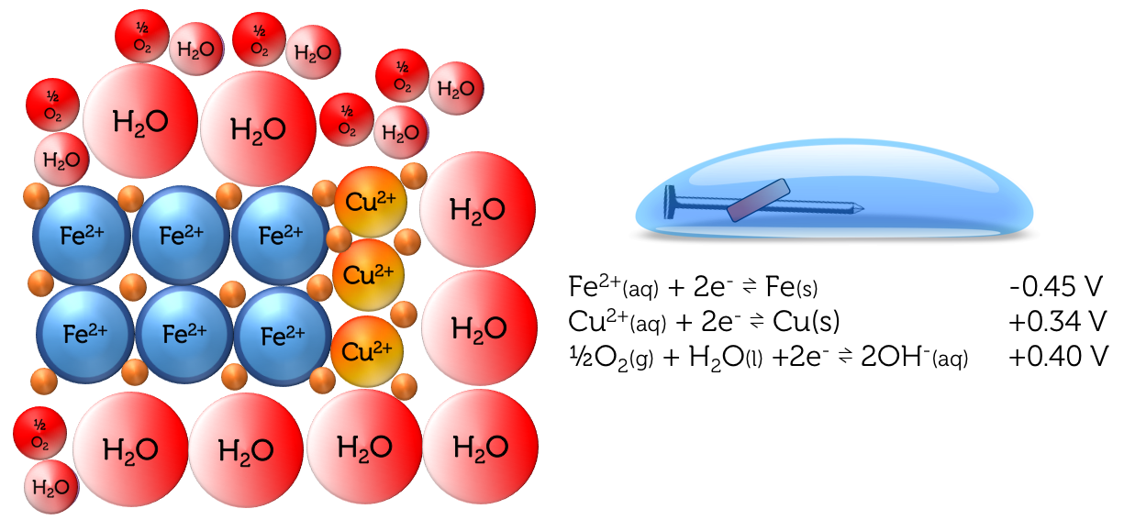

In this model the size of the circle indicates how good a substance is at attracting electrons. Smaller circles indicate the particle is better at attracting electrons. In example 3 on the next page, copper is better at attracting electrons (the orange dots) than water. As such, copper cannot donate electrons to water.

We will be using a special indicator called ferroxyl. This pale orange solution turns blue in the presence of iron ions and pink in the presence of hydroxide ions (formed if water accepts electrons from another substance).

For each situation (numbers 1–5) place a tick in one box in each row to predict what will happen. Number 3 has been done for you.

1. Iron in water  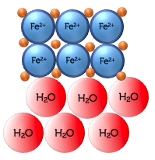 | Electrons are able to move from iron to water  Hydroxide ions will be formed – the indicator will turn pink  Iron ions will dissolve – the indicator will turn blue | Electrons are not able to move from iron to water  The indicator solution will remain a pale orange colour
2. Magnesium in water  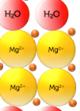 | Electrons are able to move from magnesium to water  Hydroxide ions will be formed – the indicator will turn pink  Magnesium ions will dissolve – but the indicator won’t turn blue as it detects iron ions | Electrons are not able to move from magnesium to water  The indicator solution will remain a pale orange colour
3. Copper in water  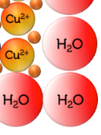 | Electrons are able to move from copper to water  Hydroxide ions will be formed – the indicator will turn pink  Magnesium ions will dissolve – but the indicator won’t turn blue as it detects iron ions | Electrons are not able to move from copper to water  The indicator solution will remain a pale orange colour  ✓
4. Magnesium with iron  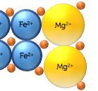 | Electrons are able to move from magnesium to iron | Electrons are not able to move in either direction | Electrons are able to move from iron to magnesium
 | The indicator is in solution so we can’t measure any effect here just by touching the two metals
5. Copper with iron  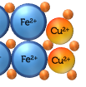 | Electrons are able to move from iron to copper | Electrons are not able to move in either direction | Electrons are able to move from copper to iron
 | The indicator is in solution so we can’t measure any effect here just by touching the two metals

Choose the correct words to add below.
Some you will not need to use, some you will use more than once.

positive, negative, attracted to, repelled by, harder, easier, stop, continue.

Although electrons can only be donated from some metals to water, metal ions can dissolve into solution. If a metal ion dissolves into solution, leaving behind a delocalised electron, the remaining piece of metal will have a _________ charge. The metal ion in solution will be ____________ the piece of metal. If another ion dissolves into solution the charge on the metal will be even more ____________. As this process continues, it gets __________ for more ions to dissolve into solution because they are more strongly _____________ the piece of metal.

Unless the remaining electrons can move away from the piece of metal and be given to another substance, this process will _____________.

