What happens when water boils?

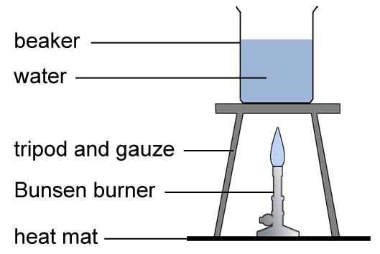

 | True | False | Don’t know
The bubbles contain a mixture of hydrogen and oxygen.
The bubbles contain carbon dioxide.
The bubbles contain steam (water vapour).
The bubbles are empty (vacuum).
The bubbles contain air.
The bubbles contain oxygen only.

My group agreed that

I changed my ideas because

What happens when ice melts?

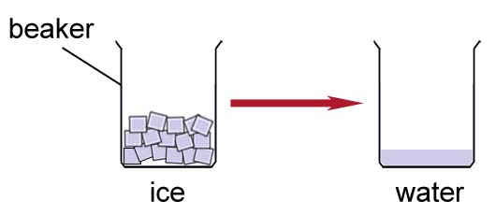

 | True | False | Don’t know
The molecules in ice get smaller because water takes up less space than ice.
The molecules in ice get warmer because the water is hotter than ice.
The molecules move around more as water than they did in the ice.
Ice molecules change to water molecules.
Ice changes to water at 0 °C.
Ice only melts above its melting temperature.

My group agreed that

I changed my ideas because

Name ………………………………

