Apparatus diagram

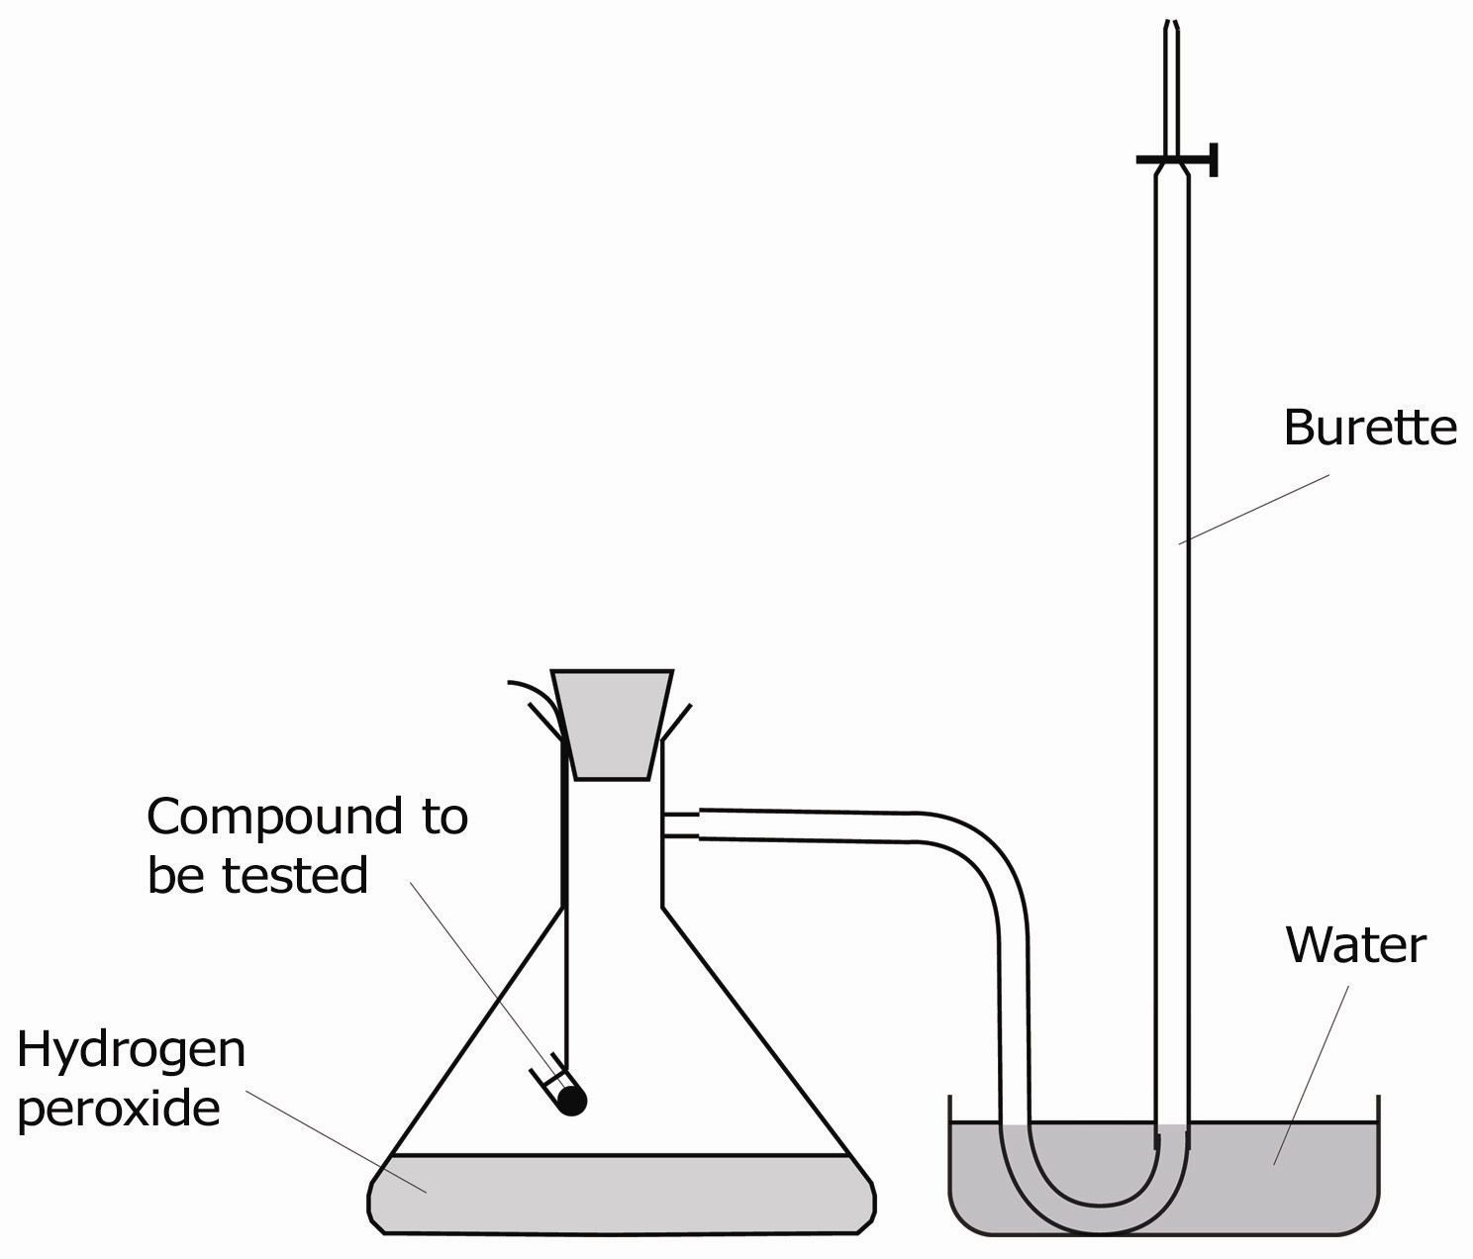

Apparatus to investigate
the effect of a catalyst on the decomposition of hydrogen peroxide

