Name:………………………………………………..…. Date:………………………………………………………
What sank the Kursk nuclear submarine?

Peroxide power in torpedoes
The decomposition of hydrogen peroxide using a catalyst has been used in rockets and torpedoes. Read these reports and then answer the questions.
Report 1
British Royal Navy: Warship losses, accidents and sinkings
HMS Sidon, 16th June 1955
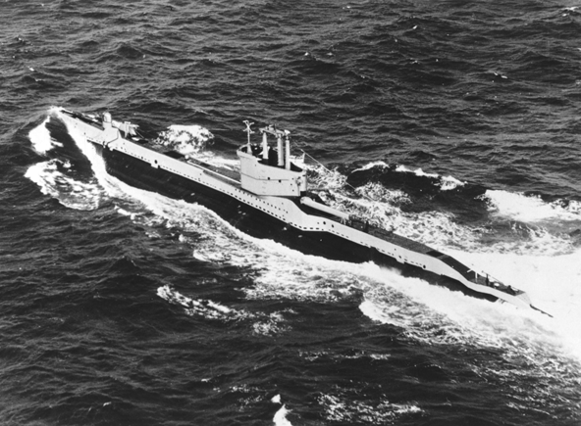 | HMS Sidon  Reproduced with kind permission from the Royal Navy Submarine Museum Photograph Archive.
HMS Sidon was a Royal Navy submarine carrying an experimental type of torpedo using high test peroxide (HTP). The Sidon sank in harbour on the south coast of England when a torpedo exploded accidentally. The torpedo had no warhead fitted, but somehow the propellant leaked out causing a reaction inside the torpedo. The force of the blast inside the torpedo tube blew off the front of the submarine. Water got in gradually, causing the Sidon to sink slowly. 13 sailors died.
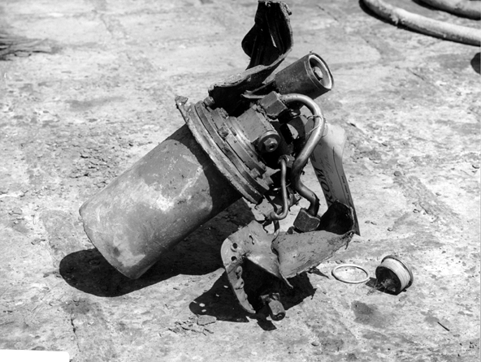 | Part of one of the HTP torpedos  Reproduced with kind permission from the Royal Navy Submarine Museum Photograph Archive.

continued on next page

continued from previous page
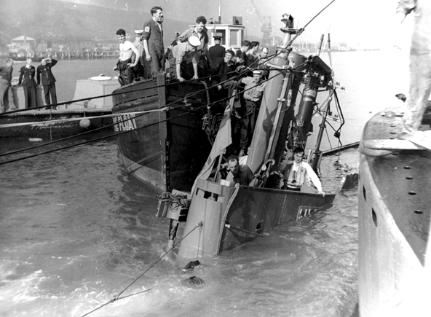 | The Sidon sinking  Reproduced with kind permission from the Royal Navy Submarine Museum Photograph Archive.
Board of Inquiry, HMS Sidon accident report
A stainless steel pipe carrying HTP burst. The torpedo had been accidentally started before firing. A combination of these two events combined to create the conditions for an explosion.
Report 2
ABC news August 19th 2000
The website for the Russian daily newspaper, The Red Star, described a quarrel between the Russian weapons industry and officials of the Russian Navy. The report said that industry officials replaced the expensive silver battery propeller system in the torpedoes with a cheaper, older system involving potentially dangerous liquid fuel.
Installing the older technology, called 'modernisation', meant the torpedoes were powered by liquid fuel and launched with a stream of gas. Navy officials said it would be complicated to store and dangerous to use. The article listed a liquid fuel explosion as one theory circulating in Russia about the sinking of Kursk.
The article appeared on the Red Star website early on Friday 18th August, but hours later had been replaced with a new story which did not mention the change in torpedo technology.
US officials could not confirm The Red Star story, but said they believe the Russians had been testing liquid-fuelled rocket motors which could be used in torpedoes. They think that a torpedo fired during exercises never left the tube. Instead, the fuel started to burn out and then a warhead exploded. A former nuclear submarine captain said that some liquid fuel systems using
hydrogen peroxide had been tested in the West, but rejected as too dangerous.
Report 3
Maurice Stradling, torpedo designer, reported in The Guardian newspaper, 5th
August 2001.
Maurice Stradling examined the similarities between the sinking of the Kursk and the Sidon submarines. He believes he may have found the explanation for the disasters.'I' taught students about the Sidon accident for years and we always believed it had something to do with the hydrogen peroxide but no one really knew how it had happened.' Stradling read the secret papers from the Board of Inquiry into the Sidon disaster. He believes the accident happened because the HTP pipe broke open, spraying the inside of the torpedo with superheated water, pure oxygen and hydrogen peroxide under pressure. 'At this point a completely uncontrolled reaction occurred, bursting the whole casing open like a balloon', he said. Stradling believes the explosion of the practice torpedo set off a chain reaction with live warheads in the bow of the Kursk, causing the massive explosion which sent Kursk to the bottom of the sea.
Sections of this article were taken from 'What really happened to Russia's unsinkable sub', Martin Bright, 05/08/01, The Guardian ©GUARDIAN
continued on next page

Questions
1. Why did HMS Sidon sink?
……………………………………………………………………………………………………………….……………………………………………………………………………………………………………….…………………………………………………………………………………………………………………………….…………………………
2. Why did the Royal Navy stop using HTP-powered torpedoes?
……………………………………………………………………………………………………………….……………………………………………………………………………………………………………….…………………………………………………………………………………………………………………………….…………………………
3. What type of torpedo was Kursk carrying according to The Red Star?
……………………………………………………………………………………………………………….……………………………………………………………………………………………………………….…………………………………………………………………………………………………………………………….…………………………
4. Why was the Kursk carrying this type of torpedo?
……………………………………………………………………………………………………………….……………………………………………………………………………………………………………….……………………………………………………………………………………………………………….……………………………………………………………………………………………………………….……………………………………………………………………………………………………………….……………………………………………………………………………………………………………….………………………………………………………………………………
5. Why was the story removed from The Red Star's website?
……………………………………………………………………………………………………………….……………………………………………………………………………………………………………….…………………………………………………………………………………………………………………………….…………………………
6. What does the torpedo designer think about the Kursk and Sidon accidents?
……………………………………………………………………………………………………………….……………………………………………………………………………………………………………….…………………………………………………………………………………………………………………………….…………………………



