Larger version cards

Chemical reactions are important in biological systems | Chemical reactions can be used as energy sources
Chemical reactions are used  to make new materials | enzymes  glucose → carbon dioxide + water

haemoglobin + oxygen → oxyhaemoglobin | Mg + CuSO₄ → ZnSO₄ + Cu
Plants use energy from the sun  to convert water and carbon dioxide  into glucose and oxygen.  This process is known as photosynthesis | To make a moulded item out of polyurethane,  the two liquid components  (polyisocyanate and polyol)  are mixed together  in exactly the right masses.  The exothermic reaction takes a minute.

CH₄ + 2O₂ → CO₂ + 2H₂O | octane + oxygen → carbon dioxide + water
n(ethene) → polyethene | 1,2-diaminohexane + hexanedioic acid → nylon-6,6

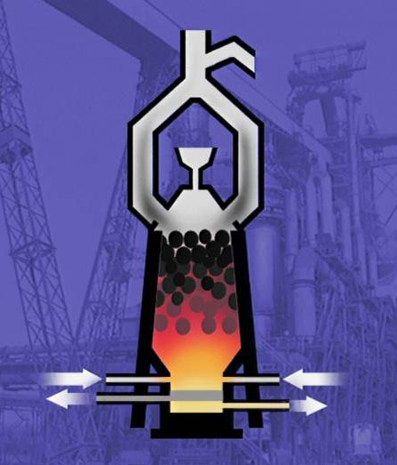 | 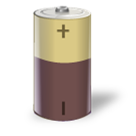
 | 

