Name:………………………………………………..…. Date:………………………………………………………
What sank the Kursk nuclear submarine?

News Timeline

Day 1
Saturday, 12th August 2000

Contact with the Kursk submarine is lost during naval exercises in the Barents Sea.

Seismic signals are detected in the Barents Sea.

Day 2

Sunday, 13th August 2000

The Kursk is found on the seabed 108 m deep by a Russian sonic depth finder about 85 miles (135 km) from Severomorsk.

Early reports from inside Russia suggest the Kursk collided with a foreign submarine at about 30 m depth and then sank. American and British officials deny any involvement of their submarines.

Day 3
Monday, 14th August 2000

The BBC reports an accident during Russian naval exercises in the Barents Sea, describing the Kursk as having 'broken down'. Knocking is claimed to be heard on the submarine's hull.

Russian officials claim no nuclear weapons are on board.

The Russian Navy claims the accident happened on Sunday.

Day 4
Tuesday, 15th August 2000

Rescue attempts are started - Russians lower a small submersible craft, but
strong currents stop this sticking on to the Kursk.

UK and USA are among countries offering help to rescue the sailors on board. Unofficial reports from the USA say that two explosions were monitored by submarines in the area where the Kursk sank.

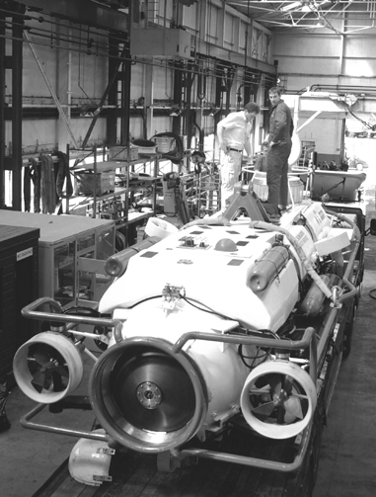 | UK submarine rescue service go through final checks on their rescue submersible  Reproduced with permission from Stephen Atkinson, PA Photos.

continued on next page



What sank the Kursk nuclear submarine?

continued from previous page

Day 5
Wednesday, 16th August 2000

New rescue attempts fail due to poor visibility underwater.

Vladimir Putin, Russia's leader, says the situation is critical, but that Russia has everything needed to rescue the sailors.

Deputy Prime Minister Klebanov says there are no signs of life on board.

Later, Russia asks the UK and Norway formally for help.

Day 6
Thursday, 17th August 2000

Russian officials report extensive damage to the front of the Kursk.

Further Russian rescue attempts fail.

Russian defence minister says that the vessel is likely to have collided with a foreign submarine monitoring the exercises. He says this theory is more credible than an on-board explosion.

Many of the crew are now believed to have died instantly.

Supply ships carrying divers and rescue equipment from the UK and Norway leave Trondheim, central Norway.

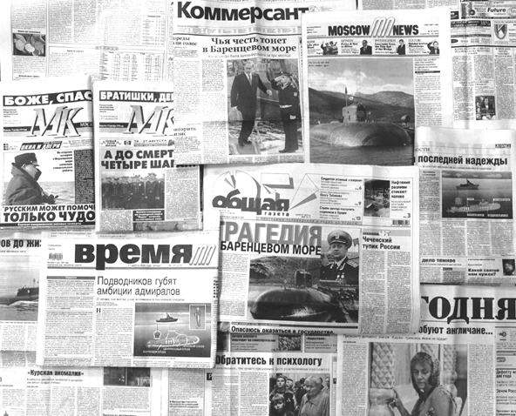 | The Kursk dominates the front pages of Russian newspapers, 17th August 2000  Reproduced with permission from Stephen Arkinson, PA Photos

Day 7
Friday, 18th August 2000

The seismological monitoring station in Norway says two explosions were
recorded in the area of the accident at about 0730 GMT.

President Putin returns to Moscow to monitor the crisis.

The Russian rescue craft latches on to the Kursk, but officials say the hatch
is too damaged for docking to be secure.

continued on next page

What sank the Kursk nuclear submarine?

continued from previous page

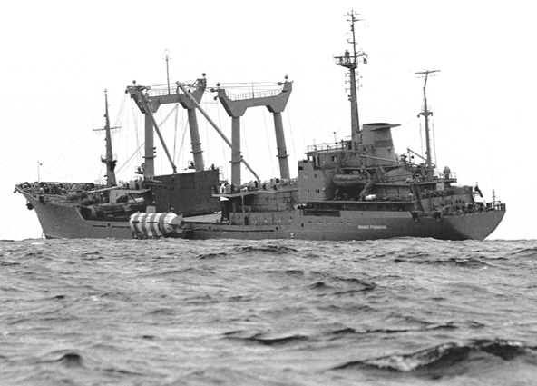 | Russian 'Mikhail Rudnitsky' vessel lowers rescue capsule  Reproduced with permission from  Stephen Atkinson, PA Photos.

Day 8
Saturday, 19th August 2000

British and Norwegian rescue teams arrive.

Day 9

Sunday, 20th August 2000

First Norwegian divers reach the submarine.

Their reports say the rear escape hatch is not too damaged to attempt opening.
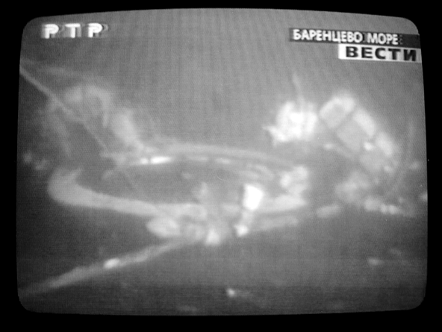 | 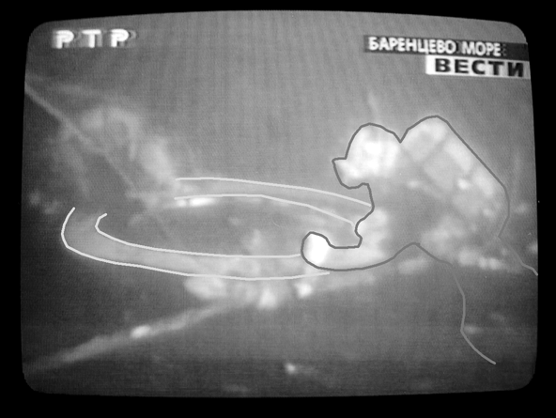  Russian state television shows footage of Norwegian divers attempting to open hatch  Reproduced with permission from  Stephen Atkinson, PA Photos.  To help you interpret this picture, the diver is outlined in black.

continued on next page

What sank the Kursk nuclear submarine?

continued from previous page

Day 10

Monday, 21st August 2000

Norwegian divers open outer hatch. The airlock is found to be flooded. No bodies are found.

Later the airlock's inner hatch is opened. The cabin inside is flooded and rescuers conclude the crew are dead.

The Russian navy announces officially that all 118 crew members are dead.
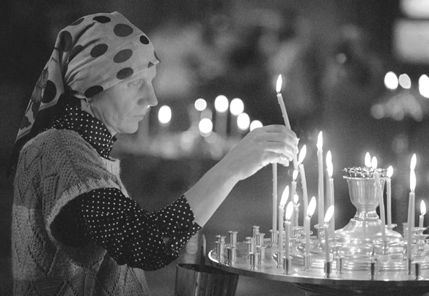 | Russia goes into mourning on announcement of the death of the Kursk's crew  members  Reproduced with permission from  Stephen Atkinson, PA Photos.

Day 13
Thursday, 24th August 2000

A mother of one of the sailors screams abuse at Russia's Deputy Prime Minister at a news conference. To stop her, she is injected with a drug to send her to sleep. These pictures are sent round the world.

 | A video-grab shows an angered relative screaming abuse at Russia's deputy prime  minister  Reproduced with permission from  Stephen Atkinson, PA Photos.

continued on next page

What sank the Kursk nuclear submarine?

continued from previous page

Other key dates in the story of the Kursk
15th February 2001
A Russian naval official says a torpedo explosion sank the Kursk submarine. Two explosions happened, a large one occurring a short time after a small one. The official said the cause of the first blast had not been established. The Russians still think it is possible the Kursk may have hit a mine or another vessel before sinking.
7th August 2001
British torpedo experts and seismologists suggest that the Kursk was carrying torpedoes carrying high concentration hydrogen peroxide, called 'High Test Peroxide' (HTP). HTP has not been used in the UK since the 1950s, after an explosion on board a submarine was caused by HTP leakage. British seismologists working at Blacknest report analysis of seismic traces are consistent with underwater explosions. At about this time, the Horizon television programme, 'What sank the Kursk?' was shown. This explored reasons for the sinking of the submarine, linking it to HTP.
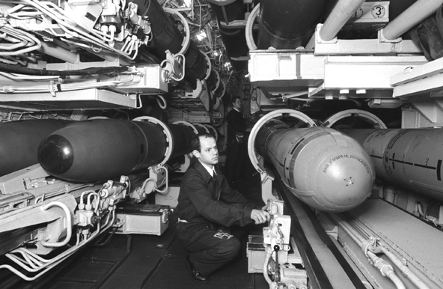 | Torpedo compartment of a Russian nuclear submarine of the same class as the Kursk  Reproduced with permission from Stephen Atkinson, PA Photos.

8th October 2001
The remains of the Kursk submarine are lifted from the seabed by a Dutch salvage team. The submarine, carrying two nuclear reactors and 22 missiles, was attached to a giant barge and towed towards Murmansk in northern Russia. The front was cut off and left on the seabed.

continued on next page

What sank the Kursk nuclear submarine?
continued from previous page

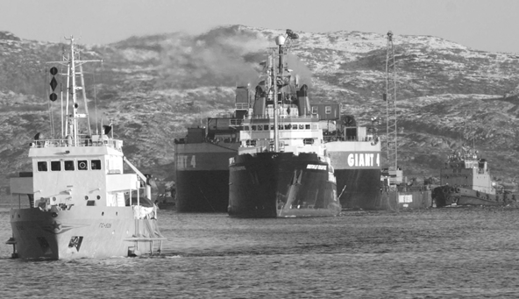 | A tugboat tows the barge with the Kursk nuclear submarine beneath  Reproduced with permission from Stephen Atkinson, PA Photos.

2nd July 2002
Russian officials finally admit that leak of hydrogen peroxide torpedo fuel caused the first explosion that sank the Kursk. Until now, the Russians have insisted that the Kursk collided with a foreign submarine or hit a mine, triggering a second larger blast that caused the sinking.
11th September 2002
The front section of the Kursk is destroyed on the seabed. The final official report on the disaster is published. Russian officials say that the event was an accident for which no-one was responsible. However, a few days earlier a 30 page report by lawyers acting on behalf of the sailors' families was released suggesting that failure to follow safety procedures was responsible.
Eventually, the Russian navy finally agreed that the Kursk sank because of the torpedo design. The Kursk had been refitted shortly before going on the exercises with a new system for propelling the torpedoes. The new system used a chemical called hydrogen peroxide.

Note: This resource can be downloaded as part of a set of activities exploring what sank the Kursk submarine (https://rsc.li/34pd4X5) or for use with a lesson plan on the same topic (https://rsc.li/2F4ypfu).

