Name:………………………………………………..…. Date:………………………………………………………
Hair
Find out what hair is, why and how it grows and what shampoo and conditioner do to hair fibres.
Hair and shampoo: the facts
Our bodies are covered with hair. Most hairs are fine, short and cannot be seen. Thick hair on our heads helps keep our heads warm. This is what we really think of as 'hair'. Hair is not alive. Hair is made by living cells buried in the scalp, the skin on our heads. Hair is made from the protein keratin and is like nails, claws, hooves and feathers on other animals.
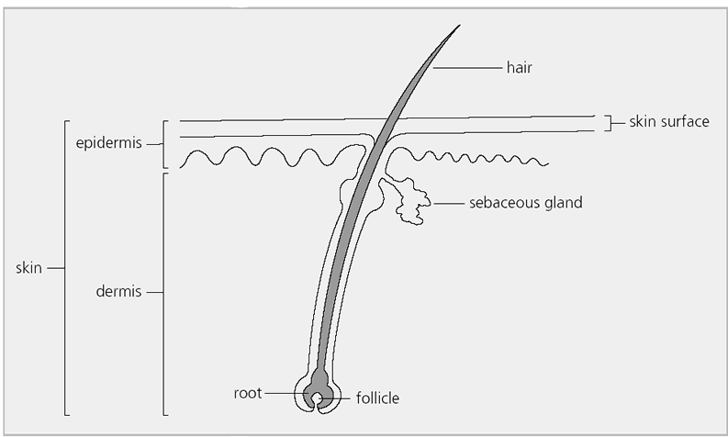
A hair on a human head.

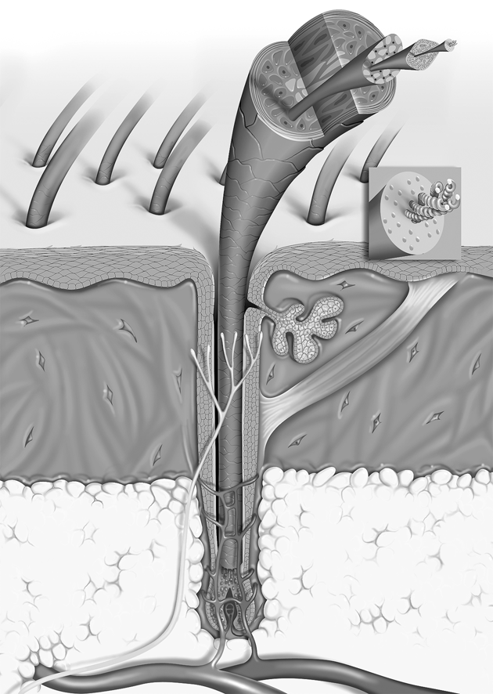
Cross section of a hair at the root
Reproduced with kind permission from Catherine Gerst, L'Oreal Recherche, Paris, www.hair-science.com (accessed November 2003).
continued on next page


Hair
continued from previous page

Each head hair is composed of three layers. In the middle is a honeycomb like structure called the medulla. This is surrounded by the cortex which forms the bulk of the hair fibre and contains the hair colour. On the outside of the hair is a thin protective layer of cells called the cuticle. The fibres grow from a living root in a sac under the skin called a 'follicle'. Cells in the follicle multiply, are pushed upwards by those underneath, and fill up with keratin. They harden and then die, making a scaly coat like roof tiles over the keratin fibres. This outer coating is called the 'cuticle' and is also made mainly from keratin.

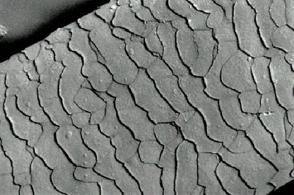 | 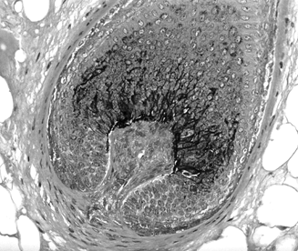
Cuticle structure  Reproduced with kind permission from Chris Gummer, Procter & Gamble  www.hair-science.com (accessed November2003). | Hair bulb  Reproduced with kind permission from Catherine Gerst, L'Oreal Recherche, Paris,

Sebaceous glands near the base of the follicle produce an oily substance called 'sebum' which makes the hair shiny, keeps the scales of the cuticle flat and prevents the fibre drying out.

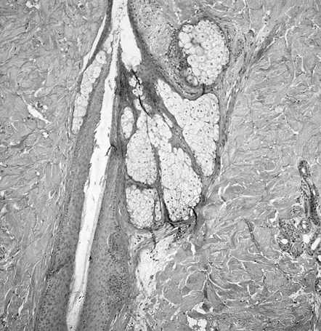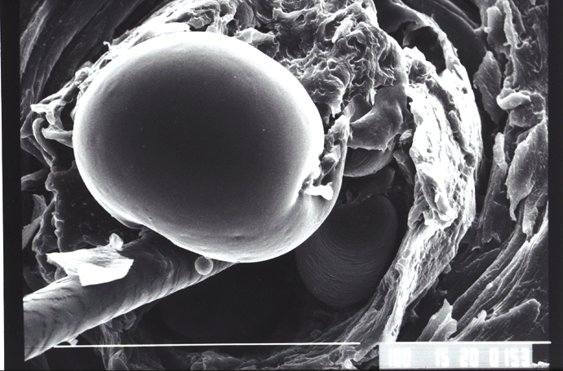

Sebaceous gland Sebaceous secretion
Reproduced with kind permission from Catherine Gerst, L'Oreal Recherche,Paris, www.hair-science.com (accessed November 2003).

We wash hair when it gets dirty. The dirt is from the body and the outside world. Dirt is 5% of hair mass. Dirty hair feels sticky and unpleasant. Unwashed hair will start to smell. Some people think that hair will wash itself if left unwashed - this is not true!
Dirt from the body is made from grease and dead skin cells. Grease, called sebum, is made by glands in the skin called sebaceous glands. Dead cells come from the scalp and cuticle.
continued on next page

Hair
continued from previous page

The outside world also makes our hair dirty. First, we have to wash off all the extra products we put on it - sprays, gels, muds, styling foams and conditioners. Then there is also dirt which floats on to hair as we move around.

Questions
1. What would happen to our body hair if we stopped wearing clothes?
……………………………………………………………………………………………………………….……………………………………………………………………………………………………………….
2. What causes different hair types, eg dry, greasy?
……………………………………………………………………………………………………………….……………………………………………………………………………………………………………….
……………………………………………………………………………………………………………….
3. Would our hair be more healthy if we did not use extra products?
……………………………………………………………………………………………………………….……………………………………………………………………………………………………………….

Washing hair - how does shampoo work?
Shampoos are good cleaners. 100 000 hair fibres each 10–20 cm long gives an area of 2–4 m² to be cleaned. This is the floor size of an average room. Even so only a small amount of shampoo is needed!
At least one chemical in shampoo is a surfactant. The diagrams show how a surfactant works on hair. Surfactant means 'surface active' chemical.

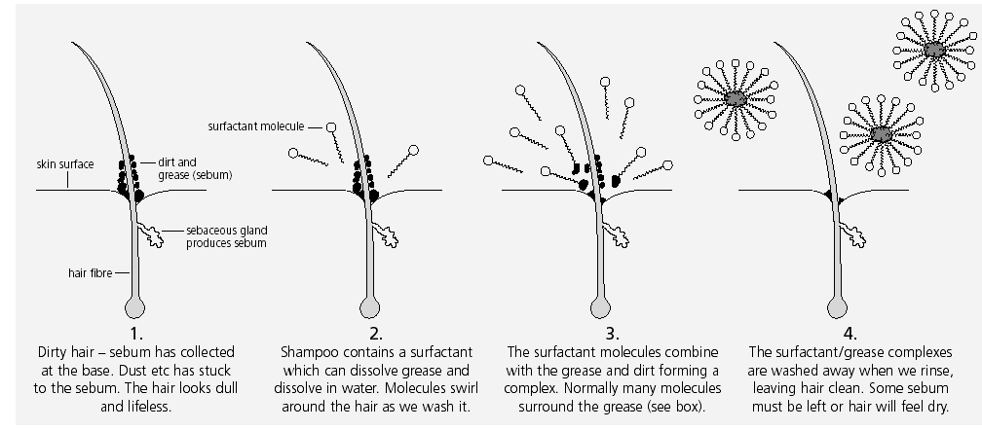

How a surfactant works on hair
continued on next page

Hair
continued from previous page

The surfactant strips away the grease and dirt, leaving only hair fibres. If the surfactant is too efficient, hair will have no natural oil and get dry. Makers choose surfactants carefully. Different surfactants act in different ways.
The main cleaning surfactants in shampoo are sodium lauryl sulfate and sodium laureth sulfate. The molecular structures of these two compounds are shown.
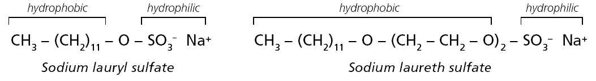
Sodium laureth sulfate has a longer chain of carbon and hydrogen atoms than sodium lauryl sulfate. Sodium laureth sulfate is less irritating. This is probably because as a larger molecule it does not get into skin pores easily.
Different surfactants lather and clean to different degrees. A second type of surfactants is found in shampoos. These molecules act as conditioners - they stick to the hair, making the fibres feel smooth and silky.
Shampoo makers have to make sure the conditioner and shampoo surfactants do not react together - otherwise the formulation will not work.

Questions
4. Which surfactant should you look for if your skin is sensitive?
……………………………………………………………………………………………………………….……………………………………………………………………………………………………………….
……………………………………………………………………………………………………………….5. Why do shampoos contain more than one type of surfactant?
……………………………………………………………………………………………………………….……………………………………………………………………………………………………………….
……………………………………………………………………………………………………………….
6. Compare surfactants in 'mild' or 'frequent wash' shampoos with those for 'greasy' hair – are there any differences? Explain any differences.
……………………………………………………………………………………………………………….……………………………………………………………………………………………………………….

7. What do conditioners do to hair?
……………………………………………………………………………………………………………….……………………………………………………………………………………………………………….
continued on next page

Hair
continued from previous page
Making hair manageable and shiny
Other compounds also 'condition' hair. These contain silicon atoms. The compound 'dimethiconol' is one. The molecules make a water-resistant coating by sticking on the hair fibre surface. When dry, silicones feel smooth and slippery. Hairdressers say this makes hair more 'manageable'.
Hair shines when light reflects off the surfaces of the hair fibres. Smooth surfaces reflect light more evenly, giving a shiny look. To make the hair surface smooth, the cuticle 'roof tiles' must lie flat. If the cuticle tiles are roughened, light is not evenly reflected and hair will not shine. To help make hair shiny, shampoos usually have pH values of 4—6, which is slightly acidic. This is because the cuticle tiles move apart at alkaline pH, causing rough fibres. Traditionally, hair can be made to shine by rinsing in vinegar or lemon juice.
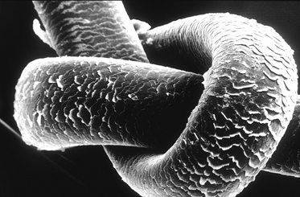
Knot in a hair, seen through a scanning electron microscope
Reproduced with kind permission from Catherine Gerst, L'Oreal Recherche, Paris, www.hair-science.com (accessed November 2003).
Questions
8. What differences do conditioners make to hair?
……………………………………………………………………………………………………………….……………………………………………………………………………………………………………….
……………………………………………………………………………………………………………….9. Were the shampoos tested acidic, alkaline or neutral? Now explain your results.
……………………………………………………………………………………………………………….……………………………………………………………………………………………………………….
……………………………………………………………………………………………………………….

