Name:………………………………………………..…. Date:………………………………………………………
Hair
Every now and again our hair goes wrong and we feel bad about how it looks. In this part, we look at typical hair problems and the chemistry behind them.
Bad hair day - some hair headaches
Chrissie is a hairdresser working in a salon. She is very knowledgeable about hair, but does not know much chemistry. Here is the advice Chrissie gave to her clients with hair problems. Explain the chemistry behind the advice marked in bold. Use the information in Hair and shampoo - the facts to help.
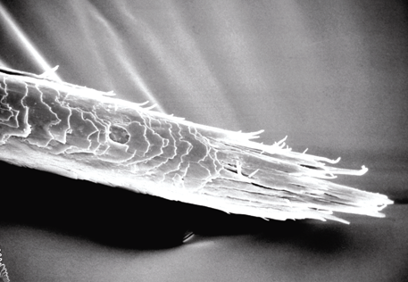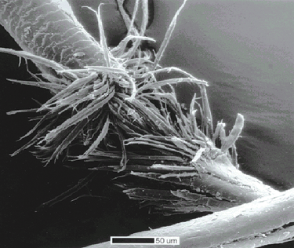
A split end, seen through a scanning electron microscope A burst hair
Reproduced with kind permission from Catherine Gerst, L'Oreal Recherche, Paris, Reproduced with kind permission from Chris Gummer, Procter &
www.hair-science.com (accessed November 2003). Gamble.
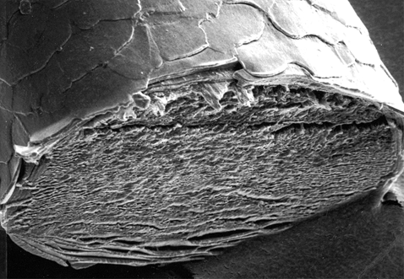
A cut hair, seen through a scanning electron microscope
Reproduced with kind permission from Catherine Gerst, L'Oreal Recherche, Paris,
www.hair-science.com (accessed November 2003).

Alisha
Problem:
Has shoulder-length hair with split ends, likes to brush her hair a lot and blow dries it every day.
continued on next page


Bad hair day - some hair headaches
continued from previous page

Chrissie says:
'Your hair is over-treated. The only way to get rid of split ends is to cut them off. You should use a hairdryer less often or set it on a cooler setting. Try using a softer brush, and use a conditioner. Try not to worry if your hair does not look perfect - finger drying can give a different look.'
Rob
Problem:
Has short hair and likes to use gels. Rob has his hair dyed a lot. Whatever he does, it never looks 'right'.
Chrissie says:
'Your hair is damaged. You have had too many hair treatments. You should wait until the last treatments grow out before having any more. Don't use too much gel. Instead, use a good silicon-based conditioner when you wash your hair.'
Carl
Problem:
His girlfriend is complaining about his dandruff.
Chrissie says:
'Dandruff is very annoying. You need to wash your hair with a medicated shampoo. You can also try a herbal based shampoo with rosemary or tea tree oil in it. Keep your hair neat and short and have it cut regularly in a good style so at least it looks nice.'
Ash
Problem:
Does a lot of swimming but does not like the chlorine smell in her hair and can't make it shiny.
Chrissie says:
'You need to wash and condition your hair after swimming. Use a mild 'frequent wash' shampoo and a separate conditioner. Leave the conditioner for a few minutes then rinse off thoroughly in warm water. Keep a short style which will be easy to look after.'

