Chemistry and diet
Did you know?
About taste and smell

We think that the tongue is the centre of our taste, but this is not true. The tongue is not very sensitive - it can distinguish only five different tastes. These are sweet, sour, salt, savoury, and bitter. In contrast the nose is very sensitive to smells, taste is thought to be 98% smell and only
2% taste through the tongue. Try tasting different flavoured crisps while holding your nose – it is much harder to tell the flavours apart!
Tastes and smells can be very complex - a strawberry flavour for example has 300 different components. In making an artificial strawberry flavour, key compounds which people most think of as 'strawberry' will be used, as it would be impossible to recreate the taste and smell of a strawberry perfectly.

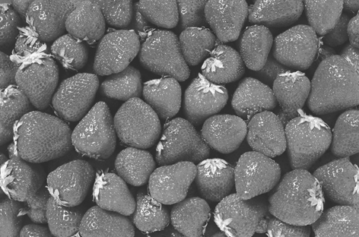
Taste and smell can be difficult to judge – two people would not always agree on a taste or smell. Companies producing food flavourings have to find ways of standardising tastes, so they know how best to create flavouring products. Quest International, which makes the flavourings for many food products sold world-wide, uses a 'flavour language' made of a wide range of
powerful smelling compounds. Food scientists are taught to recognise the compounds so that when they smell products they are able to identify the components. The learning process takes about two years and employees are tested regularly.



