Chemistry and diet
Did you know?
About fat

What we call 'fat' is a chemical known as a lipid. Oils and fats are both lipids, but oils are liquids at room temperature, while fats are solids. When we say 'fat' we really mean both solid and liquid lipids. Lipid molecules are shaped like the capital letter 'E'. They are made from three
chains of carbon and hydrogen atoms linked together. The molecules are too large to be taken into the body in one piece, so enzymes called lipases break them down into smaller molecules called fatty acids and glycerol. These are taken into the body.

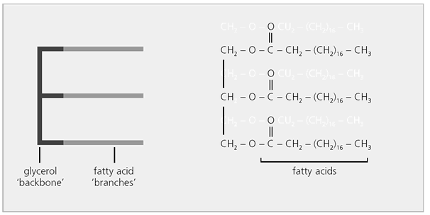

A lipid molecule
Inside, the body uses fatty acids and glycerol to make cell membranes and some chemical messengers called hormones. Any spare molecules are made into fat stored in special cells called adipose tissue. We need some adipose tissue to keep our bodies warm and to supply energy if, for some reason, we cannot eat food for a few days, for example during an illness. So lipids are not 'bad for you' - we need them. The problem is that we often eat food with too much lipid and do not exercise enough. This can make us 'put on weight', so we store more fat than we should.



