Name:………………………………………………..…. Date:………………………………………………………

Fats, oils and fatty acids
Fats and oils have different 'fatty acids' in them (see Did you know about fat? and Did you know more about fat? for more information). Here you can find out how to test for different molecules.
What you need

- About 5 cm³ of each fat (melted) or oil
- Measuring cylinder or pipette to measure each fat or oil
- One test-tube for each fat or oil
- Iodine solution, 2% (Harmful) in potassium iodide solution – use with care, will stain hands and clothes
- Dropping pipette
- White card for background
- Stopwatch
- 250 cm³ beaker
- Glass rod
- Hot water
- Test-tube rack
- Eye protection.

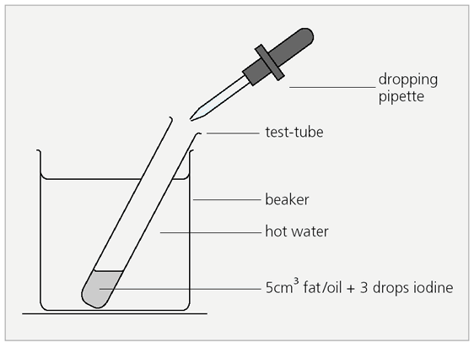

What you do
1. Half fill a test-tube with a melted fat or oil. This should be about 5 cm³.
2. Add exactly three drops of iodine solution. Stir so the iodine colour spreads out.
3. Place the test-tube in the beaker of hot water.
4. Start the stopwatch immediately.
5. Stop the watch when the red colour disappears. Record the time elapsed.
6. Repeat with the other fats and oils, using a clean test-tube for each.

continued on next page


Fats, oils and fatty acids
continued from previous page

Safety
Wear eye protection.

Results
Put your results in the table.

Results table
Fat or oil | Appearance | Time for red colour to fade / seconds | Comments

continued on next page

Fats, oils and fatty acids
continued from previous page

Questions
Use Did you know more about fat? to help you make sense of the results.
1. Which fat or oil has the most unsaturated fatty acids?
……………………………………………………………………………………………………………….
2. Which fat or oil has the least unsaturated fatty acids?
……………………………………………………………………………………………………………….
3. Explain why 'unsaturated' fats are supposed to be 'good' for the body.
……………………………………………………………………………………………………………….……………………………………………………………………………………………………………….
……………………………………………………………………………………………………………….……………………………………………………………………………………………………………….

continued on next page

Fats, oils and fatty acids
continued from previous page

Alternative questions
1. Which fats took the longest and the shortest times to decolourise the iodine?
……………………………………………………………………………………………………………….
……………………………………………………………………………………………………………….
2. Which fat is the most saturated and which is the least saturated?
……………………………………………………………………………………………………………….
……………………………………………………………………………………………………………….
3. Which fat is the most ‘healthy’ of those you tested?
……………………………………………………………………………………………………………….
……………………………………………………………………………………………………………….
4. Discuss how this information could be used to inform people’s eating habits.
……………………………………………………………………………………………………………….
……………………………………………………………………………………………………………….
……………………………………………………………………………………………………………….
……………………………………………………………………………………………………………….
5. What other tests could you carry out to decide if a fat is ‘healthy’ or not?

Note: This resource can be downloaded as part of a set of activities exploring lipid chemistry and dietary fats (https://rsc.li/3iHoqdV) or for use with a lesson plan for 16–18 year olds investigating ‘healthy’ fats and unsaturation (https://rsc.li/3hAndVu).

