Vitamins
Did you know?
About Linus Pauling
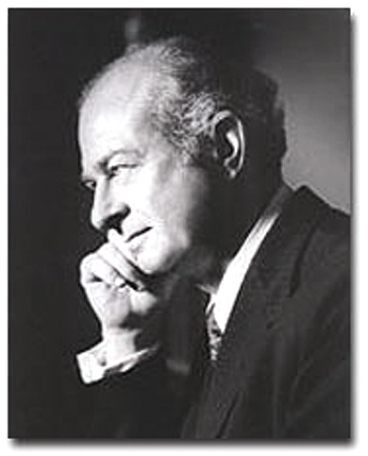  Linus Pauling  Reproduced with kind permission from Aaron Schmidt, Boston Public Library Print Department and John Woodford, Michigan Today. | Linus Pauling was an American chemist who lived from 1901–1994. He is thought of as one of the greatest scientists of the 20th century. Linus  Pauling was the son of a pharmacist who died young leaving three small children, so Linus grew up in a poor family. He went to school and eventually to college, where he worked while studying to pay his fees. At the age of 26, Linus Pauling was lecturing at the California Institute of Technology, called CalTech. He worked on chemical bonding, working out how to apply new theories from physics to chemistry. He won a Nobel Prize for chemistry in 1952. Linus Pauling led a campaign in the USA and worldwide against the use of atomic bombs and was awarded the Nobel Peace Prize for this work in 1962. He is the only man in history to win two Nobel Prizes working by himself. Linus Pauling became interested in vitamin C in 1966, publishing his book 'Vitamin C and the Common Cold' in 1970. He continued working in scientific research until he was at least 91. At one lecture in Sweden Linus Pauling said, 'Young people should always listen to their elders, but not necessarily believe what they say.'  For more information look at www.nobel.se/chemistry/



