Star chemistry
Did you know?
About hydrogen
Hydrogen is the most common element in the universe. 88% of all atoms are hydrogen atoms so there is more hydrogen than any other substance. The name comes from the two Greek words hydro and genes, which together mean 'water-forming'. Hydrogen atoms were made in the Big Bang, when the universe is believed to have started. The diameter of a hydrogen atom is 0.000000074 mm - this means that 1.63 x 10¹² hydrogen atoms would be needed to stretch
across a £1 coin (22 mm diameter). Hydrogen is 'star fuel'; in stars, atoms fuse together under very high temperatures and pressures to make helium and other chemical elements. In the centre of our Sun about 600 million tonnes of hydrogen per second are converted into helium. In this process, about 5 million tonnes of matter are converted into energy, according to Einstein's
famous equation E=mc² (in which E = Energy, m= mass and c= speed of light, 3 x 10⁸ ms⁻¹).

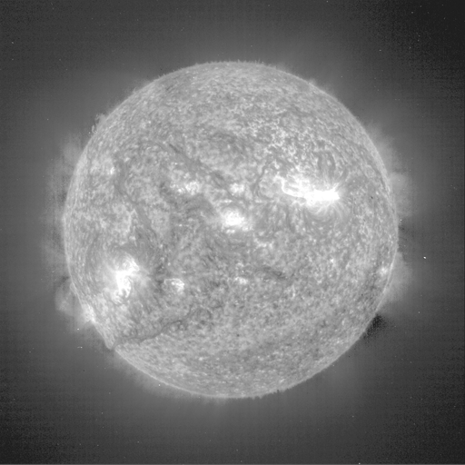

The Sun
Reproduced with kind permission from SOHO-EIT / ESA - NASA.



