Cleaning chemistry
Did you know?
About shower gels and soaps
Shower gels and soap bars are mixtures of chemicals. The ingredients are always listed in order, by mass, with the largest first.
In a liquid shower gel, water, called 'aqua' on the labels, is the main ingredient, so this is first. Next is the detergent compound(s). Most ingredients dissolve in water, making a solution. Others are fine powders which do not dissolve. The powder particles are suspended in the liquid. This makes a suspension, so the product appears 'cloudy'. Oils may be added which soften and moisturise skin. Oil will usually form a layer on top of water. An emulsifier helps oil and water to mix. A mixture of two immiscible liquids is called an emulsion. Perfumes are added to make it smell pleasant and preservatives to help stop bacteria growing. Adding colour makes it look nice.
In a solid soap, the soap compounds are the main ingredients, with aqua next. It is strange to think that there is water in the soap bar, but it is true! We cannot see it because the water molecules are spread out between much larger molecules. Other compounds added to soap bars include oils, perfumes, colours and preservatives.
The volume of liquid in the bottle is often given in ml (millilitres) which is not a unit used in the international scientific system of units. However, 1 ml = 1 cm³.
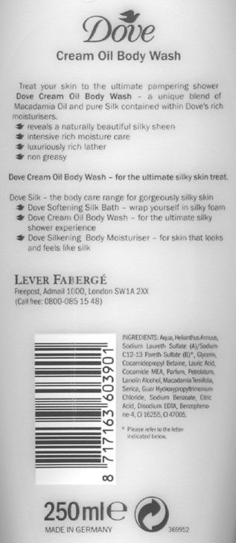 | 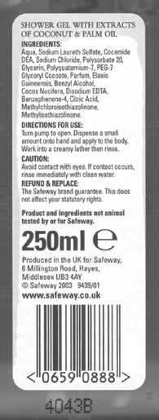 | 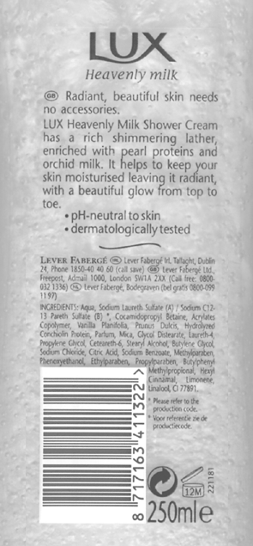

Product labelling on shower gels



