Name:………………………………………………..…. Date:………………………………………………………
Cleaning chemistry
Forever blowing bubbles
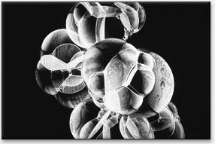
Cluster of soap bubbles
Reproduced with permission from Michael Douma
What you do
Use your knowledge about soaps and detergents to design an experiment which would help you answer these questions:
1. Why do the bubbles made by bubble bath disappear when you then use ordinary soap?
2. Does this depend on the type of soap, the type of bubble bath, or both?



