Name:………………………………………………..…. Date:………………………………………………………
Nanochemistry
Carbon and its various forms
Diamond and graphite are two well-known forms of carbon. In 1985 scientists discovered a third form of carbon based on 60 atoms bonded in a football-like structure. Scientists called this 'buckminsterfullerene', or 'buckyball'. This started a search for other carbon structures. In 1991 a Japanese scientist called Sumio Iijima found carbon nanotubes. These are about 10 000 times thinner than a human hair, made from carbon atoms bonded in sheets and rolled into tubes. A carbon nanotube is about 1 nm in diameter and 1–10 µm long. The tubes are often capped at each end with a half-buckyball structure. Scientists are working to find out more about carbon nanotubes and what they could be used for.
What do nanontubes look like?
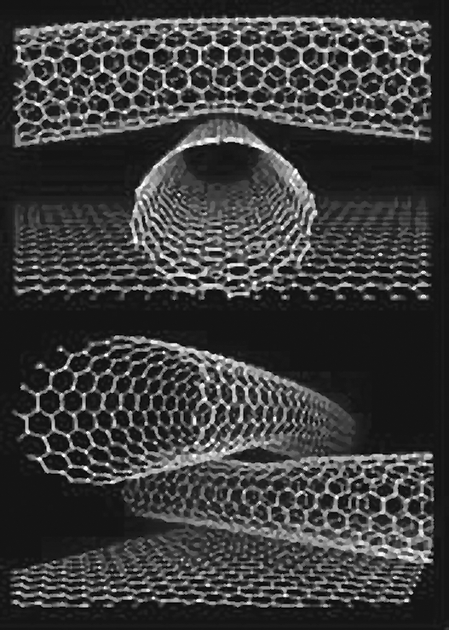 | Piled high  Reproduced with kind permission from Mike Ross, IBM Almaden Research Center, California USA.

Questions
1. Describe the appearance of the nanotubes in the figure Piled high. What do they remind you of? ……………………………………………………………………………………………………………….
……………………………………………………………………………………………………………….
2. Name the chemical element that nanotubes are made from. ……………………………………………………………………………………………………………….
3. Name another form of this element which has a structure similar to nanotubes. How are nanotubes different from this substance? ……………………………………………………………………………………………………………….
……………………………………………………………………………………………………………….
4. Explain in terms of chemical bonding why this chemical element exists in several different forms, each with different properties.
……………………………………………………………………………………………………………….
………………………………………………………………………………………………………………


