Name:………………………………………………..…. Date:………………………………………………………
Nanochemistry

Modelling nanotubes

What you need
- Nanotube grids 1 and 2
- Scissors
- Glue

What you do

DO NOT cut anything out at this stage.
Nanotube grid 1
1. Count the number of hexagons (corresponding to a chain of carbon atoms) along the line XX.
2. Write down the numbers in brackets like this (5,6). Use a 0 as the second number if only one line was counted.
3. Starting at P on the grid mark a zig-zag line following the hexagons across the grid. The line has been started for you.
4. Use the table to find out which type of nanotube the model corresponds to.
Number(s) | Type of line across the sheet | Conducts? | Type of nanotube
(15,0) | Zig-zag, angle 90° to end | Yes, metallic | Zig-zag
(11,7) | Zig-zag, line not straight angle <90° | Under some conditions semiconductor | Chiral
Nanotube grid 2
1. Count the number of hexagons (corresponding to a chain of carbon atoms) along the line YZY.
2. Write down the numbers in brackets like this (5,6) where the numbers show how many hexagons are in each straight line.
3. Starting at Q on the grid mark a zig-zag line across the grid. The line has been started for you.
4. Use the table to find out which type of nanotube the model corresponds to.
Now you can:
1. Cut out the nanotubes, following lines around the tabs.
2. Glue carefully along the tab on the long side.
continued on next page


Nanochemistry
continued from previous page
3. Make the tubes, sticking the tabs underneath. Make sure the hexagons join neatly.
4. Look at Figures 1a and 1b. Have you made this nanotube? Which type is it?

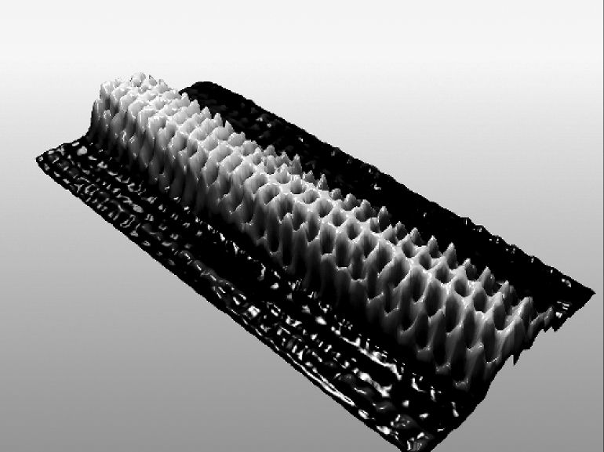
Figure 1a A picture of a nanotube: which type?
Reproduced with kind permission from Cees Dekker, TU Delft, The Netherlands.

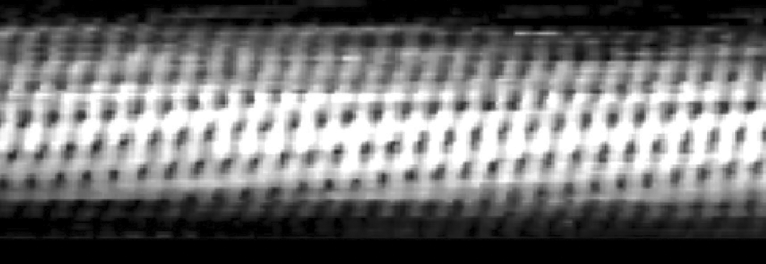
Figure 1b The same nanotube: which type?
Reproduced with kind permission from Cees Dekker, TU Delft, The Netherlands.

continued on next page

Nanochemistry
continued from previous page

Nanotube grid 1
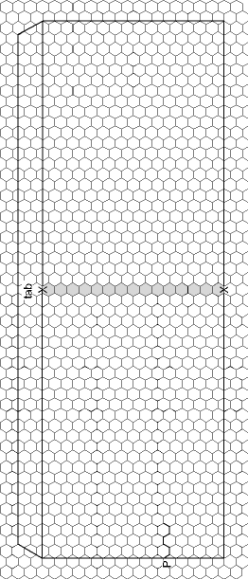
continued on next page

Nanochemistry
continued from previous page

Nanotube grid 2
