Name:………………………………………………..…. Date:………………………………………………………
Nanochemistry
Combining nanotubes
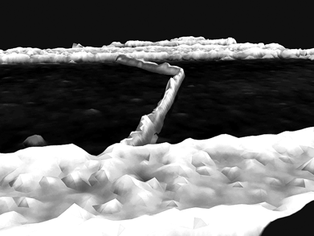 | 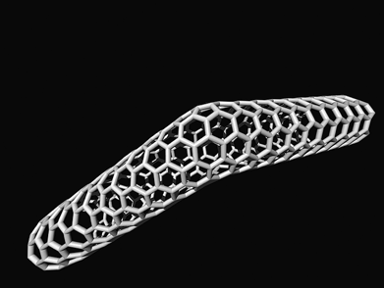
Figure 1a A 'kinked' nanotube joining electrodes Figure 1b A model of the nanotube joining the two
(light) on a silicon dioxide base (dark) electrodes
Reproduced with kind permission from Cees Dekker, TU Delft, The Netherlands.
What you do
1. Look at Figures 1a and 1b. Figure 1a shows a nanotube being used to connect two electrodes. Figure 1b shows a model of this nanotube.
2. What types of nanotube are in the picture of the model (Figure 1b)?
3. Make a paper model of this nanotube using Nanotube grid 3. Work out how to make the 'kink'.
A nanotube with this structure will act as an electrical component called a 'diode'. A diode allows an electric current to pass through in one direction only. Diodes are vital components in microchip circuits.
Questions
1. What is the main structure difference between semiconducting and metallic nanotubes? ……………………………………………………………………………………………………………….……………………………………………………………………………………………………………….
……………………………………………………………………………………………………………….……………………………………………………………………………………………………………….……………………………………………………………………………………………………………….
……………………………………………………………………………………………………………….
2. What might metallic and semiconducting nanotubes be used for?
……………………………………………………………………………………………………………….……………………………………………………………………………………………………………….
……………………………………………………………………………………………………………….………………………………………………………………………………………………………………. continued on next page


Nanochemistry
continued from previous page

What you do
The nanotube extension
1. Use the blank Grid 3 to make other tubes with these numbers:
- Metallic: (12,9), (6,6), (18,3)
- Semiconducting: (12,8), (12,10), (15,1)
2. Count a straight line of hexagons, then turn through 120° for the second line (see Grid 2).
3. Join the starting point of the first line to the end point of the second.
4. Draw lines 10 cm long at right angles (90°) to both ends of this line. This will give the basic shape.
5. Make a rectangle by connecting the ends of the 10 cm lines.
6. Add tabs to two of the four sides, 1 cm deep.
7. Cut out the nanotube shape and stick the long sides together as before.
Questions
3. What do you notice about the diameters of the finished tubes?
……………………………………………………………………………………………………………….……………………………………………………………………………………………………………….
……………………………………………………………………………………………………………….
4. A metallic tube has numbers which are connected mathematically. What is the connection? ……………………………………………………………………………………………………………….……………………………………………………………………………………………………………….
……………………………………………………………………………………………………………….
Getting longer
Your tube is 2 cm in diameter and 10 cm long. A real nanotube is about 1 nm in diameter and up to 100 mm long.
Join your nanotube to 9 others using the tab on the short, now rolled, end. Make sure they are all the same type. Make the joins as neat as possible so hexagons are complete. Measure (or work out) the length of the new, long tube.
5. On the scale of 1 nm = 2 cm, work out:-
The length of your long tube in nanometres. Change this figure to micrometres (use Getting down to nanometres to help).
……………………………………………………………………………………………………………….……………………………………………………………………………………………………………….
……………………………………………………………………………………………………………….
6. A nanotube can be 100 mm long. Change this to cm using the scale 1 nm = 2 cm.
……………………………………………………………………………………………………………….
7. How many 10 cm nanotubes would be needed to make one single tube this length?
……………………………………………………………………………………………………………….……………………………………………………………………………………………………………….
……………………………………………………………………………………………………………….
continued on next page

Nanochemistry
continued from previous page


