Hair
Did you know?
Hair today, gone tomorrow

The truth about baldness  Hair follicles go through a fixed number of cycles. This means they can produce only a certain number of hairs during a lifetime. Each cycle takes about 2—5 years. In some people the hair cycles go much faster, taking about 6 months. So, the follicles 'run out' of hair much sooner.  This happens much more in men than in women. About 15% of men will have lost an obvious amount of hair by age 30 and 50% will have done so by the age of 45. Hair loss in women is much less dramatic. Baldness goes in families as there is a genetic link. | 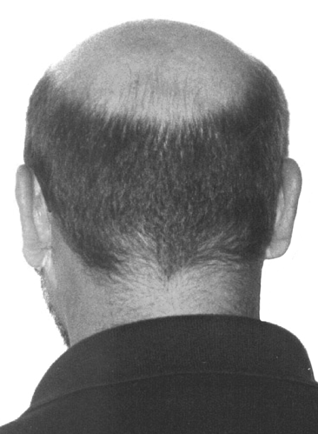

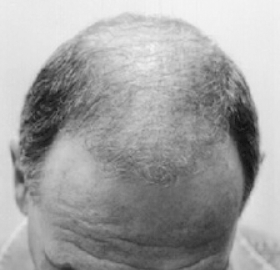 | Hair transplants are the most effective treatment. Other than this men just have to make the best out of looking mature and wise as they lose their hair.  1 in 50 people get a disease sometime in their lives called 'alopecia areata' which causes patchy hair loss. This is because the immune system attacks hair follicles, stopping them from producing hairs. This is very hard to treat. In most people alopecia stops after a time and hair will grow back.



