Name:………………………………………………..…. Date:………………………………………………………
Vitamins
Ascorbic acid, the compound we call vitamin C, dissolves in water. So it is quite easy to take into our bodies - we just need to drink a solution of the compound every day, such as a fresh and tasty fruit juice. In this experiment, you can compare the amounts of vitamin C in different fruit juices using a basic test, then plan one of the investigations.
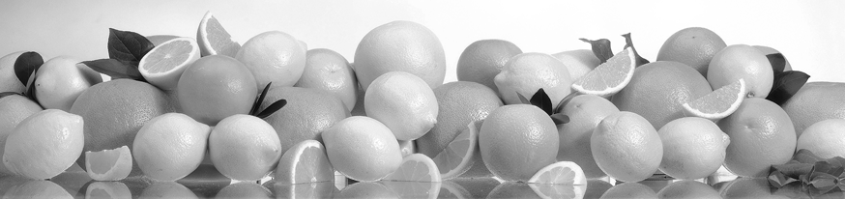
Testing for vitamin C
How the test works
This test involves reacting the vitamin C compound, ascorbic acid, with iodine. The equation for the reaction is:
iodine | + | ascorbic acid |  | dehydroascorbic acid | + | iodide ions | + | hydrogen ions
I₂ | + | C₆H₈O₆ |  | C₆H₆O₆ | + | 2I⁻ | + | 2H⁺
The iodine and ascorbic acid react together making two new substances. Iodine looks brown in solution. Iodide ions are colourless in solution. We can see the colour of iodine more easily by adding starch - the iodine and starch molecules combine together to make a blue-black 'complex'. When all the iodine has reacted with ascorbic acid, there will be no blue-black coloured complex left. This is called the end-point of the reaction.
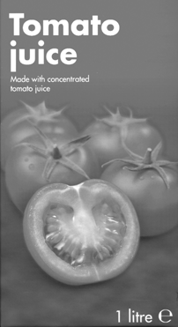 | 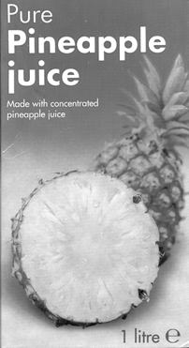 | 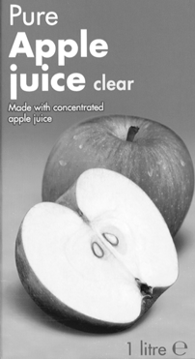 | 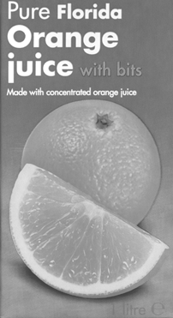 | 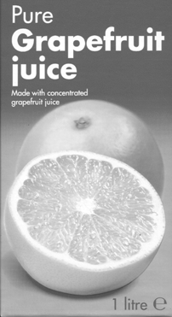
continued on next page



Vitamins
continued from previous page
What you need
- 10 cm³ vitamin C solution
- 1 drop per test of iodine solution (care - will stain hands and clothing)
- 10 cm³ starch solution
- 50 cm³ water
- Fruit juices to test – have the packaging available
- Droppers or plastic pipettes, one for each solution and fruit juice
- Test-tubes, a clean one for each test
- Test-tube rack
- 10 cm x 10 cm piece of white paper or card for background
- Eye protection.
What you do
1. Put 1 cm³ of starch solution in a test-tube.
2. Add 5 cm³ of water and mix by gently shaking the tube.
3. Add 1 drop of iodine solution. A blue-black colour will appear.
4. Hold a white piece of paper behind the test-tube. This helps see the colour change.
5. Add the vitamin C solution drop by drop. Shake the mixture after every 5-10 drops. Keep adding until the blue-black colour disappears. This will produce a grey/white colour in the tube. COUNT THE DROPS.
7. Keep this tube to check for the same final colour in all the tests.
8. Take a fresh test-tube and repeat steps 1, 2 and 3
10. Add fruit juice drop by drop until the colour is the same as that in the first test-tube, COUNTING THE DROPS as before. Check the final colour is the same.
11. Test at least two different juices.
12. Create and complete the table showing the number of drops needed for all the juices tested and the vitamin C solution.
Safety
Wear eye protection.

Questions
1. Which juice has the most vitamin C of the ones you tested? Explain how you can tell.

……………………………………………………………………………………………………………….……………………………………………………………………………………………………………….
……………………………………………………………………………………………………………….
continued on next page

Vitamins
continued from previous page

2. Which has the most in the whole class?

……………………………………………………………………………………………………………….
3. Why does the juice or vitamin C solution have to be added drop-by drop?
……………………………………………………………………………………………………………….……………………………………………………………………………………………………………….
……………………………………………………………………………………………………………….
4. Look at the labels on the juice packaging. Does the information match your results?
……………………………………………………………………………………………………………….……………………………………………………………………………………………………………….
……………………………………………………………………………………………………………….
5. What factors might affect the amount of vitamin C in the juices?

……………………………………………………………………………………………………………….……………………………………………………………………………………………………………….
……………………………………………………………………………………………………………….
Extension questions
1. Use the results for the 'standard' solution to work out how much vitamin C is in 1 cm³ of the juices.

2. Which juice(s) give the 'recommended daily allowance' in one 100 cm³ glass?
3. Which fruits would you recommend sailors take on board ship to protect themselves from scurvy?

continued on next page

Vitamins
continued from previous page
4. Advise the Navy:
It is 1793. The Royal Navy is busy making sure Britain is not invaded. Every ship is needed with a full crew. Sailors are dying every day from scurvy. The Admirals think that to prevent the disease, they need to keep the ships clean and tidy, keep good morale and feed the sailors a healthy diet.
Write a report advising the Admirals what the diet should include. Remember – the Admirals are tough and take a lot of persuading, so any evidence has to be good!

Extension work
Investigating vitamin C
Here are some investigations to find out more about vitamin C:
- How does the amount of vitamin C in fruit juice change with temperature?
- What happens to the amount of vitamin C when juice is stored in a fridge for a week?
- The juice of which fruit contains the most vitamin C?
- How does packaging and light affect vitamin C levels? Compare fruit juices stored in cardboard cartons (dark) and clear plastic bottles (light).
- Does the amount of vitamin C depend on the fruit variety? Compare juice from different types of fruit.
- Does frozen concentrated orange juice contain more vitamin C than juice from ordinary cartons?
- Test how a 'slow release' vitamin C tablet works. Does the amount of vitamin C increase as the tablet dissolves?

