Analysing ice cream
Education in Chemistry
July 2021
https://rsc.li/33TvLSO
The amount of fat in the recipe changes the viscosity of ice cream – but how? In this data analysis exercise, you will find out how scientists determine the viscosity of ice cream and see how it varies with the ice cream’s fat content.
Viscosity is a measure of how easily something flows; the less viscous it is the more easily it flows.
Scientists have been investigating how different additives affect the viscosity of ice cream since the 1930s. In a paper published in 1934, scientists described a new method they had developed for measuring the viscosity of ice cream – the sagging beam method of measurement.¹
A cylinder of ice cream was suspended over a series of aluminium supports and kept at a temperature of
–8 °C. This temperature was chosen because it is the approximate temperature at which ice cream is usually served.
The rate of sag of the ice cream was determined by measuring the distance labelled a in Figure 1 at regular intervals and comparing it to the same distance at the start when no sagging was seen.
Figure 1 The sagging beam experiment
Once the rate of sag was known, the scientists could calculate the viscosity of the ice cream.
Table 1 shows how one ice cream recipe sagged over a period of 7 h.
Time in h | Sag in cm
0 | 0.00
1 | 0.45
2 | 0.90
3 | 1.30
4 | 1.90
5 | 2.25
6 | 2.65
7 | 3.10
Table 1
1. a. Plot a graph of time in h (x-axis) against sag in cm (y-axis). Draw a line of best fit.
b. Determine the rate of sag by calculating the gradient of the line of best fit. Include the units.
The scientists used their sagging beam method to investigate how the amount of milk fat in an ice cream recipe affected the ice cream’s viscosity.
Their results are shown in Table 2.
Parts milk fat | Relative viscosity
0 | 0.25
3 | 1.00
6 | 0.37
9 | 0.13
12 | 0.05
15 | 0.04
18 | 0.04
21 | 0.25
Table 2
2. a. State the independent variable in the experiment.

b. State the dependent variable in the experiment.

c. State two control variables the scientists needed to control.

d. Describe what is meant by relative viscosity (as compared to actual viscosity).

e. Plot the data on a set of axes with parts milk fat on the x-axis and relative viscosity on the y-axis.
Join the points dot-to-dot to form a line graph.
f. An ice cream company wishes to reduce the amount of fat in their ice cream. It currently contains 18 parts milk fat.
Use the scientists’ results to predict what effect this is likely to have on the viscosity of the ice cream.

^{1.} https://www.journalofdairyscience.org/article/S0022-0302(34)93282-3/fulltext

Analysing ice cream: answers

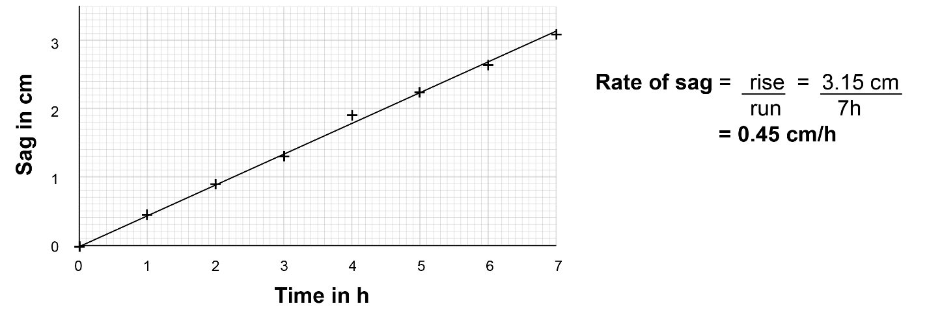

- a. The independent variable was the amount of fat/parts milk fat.
b. The dependent variable was the viscosity (determined from the rate of sag).
c. Control variables include: the diameter of the ice cream cylinder, the temperature, the other ingredients in the ice cream and the amount of air in the ice cream.
d. Relative viscosity means the viscosity of the different ice cream recipes compared to a standard. In this case the ice cream containing 3 parts of milk fat was set as the standard and given a relative viscosity of 1.
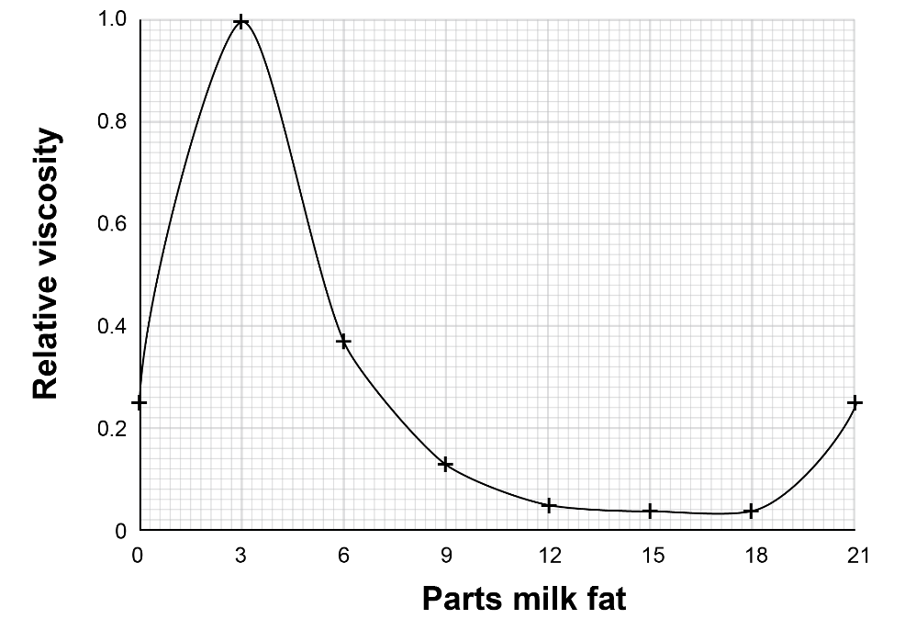
e.

f. Reducing the amount of fat from 18 parts milk fat down to 12 parts is likely to result in a very small increase in the ice cream’s viscosity.
Reducing the fat content below 12 parts milk fat is likely to have a much larger effect, with a maximum viscosity when the milk fat content is 3 parts.
As the fat is reduced to below 3 parts milk fat, the viscosity is likely to reduce rapidly but will still be substantially higher than the viscosity of ice cream containing 18 parts milk fat.

