Addition polymerisation: teacher guidance
This resource forms part of the Review my learning series from the Royal Society of Chemistry. The worksheets assess learner’s understanding of content from common 11–14 and 14–16 curriculums. They can be used to identify knowledge gaps and misconceptions once that part of the curriculum has been taught.
The addition polymerisation worksheets cover the following topics:
- the terminology: monomers, polymers and polymerisation
- forming addition polymers
- naming addition polymers
- repeating units
- writing equations to represent addition polymerisation reactions
- deducing monomers from a repeating unit and vice-versa
If learners successfully answer questions on these topics, they can attempt the extension question. This gives learners further practice in deducing repeating units from the monomer and vice versa. Learners also draw a diagram to represent a section of the copolymer poly(ethenetetrafluoroethene) given the two monomers.

Scaffolding
Level 1 (*) is a scaffolded worksheet which supports learners in a variety of ways, such as selecting words from a word bank, providing answer options to choose from or completed examples, Level 2 (**) is a partially scaffolded worksheet with a reduced level of support, such as partially completed sentences or a wider range of answer options to select from. Level 3 (***) is an unscaffolded worksheet in which most of the tasks involve answering questions with a minimum of prompts.

Metacognition
The ‘What do I understand?’ page is common to all levels of worksheet and can be used both to identify areas needing whole class attention and as an indicator for learners to help guide their revision.
Below you will find model answers for each level and guidance on learners’ misconceptions. Learners can use the model answers to self- or peer assess.

When to use
The worksheets can be used in a variety of ways:
- To assess learners’ knowledge at the beginning or end of a period of teaching. Match the level of the worksheet to the support needs of the learners.
- To assess knowledge during a period of teaching once learners have completed the relevant topic.
- As part of revision.
- As a refresher exercise for teachers or non-subject specialists.
There is also scope for the level of the worksheets used to be increased as learners progress through their curriculum.

Further support
For more resources to support teaching of this topic and address any misconceptions identified, go to rsc.li/3Vf8ZAE.

Answers

Addition polymerisation: knowledge check
- (Level 1, 2 and 3)
monomer
Name: ethene double C=C covalent bond
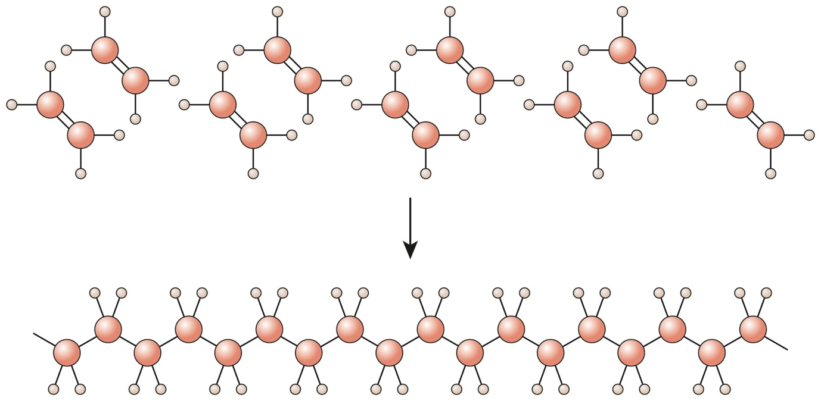
polymer single C–C covalent bond
Name: poly(ethene)

Guidance: This type of diagram represents a very small portion of a polymer chain, and learners may not understand that polymer chains are giant covalent molecules.

- (Level 1, 2 and 3)

Level 1 and 2 | True/False | Level 3
During polymerisation, a large molecule is broken up into smaller molecules. | False | During polymerisation, a large molecule is formed from many smaller molecules joining together.
Alkanes are used to make addition polymers. | False | Alkenes are used to make addition polymers.
Only one product is formed during addition polymerisation. | True
The polymer formed from ethene is poly(ethene). | True
The monomer used to make poly(propene) is propane. | False | The monomer used to make poly(propene) is propene.

Guidance: Learners may not realise that no other products are formed when addition polymers are made. Learners may also confuse the terms alkanes and alkenes and use the incorrect term when describing the formation of addition polymers. Learners must remember that only alkenes contain the double C=C bond and therefore only alkenes can form addition polymers.

- (Level 1, 2 and 3)

ethene; poly(ethene); double covalent bond; poly; monomer; large; repeating unit

Guidance: Misunderstandings include:
- confusing monomers and polymers
- confusing scientific names for polymers with names in common use, eg polythene
- misspelling poly(ethene) as poly(ethane)
- not realising that although polymers are very large molecules, we cannot write a molecular formula for them because the molecules vary in chain length. Using repeating units overcomes this issue.

Addition polymerisation: test myself
- (Level 1, 2 and 3)

C is the monomer.

Guidance: A common misconception is not realising that monomers in addition polymerisation reactions must contain a double covalent bond.
- (Level 1)

butene and pentene
(Level 2 and 3)

butene, pentene and ethene

Guidance: Misconceptions include not recognising the suffixes ‘ane’ and ‘ene’ and the different homologous series they represent. Learners may mistakenly select ‘methene’ as a correct answer based on the ‘ene’ ending, so may need reminding that methene cannot exist, as an alkene must contain at least two carbons atoms and the prefix ‘meth’ means that only one carbon atom is present.
- (Level 1, 2 and 3)

chloroethene

Guidance: A common misconception is confusing chloroethene with chloroethane.
- (Level 1, 2 and 3)

poly(tetrafluoroethene)

Guidance: The name of the polymer may be unfamiliar to learners, but learners should realise that the name of the polymer is the monomer name in brackets preceded by ‘poly’.
- (Level 1, 2 and 3)
D
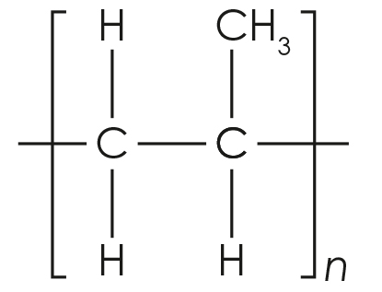

Guidance: In Level 1 and 2, students need the prior knowledge that propene is CH₂CHCH₃, and that there is a double covalent bond between the first and second carbon atoms. In the repeating unit, students need to recognise the same numbers and types of atoms as in propene, but without the double bond. They may compare this to condensation polymers where a small molecule has been eliminated between each monomer.
- (Level 1)
The monomer is D.
(Level 2 and 3)
The monomer is
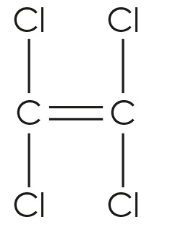

Guidance: Learners may forget the difference between the structure of the monomer and the representation of the repeating unit. In Level 1, learners may give B as an incorrect answer if they forget that the monomer must be an alkene.
- (Level 1, 2 and 3)
The repeating unit is
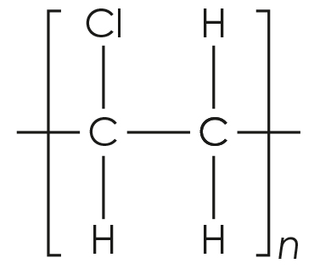

Guidance: Errors result from not understanding how a repeating unit relates to a section of the polymer chain.

Addition polymerisation: feeling confident?
- (Level 1, 2 and 3)
Monomer | Repeating unit of polymer
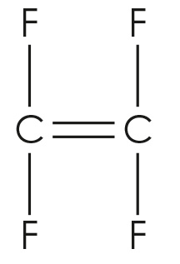 | 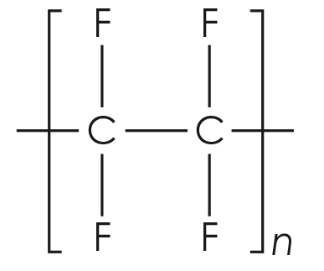
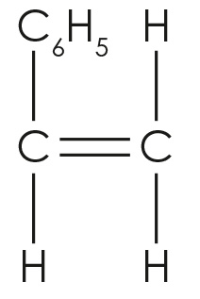 | 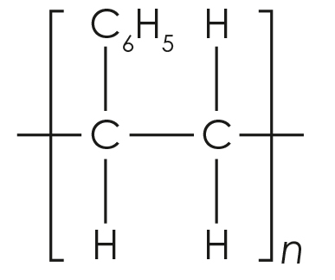
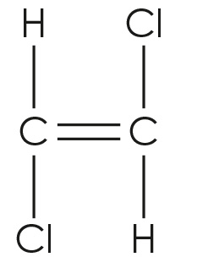 | 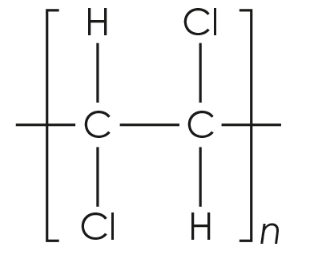

Guidance: See guidance for questions 2.5, 2.6 and 2.7.
- (Level 1 and 2)
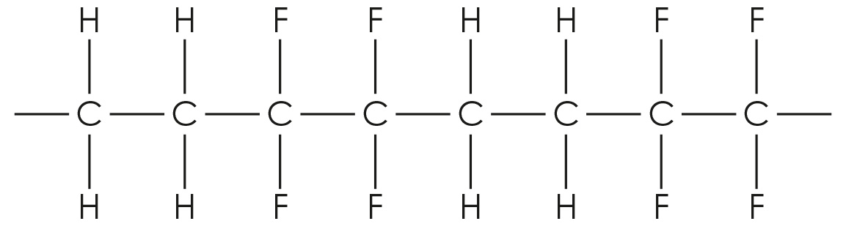
(Level 3)
  - ethene and tetrafluoroethene

Guidance: In this question, learners need to apply their knowledge to the information they are given. Errors may arise from not reading the question carefully and misunderstanding the process of polymerisation.

Addition polymerisation: what do I understand?
Mini-topic | Assessed via:
I can understand the meanings of the terms monomer, polymer and polymerisation. | 1.1
I can explain how addition polymers are formed. | 1.2
I know how to name addition polymers. | 1.3
I can interpret equations used to represent the process of addition polymerisation. | 2.1, 2.2, 2.3, 2.4
I can identify repeating units. | 2.5, 2.6
I can deduce the identity of monomers from repeating units and vice-versa. | 2.7
Feeling confident? topic | Assessed via:
I can draw the structure of monomers from repeating units and vice-versa. | 3.1
I can draw a section of a polymer chain formed from two monomers. | 3.2

