Addition polymerisation: knowledge check
- The diagram represents a reaction in which a small section of polymer is formed.

Label the diagram using the words provided.
monomer polymer
single C–C covalent bond double C=C covalent bond

__________________
Name: ethene __________________
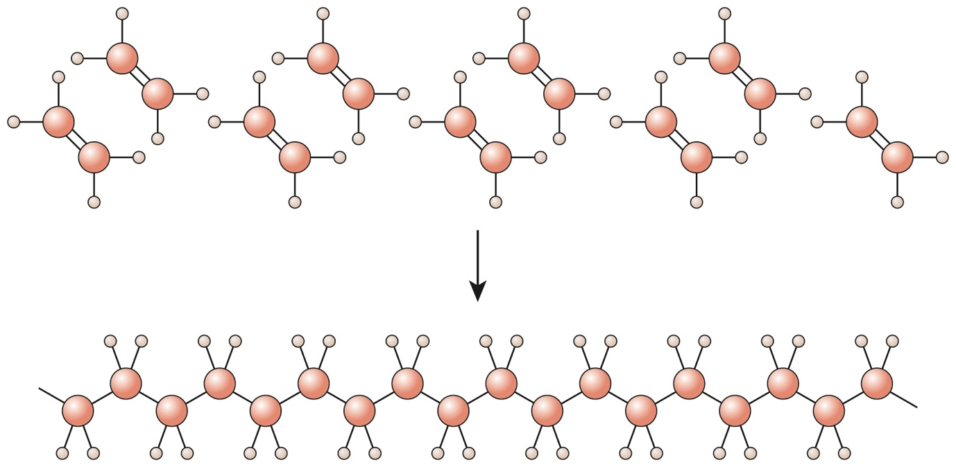
__________________ __________________
Name: poly(ethene)

- Decide whether each of the following statements is true or false and add your answer in the box provided.
  - During polymerisation, a large molecule is broken up
into smaller molecules. True False
  - Alkanes are used to make addition polymers. True False
  - Only one product is formed during addition
polymerisation. True False
  - The polymer formed from ethene is poly(ethene). True False
  - The monomer used to make poly(propene) is propane. True False
- Alkenes can be used to make addition polymers. The equation shows ethene molecules joining up to form poly(ethene).
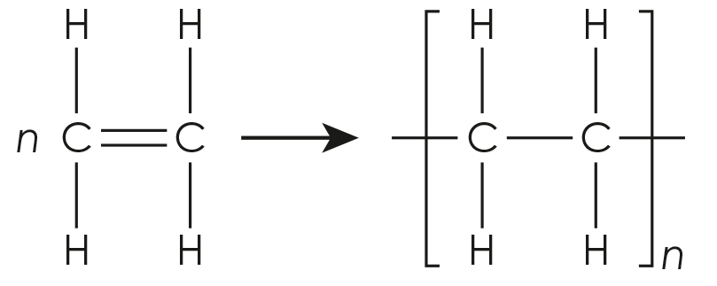

Use the words to complete the sentences describing this equation.
monomer double covalent bond ethene
repeating unit poly large poly(ethene)

The name of the monomer used in this addition polymerisation reaction is __________________ . The name of the polymer formed is __________________ .

The __________________ in the monomer molecules allows them to join together to form an addition polymer.

Addition polymers have the prefix __________________, followed by the name of the __________________ in brackets.

As addition polymer molecules are so __________________, they are represented by drawing the part of the polymer that is repeated many times. This is known as the __________________ .
Addition polymerisation: test myself
Answer questions 2.1 to 2.6 by circling the correct answer(s). There may be more than one correct answer in each question.
- Which of these molecules is a monomer for an addition polymer?
A  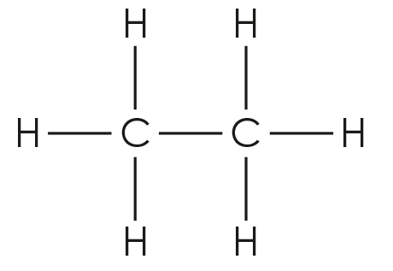 | B  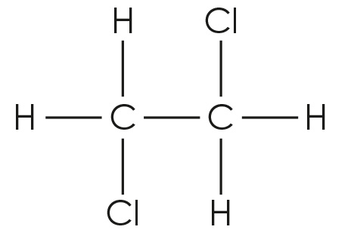
C  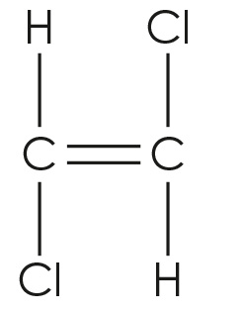 | D  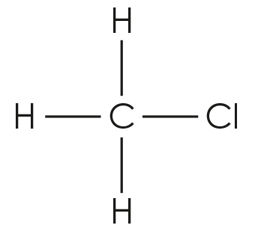

- Which two of these molecules are suitable monomers to make an addition polymer?

butene

propane

pentene

butane
- What is the name of the monomer used to make poly(chloroethene)?

chloroethane

ethene

chloroethene

ethane
- What is the name of the polymer made from the monomer tetrafluoroethene?

poly(fluoroethene)

poly(tetrafluoroethane)

poly(ethene)

poly(tetrafluoroethene)

- Which of the following shows the correct repeating unit for poly(propene)?
A  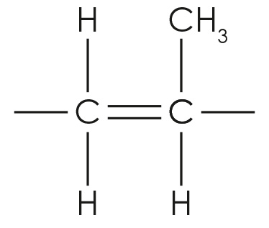 | B  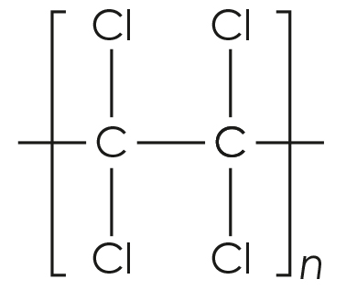
C  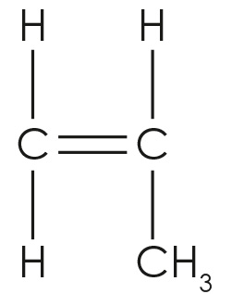 | D  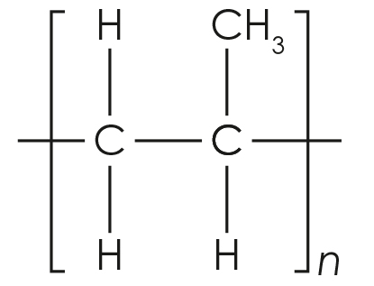
- The diagram shows the repeating unit of an addition polymer:

Which of the following shows the displayed formula of the monomer being represented by this repeating unit?
A  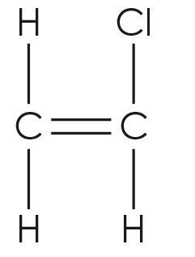 | B  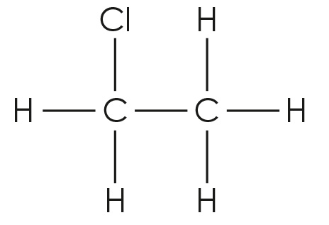
C  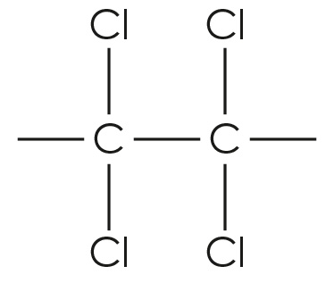 | D  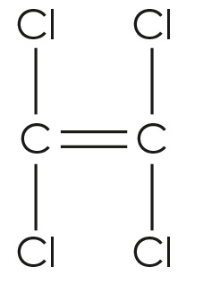
- The diagram shows a section of a polymer.
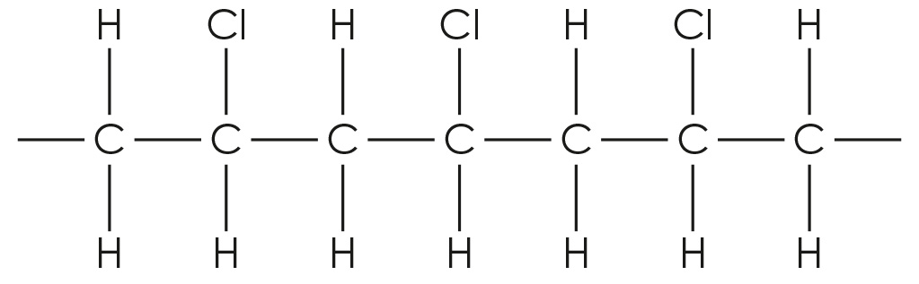

Draw the repeating unit of this polymer.
[Hint: Remember to use square brackets with bonds extending left and right through the brackets. You should also include a subscript ‘n’ on the bottom right of the brackets.]

Addition polymerisation: feeling confident?
- Use the formulas to complete the table.
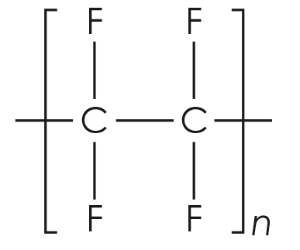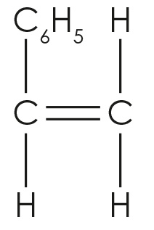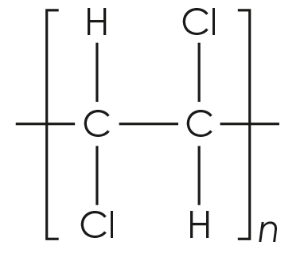
Monomer | Repeating unit of polymer
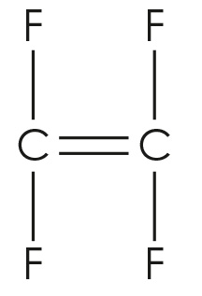
 | 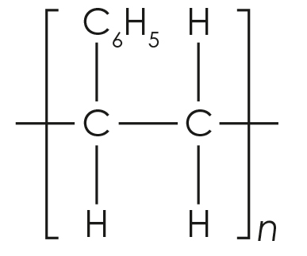

- Poly(ethenetetrafluoroethene) is made from the two monomers shown:
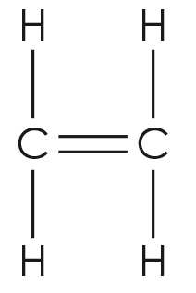
ethene tetrafluoroethene

The two monomers join in the polymer chain in an alternating pattern.

Complete the diagram to produce a section of the polymer chain that contains two molecules of each monomer and is eight carbon atoms long.
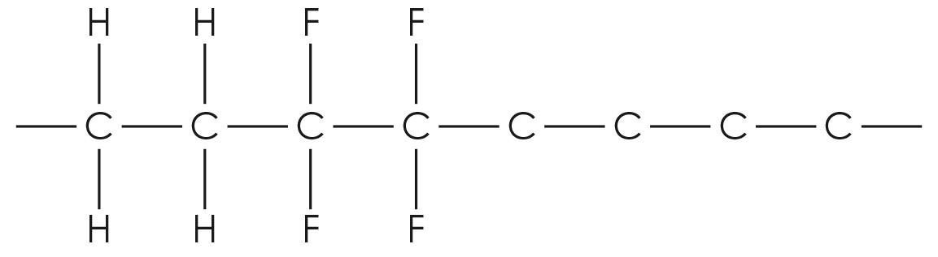

Addition polymerisation: what do I understand?
Think about your answers and confidence level for each mini-topic. Decide whether you understand it well, are unsure or need more help. Tick the appropriate column.
Mini-topic | I understand  this well | I think I understand this | I need more  help
I can understand the meanings of the terms monomer, polymer and polymerisation.
I can explain how addition polymers are formed.
I know how to name addition polymers.
I can interpret equations used to represent the process of addition polymerisation.
I can identify repeating units.
I can deduce the identity of monomers from repeating units and vice-versa.
Feeling confident? topics | I understand  this well | I think I understand this | I need more  help
I can draw the structure of monomers from repeating units and vice-versa.
I can draw a section of a polymer chain formed from two monomers.

