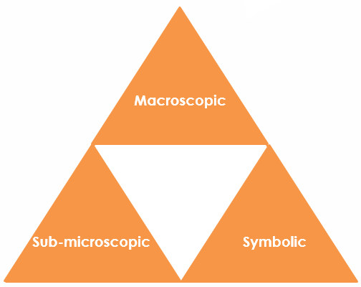
Ionic bonding in sodium chloride: Johnstone’s triangle

Learning objectives
- Describe an ionic compound based on observations.
- Use symbolic models to represent an ionic compound.
- Explain how the bonding in an ionic compound relates to the properties you can observe.

Introduction

Sodium chloride is the chemical name for common table salt. It is an ionic compound.

Johnstone’s triangle

In chemistry we make sense of the things that we can see by representing what we can’t see using formulas, equations, diagrams and models.

Johnstone’s triangle is a way of thinking about these different concepts as different corners of a triangle:

- Macroscopic – what we can see. Think about the properties we can observe, measure and record.
- Sub-microscopic – smaller than we can see. Think about the particle or atomic level.
- Symbolic – representations. Think about how we represent chemical ideas including symbols and diagrams.

Being able to connect and move between these three different levels is important for scientific understanding.



Macroscopic – what we can see

Describe table salt:

Task: Watch the teacher demonstration. What are the properties of salt you have observed?

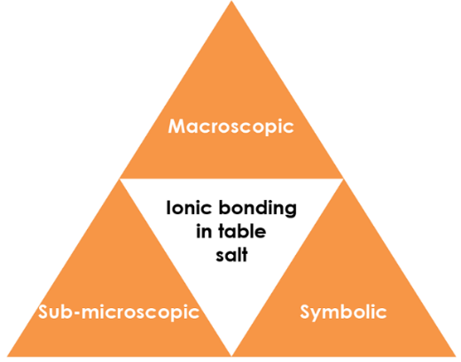

Symbolic – representations

Write the chemical formula for table salt.

Draw a dot and cross diagram for a sodium ion and a chloride ion.

Label a sodium ion and a chloride ion on the ionic lattice diagram:

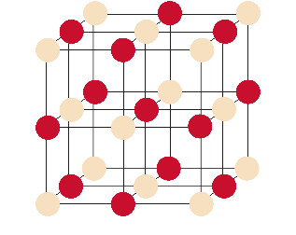

Sub-microscopic – smaller than we can see

Explain the electrical conductivity of salt. (You might find it helpful to refer to the symbolic diagrams.)

