Ionic structure and bonding in rubies

Rubies, like the one shown in the diagram, are valuable gemstones. They are used to make stunning jewellery, as well as being used as parts in watches and lasers. Rubies are 99.95$\%$ aluminium oxide.

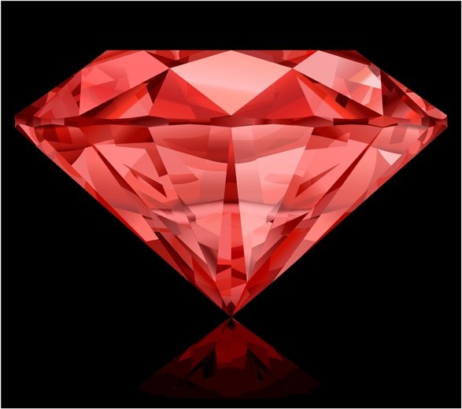

Source: © Shutterstock

(a) What type of structure does aluminium oxide have?

  - Aluminium is in group 3 of the periodic table and oxygen is in group 6. State the charges on:
- an aluminium ion.

- an oxide ion.

  - What information does the empirical formula of an ionic compound give?

  - State the empirical formula of aluminium oxide.

- The electronic configuration of an aluminium atom is 2, 8, 3.
The electron configuration of an oxygen atom is 2, 6.
  - Complete the table to show the electron configurations of aluminium and oxygen atoms, and aluminium and oxide ions in aluminium oxide.

Element | Electronic configuration of an atom | Electronic configuration of an ion

aluminium

oxygen
  - Which noble gas has the same electron configuration as:
- an aluminium ion?

- an oxide ion?

  - Draw a dot and cross diagram to show the electronic structure of the ions in aluminium oxide (${Al}_{2}O_{3}$). Show the outer electron shells only and include the charges.

- (a) Calculate the relative formula mass of aluminium oxide, ${Al}_{2}O_{3}$.

A_{r} aluminium = 27 A_{r} oxygen = 16

  - Calculate the percentage by mass of aluminium in
aluminium oxide, ${Al}_{2}O_{3}$.

Give your answer to two decimal places.

  - A ruby crystal has a mass of 0.20 g. Assume the ruby is pure aluminium oxide.

How many moles of aluminium oxide does the ruby contain?

Give your answer to three decimal places.

  - Another ruby crystal contains 0.05 mol aluminium ions.

Calculate the number of aluminium ions in the crystal.

Avogadro’s constant $=$ 6.02 × 10²³.

- Pure aluminium oxide crystals are colourless and clear. Rubies are red because they contain about 0.05% chromium(III) oxide (${Cr}_{2}O_{3}$) as an impurity. The Cr³⁺ ions replace the Al³⁺ ions in the structure.
  - What mass of chromium(III) oxide does the 0.20 g ruby contain?

  - Calculate the mass of chromium in the 0.20 g ruby crystal.

Give your answer to two decimal places.

A_{r} chromium $=$ 52 A_{r} oxygen $=$ 16


Which question(s) did you get wrong? Why?

What will you do next time you’re asked a similar question?

