Diffusion of colour in water: Johnstone’s triangle

This resource is from the Johnstone’s triangle series which can be viewed at: rsc.li/43jMfSn. It will help learners to understand the different ways you need to think in chemistry, building their mental models and understanding.

Learning objectives
- Describe the process of diffusion.
- Explain diffusion using the particle model.

How to use Johnstone’s triangle

Use Johnstone’s triangle to develop learners’ thinking about scientific concepts at three different conceptual levels:
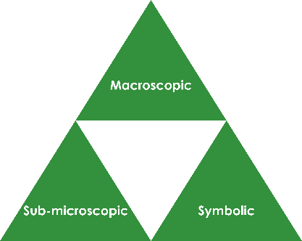
- Macroscopic – what we can see. Think about the properties you can observe, measure and record.
- Sub-microscopic – smaller than we can see. Think about the particle or atomic level.
- Symbolic – representations. Think about how we represent chemical ideas including symbols and diagrams.

For learners to gain a deeper awareness of a topic, they need to understand it at all three levels.

When introducing a topic, do not try to introduce the three levels of thinking at once. This will overload working memory. Instead complete the triangle over a series of lessons, beginning with the macroscopic level before introducing the sub-microscopic and then the symbolic levels, once understanding of the previous stages is secure.

The three levels are interrelated, for example, learners need visual representation of the sub-microscopic level to develop mental models of the particle or atomic level.

Find further reading about Johnstone’s triangle and how to use it in your teaching at rsc.li/3Y73h4j.

Scaffolding

It is important to share the structure of the triangle with learners prior to use. Tell them why you want them to use the triangle and how it will help them to develop their understanding. Use an ‘I try, we try, you try’ approach when you are introducing Johnstone’s triangle for the first time.

More resources

To further develop learner’s thinking in all areas of Johnstone’s triangle, try our Developing understanding of diffusion and dissolving worksheet (rsc.li/4mL4RUf). This includes icons in the margin referring to the conceptual level of thinking needed to answer the question.

Use this demonstration of the diffusion of colour in water, or the alternative learner activity, to encourage learners to observe and describe the macroscopic diffusion of colour in water.

Teacher demonstration

Equipment for teacher
- Petri dish containing water
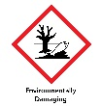
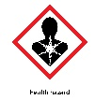
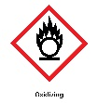
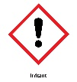
- Tweezers
- Crystal of potassium manganate(VII)
- WARNING: irritant (skin and eyes); harmful if swallowed
- DANGER: oxidiser (may intensify fire)
- Very toxic to aquatic life with long-lasting effects.
- Stains glass, plastic, clothing and skin.
- Avoid direct contact and store in the dark.
- See CLEAPSS Hazcard HC081
- Visualiser

Method

Wear eye protection
- Position Petri dish underneath a visualiser.
- Add the crystal carefully to the water.
- Learners to write their observation in the macroscopic section of the Johnstone’s triangle worksheet.

Alternative learner activity

Equipment per learner pair
- Petri dish
- Water
- 1 coloured sweet (e.g. Skittle or Smartie)

Method
- Carefully pour a small volume of water into a Petri dish.
- Place a coloured sweet in centre and observe.
- Write down observations in the macroscopic section of the Johnstone’s triangle worksheet.

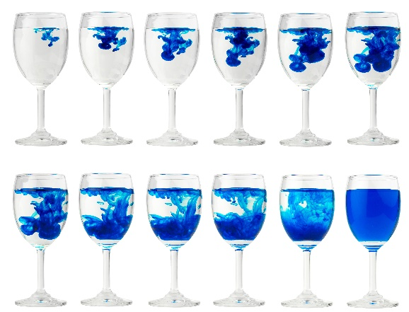
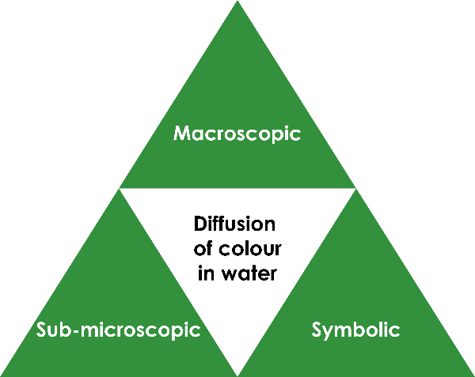
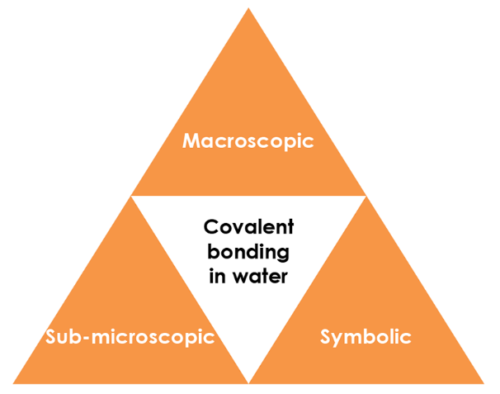

Macroscopic – what we can see

Watch the demonstration. Describe what you observe.

Over time the colour spreads out from where it starts (the crystal or the sweet) to become more evenly spread throughout the water.

Image adapted from: © Shutterstock / NARUDON ATSAWALARPSAKUN

Symbolic – representations

The diffusion of particles can be presented by using diagrams as shown below:

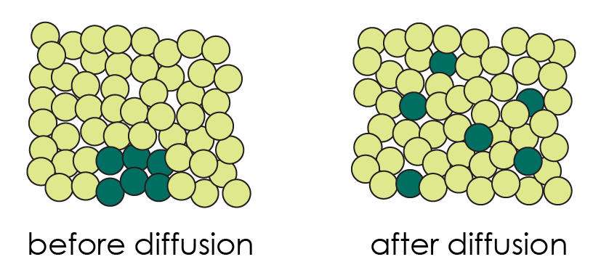

Describe what these diagrams show happening during diffusion.
- The diffusing particles start close together.
- They spread out and mix with the water particles.
- At the end the diffusing particles are evenly spread throughout the liquid.

Give some limitations of this type of diagram.

Sub-microscopic – smaller than we can see

Complete the sentence:

Particles in a liquid move randomly. When they collide with each other they change direction. This means that, over time, they spread out until they are evenly distributed through the solvent.

Before particles in a solid can diffuse the solid has to dissolve. Describe the difference between dissolving and diffusion.

When a solid dissolves the particles separate and mix with solvent particles to form a solution.

Diffusion is when the particles move from an area of high concentration to an area of low concentration.

