Diffusion and chemical reactions

This resource is from the Johnstone’s triangle series which can be viewed at: rsc.li/3Z29Rd5. In this series you will also find our Diffusion: Johnstone’s triangle worksheet which introduces the triangle in the context of the diffusion of colour in water and can be viewed at: rsc.li/3Y73h4j.

Learning objectives
LO | Objective | Where assessed
1 | Connect understanding of diffusion and chemical reactions to explain the formation of a product from the reaction of two substances in the gas state. | Q1
2 | Connect understanding of diffusion and chemical reactions to explain the formation of a solid product from when particles of two dissolving substances meet. | Q2

How to use this resource

This resource aims to develop learners’ understanding of diffusion and chemical reactions. The questions encourage learners to think about the diffusion of reactants in the gas state and in solution and the formation of a product where they meet. As a result, learners should develop more secure mental models to support their thinking about this topic.
When to use? |   Introduce |   Develop |   Revise |   Assess
When to use? | Use after initial teaching or discussion of this topic to develop ideas further. You can also use as a revision activity.
Group size? |   Independent |   Small group |   Whole class |   Homework
Group size? | Suitable for independent work either in class or at home. Or use the questions for group or class discussions.
How long? | 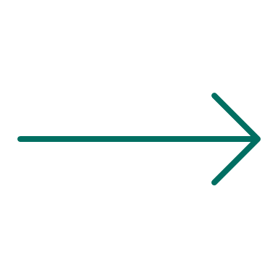 |  | 15–30 mins

Johnstone’s triangle

Johnstone’s triangle is a model of the three different conceptual levels in chemistry: macroscopic, sub-microscopic and symbolic. You can use Johnstone’s triangle to build a secure understanding of chemical ideas for your learners.

Find further reading about Johnstone’s triangle and how to use it in your teaching at rsc.li/3Fvrn2I.

Johnstone’s triangle and this resource

The icons in the margin indicate which level of understanding each question is developing to help prompt learners in their thinking.

 | Macroscopic: what we can see. Think about the properties that we can observe, measure and record.
 | Sub-microscopic: smaller than we can see. Think about the particle or atomic level.
 | Symbolic: representations. Think about how we represent chemical ideas including symbols and diagrams.

The levels are interrelated, for example, learners need visual representation of the sub-microscopic to develop mental models of the particle or atomic level. Our approach has been to apply icons to questions based on what the learners should be thinking about.

Questions may be marked with two or all three icons, indicating that learners will be thinking at more than one level. However, individual parts of the question may require learners to think about only one or two specific levels at a time.

Support

This worksheet is ramped so that the earlier questions are more accessible. The activity becomes more challenging in the later questions. You can give extra explanations for the more challenging questions. If completing as an in-class activity it is best to pause and check understanding at intervals, as often one question builds on the previous one.

It is useful for learners to observe macroscopic properties first-hand. You could circulate examples of substances in the classroom, run a class practical of a chemical reaction or show a teacher demonstration of properties. We recommend:
- Watch an Exhibition chemistry video and download instructions to demonstrate the experiment in Question 1 from: rsc.li/3IuFDty
- Ensure learners are familiar with observing microscale diffusion reactions with these integrated instructions and a video of the reaction in Question 2, available from: rsc.li/4euQ3W2

Additional support may be needed for any learners still lacking in confidence in the required symbolic representation, for example by sharing and explaining a diagram or a simulation that can show movement of the particles.


Answers
- Guidance note: This question develops learners’ understanding of the diffusion of gases in terms of particles (sub-microscopic understanding) and the observation of this in terms of two diffusing gases meeting and reacting to form a visible white solid (macroscopic understanding).

Watch an Exhibition chemistry video and download instructions to demonstrate this experiment from: rsc.li/3IuFDty
- A diagram showing ammonia particles spaced out between the air particles reaching the left of the diagram. For example:
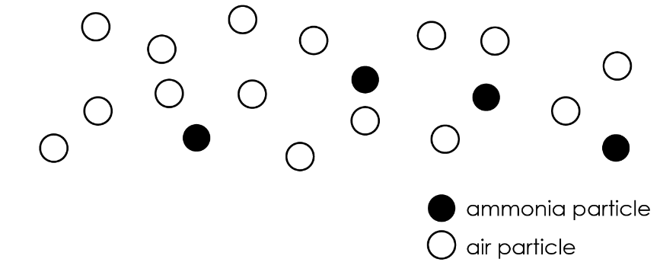
- The ammonia and hydrogen chloride particles have diffused and moved away from the ends of the tube. The white ring has formed because the particles have met each other and have reacted to form the white solid.
- The particles do move very fast, but they move in random directions. The tube also contains air particles which get in the way. It therefore takes a long time for them to move along the tube.
- The white ring forms nearer the left of the tube because the ammonia particles have less mass and have therefore diffused further than the hydrogen chloride particles in the same amount of time.
- Guidance note: This question develops learners’ understanding of the formation of an observable solid product (precipitate) when soluble reactants meet through diffusion across a water droplet (macroscopic understanding). This question assumes some familiarity with dissolving and diffusion as well as experience of observing microscale reactions (download instructions and watch a video of this reaction from: rsc.li/4euQ3W2).

- The potassium iodide gradually dissolves in the water. This forms potassium iodide solution near the crystal. Lead nitrate solution forms near the lead nitrate crystal. Gradually potassium iodide diffuses from the right of the droplet. Lead nitrate diffuses from the left of the droplet.

(b) Lead iodide

(c) The potassium iodide diffuses faster than the lead nitrate.

