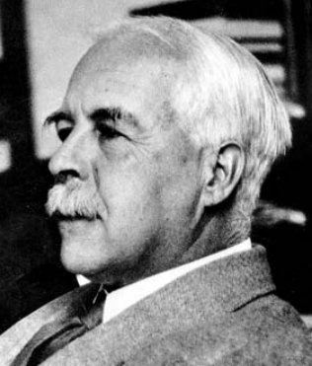
Bonding models

Gilbert Newton Lewis

The person who is largely credited with developing the ‘dot and cross’ model of bonding was an American called Gilbert Newton Lewis (1875–1946). Dot and cross representations are also called Lewis structures, particularly in America.

Lewis’s ideas developed over a long period of time, based on the observation that the periodicity of the properties of the elements seemed linked to the number eight. If you arrange the elements in order of increasing atomic number, the properties of the elements fall into a repeating pattern every eight elements (with some exceptions!). It follows from the work of Dmitri Mendeleev on the periodic table.

He initially represented electron shells as cubes rather than the circles we use in the modern dot and cross model.

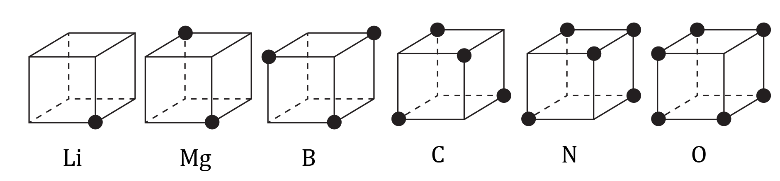
How Lewis represented the structure of atoms in 1916

His ideas can be expressed as follows:
- The electrons in an atom are arranged in concentric cubes.
- A neutral atom of each element contains one more electron than a neutral atom of the next smallest element in the period.
- The cube of eight electrons is reached in the atoms of the noble gases and this cube becomes, in some sense, the core about which the larger cube of electrons of the next period is built. (Lewis believed that helium had eight electrons).
- The electrons of an outer, incomplete cube may be given to another atom, as in ${Mg}^{2+}$. Or enough electrons may be taken from other atoms to complete the cube, as in ${Cl}^{-}$, thus accounting for positive and negative ions.

Questions
- Can you suggest reasons why Lewis was attracted by the idea of the electrons occupying the corners of a cube?
- Draw the electronic structure of neon using Lewis’s ideas.
- Draw the electronic structure of a sodium ion and a chloride ion.

Oppositely charged ions attract each other. This attraction gives rise to ionic bonding. The ions group together in a vast three-dimensional array called a giant lattice. In the sodium chloride lattice, each ion has six nearest neighbours of the oppositely charged ion. Sodium chloride is said to have a coordination number of six.
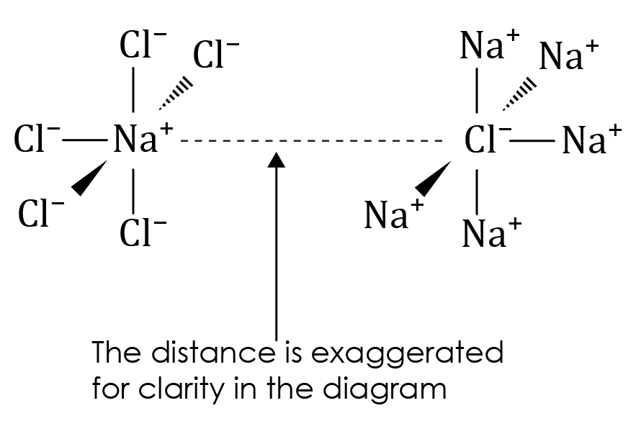 | 
$NaCl$ coordination number six. Note: the lines do not represent discreet bonds. | Photo of a $NaCl$ model that is commonly used in schools.

- Explain how Lewis’s cubic model would account for the coordination number of the sodium chloride.
Hint: Can you find a connection between the shape of cubes and six?
- Lewis could account for covalent bonds as the sharing of electrons. The diagram below shows the structure of ${Cl}_{2}$. Draw similar diagrams for $OF_{2}$ and $O_{2}$.

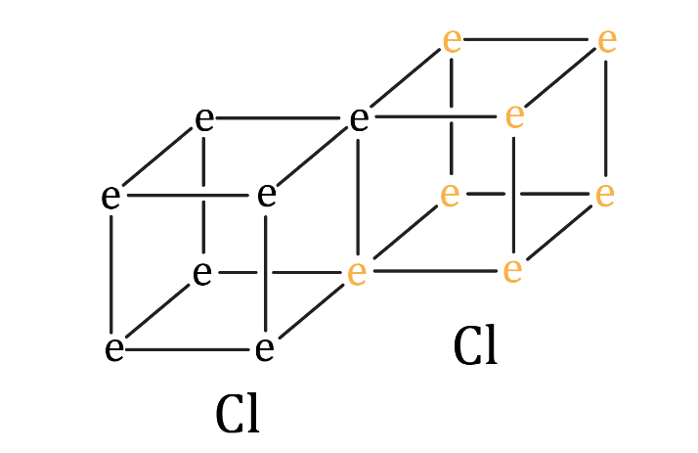
- Is it possible to draw a structure similar to the one above showing a triple bond, as in the molecule $N_{2}$?

Acknowledgements

Photograph of Gilbert Newton Lewis is used with permission of Edgar Fahs Smith Collection, Kislak Center for Special Collections, Rare Books and Manuscripts, University of Pennsylvania Libraries.
Photo source: https://colenda.library.upenn.edu/catalog/81431-p3r785z2v

Photo of sodium chloride model © Shutterstock/TOP-STOCKER.

All other images © Royal Society of Chemistry.

