Spot the bonding

This resource is from Chemical misconceptions – prevention, diagnosis and cure, which can be viewed at: rsc.li/456d4fF. This series of resources includes classroom activities you can use to identify learner misconceptions; challenge some of these alternative ideas; and help learners construct the chemical concepts they need to grasp.

Resource components
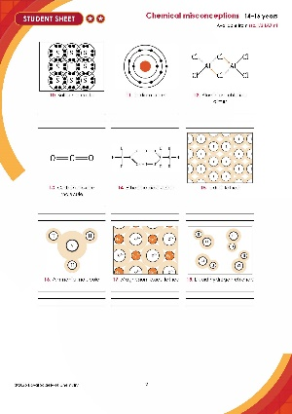  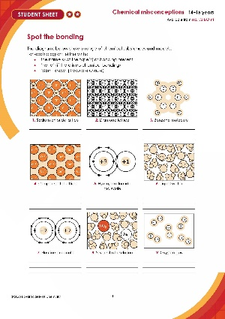 | 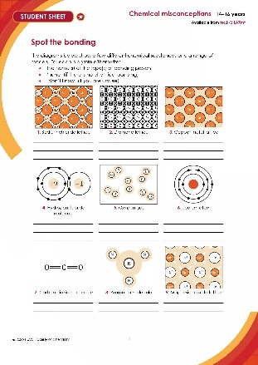 | 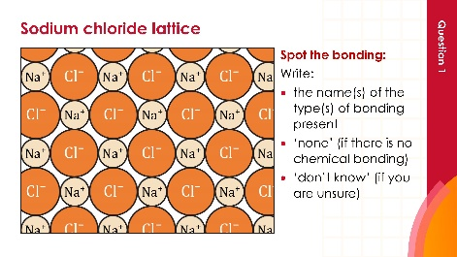
Standard student sheet: a set of 18 diagrams where learners must identify the type/s of bonding represented in each one. | Scaffolded student sheet: a set of 9 diagrams specifically chosen for their familiarity to 14–16 learners. | Presentation: all 18 diagrams are displayed one per slide, followed by answers.

Rationale

Research suggests that learners focus on covalent and ionic bonding, and can either miss, or down-play the importance of, other types of bonding. You can read a discussion of learners’ ideas about atomic structure and other chemical structures here: rsc.li/3NOaVvL. Use this resource to quickly audit learners’ awareness of different bond types.

A variety of types of diagram are used in this resource, as it is important for learners to be able to interpret and use various ways of representing chemical species (read more about learners’ beliefs in alternative ideas at: rsc.li/44mXmJf).

How to use this resource

Point out to learners that some of the diagrams refer to individual atoms or molecules, while others show some of the particles in named substances and they should therefore pay close attention to the labels under the figures.
When to use? |   Introduce |   Develop |   Revise |   Assess
When to use? | Use with 14–16 learners, to see if they can identify examples of the bond types met at this level (covalent, ionic and metallic bonds).
Group size? |   Independent |   Small group |   Whole class |   Homework
Group size? | Suitable for independent work in class to diagnose learners’ misconceptions.
Topics assessed? | Chemical bonding (including: ionic, covalent, metallic, polar, hydrogen, dipole-dipole, van der Waals, solvation, dative, double, delocalised).
How long? |  |  | 10–15 minutes

Although 14–16 learners should be able to identify ionic, covalent and metallic bonding in any of the diagrams in the full-length (✪✪) resource, some of the chemical species are particularly challenging due to the complexity and unfamiliarity of either the substance, diagram or both.

For example, 14–16 learners may find identifying the bonding in the Aluminium chloride dimer challenging as they may not have come across the word ‘dimer’, nor the arrow notation in the diagram and will expect a metal and a non-metal to form an ionic compound. However, 14–16 learners will be familiar with the use of a single line to represent a single covalent bond in a structural formula. This will challenge learners’ ability to interpret diagrams and give the opportunity to preview the more complex nature of bonding they will encounter in post-16 studies.

Scaffolding

Use the simplified version of the resource (✪), with only nine diagrams to interpret, to support less confident learners. The diagrams in the shortened version have been specifically chosen for their familiarity to 14–16 learners.

A 16-18 version of the resource is also available at: rsc.li/43YFULa

Answers

The question number in brackets is for the shortened (scaffolded) student sheet.
Question no. | Figure | Answer | Additional (stretch) answers
1 (1) | Sodium chloride lattice | Ionic
2 (2) | Diamond lattice | Covalent
3 | Benzene molecule | Covalent | Delocalised
4 (3) | Copper lattice | Metallic
5 (4) | Hydrogen fluoride molecule | Covalent | Polar
6 | Liquid water | Covalent | Polar, hydrogen, van der Waals forces, dipole-dipole forces
7 | Fluorine molecule | Covalent
8 | Silver nitrate solution | Covalent (water)  Ionic (silver nitrate) | Polar, hydrogen, van der Waals forces, dipole-dipole forces, solvent-solute interactions
9 (5) | Oxygen gas | (Double) covalent | van der Waals, sigma + pi
10 | Sulfur molecule | Covalent
11 (6) | Sodium atom | No chemical bonding | Although intra-atomic forces of similar nature
12 | Aluminium chloride dimer | Covalent | Polar, including dative (coordinate) covalent
13 (7) | Carbon dioxide molecule | (Double) covalent | Covalent, polar (double/sigma + pi)
14 | Ethanoic acid dimer | Covalent | Polar, hydrogen
15 | Iodine lattice | Covalent | van der Waals forces
16 (8) | Ammonia molecule | Covalent | Polar
17 (9) | Magnesium oxide lattice | Ionic
18 | Liquid hydrogen chloride | Covalent | Polar, van der Waals forces

The Additional (stretch) answers are suitable for learners who have studied bonding at post-16 level. Learners aged 14–16 are not expected to provide the full range of responses. Use these answers to highlight that the limited range of bonding types studied at 14–16 is not a complete answer. This will avoid reinforcing misconceptions and provides an opportunity to sign-post further chemistry study.

A 16-18 version of the resource is also available at: rsc.li/43YFULa

