Experiments with particles

Learning objectives
- Predict how the volume will change when two substances are mixed together.
- Make careful observations.
- Apply your knowledge of particles to explain your observations.

Introduction

Learners measure any changes in volume when solids are mixed with solids, alcohol is mixed with water and salt is dissolved in water.

Before starting the practical, learners should make and note down on their worksheet a prediction for each practical activity (learning objective 1). Encourage them to state a reason for their prediction. You may need to remind learners what is meant by the term prediction and have a general discussion about what could happen when substances are mixed before they make their predictions.

Learners should carry out the practical activities in groups of two or three and record their observations on the student sheet (learning objective 2).

By working through the questions on the worksheet, learners will suggest explanations for their observations (learning objective 3).

Scaffolding

There are two versions of the student worksheet: scaffolded (✪) and unscaffolded (✪✪). The scaffolded sheet offers more support such as pre-drawn results tables and more structured answers to the questions.

Some groups of learners may need reminding not to try and measure 25 cm³ accurately straight away. It is better to pour approximately, then take an accurate measurement.

For those learners working at a fast pace, a suitable extension activity would be to plan (and carry out) an experiment to show that conservation of mass occurs when these substances are mixed.

Technician notes

Read our standard health and safety guidance (rsc.li/3zyJLkx) and carry out a risk

assessment before running any live practical.

Apparatus

Per learner
- Eye protection: safety glasses to EN166F

Per group
- Stirring rod
- Measuring cylinders x 2 (100 cm³)
- Spatula

Chemicals (per group)
- Sodium chloride crystals (~40 g)
- Water (~100 cm³)
- Sand (~25 cm³)
- Dried peas (~25 cm³)
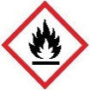
- Ethanol (~25 cm³) (DANGER: highly flammable liquid and vapour)

Health and safety
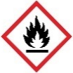
- Always wear eye protection.
- Ethanol is flammable, ensure no naked flames or other sources of ignition (see CLEAPSS Hazcard HC040a/SSERC)

Teaching notes

The learner predictions and their suggestions will provide an insight into their understanding of particles and how they mix.

In each activity, the combined volume will be less than the total of the two individual volumes.

Suggested reasons may include the idea that different particles have different sizes and so the smaller one might fit in between the larger ones.

The idea that water and alcohol are continuous materials, with the heavier one resting on the other – therefore squashing the lighter one.

In questions 1 and 2, learners should be encouraged to suggest explanations for their results, even if the inferences seem not to support their predictions – e.g. 25 cm³ peas + 25 cm³ sand = 46 cm³ total volume.

Answers
- The combined volumes are less than the sum of the parts. Particles of sand are much smaller than particles of dried peas and so they can fit into the spaces between the dried peas; therefore the overall volume decreases.

Teacher guidance: Check that the learners are using the correct data from their results table.
- The combined volumes are less than the sum of the parts. There are attractive forces between the particles of water and ethanol that bring them closer together when they are mixed.

Teacher guidance: Check that the learners are using the correct data from their results table.
- Particles should be drawn into the boxes.
- water | - salt crystals | - salt solution
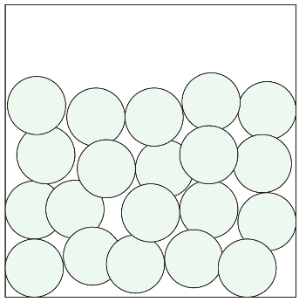 | 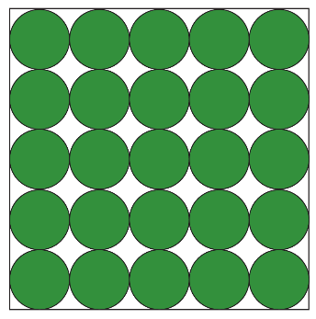 | 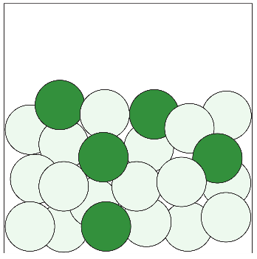

Teacher guidance: Water particles should be touching and in an irregular pattern. Salt particles should be touching and arranged in a regular pattern of rows and columns. Water and salt particles should be drawn in different colour/shadings/sizes. For the salt solution the two types of particles, should be mixed together, touching and in a random pattern. The salt particles should be separated and surrounded by water particles.
- When salt and water mix, the salt dissolves and the salt particles are separated instead of touching in a regular pattern. The liquid water particles are not perfectly packed together so the salt particles are able to fit into spaces between the water particles. This means that the salty water has a smaller overall volume than the combined volume of salt and water separately.

Teacher guidance: This is why seawater, or salt water, is more dense than freshwater. Also accept answers that include the idea of attractive forces, bringing the water molecules, sodium ions and chloride ions closer together, so the volume is reduced. Although, this involves knowledge of ions and charge that is not expected prior knowledge to complete this activity.

Extension question

The method will be similar to activity 1, apart from this time the mass of the dried peas and sand will be measured using a balance and recorded at the start and when they are mixed together.

The method should follow a logical sequence that could be carried out by someone else.

Explanation

All particles have mass. When the dried peas and sand are mixed, no particles are made or destroyed. There will be the same number at the start and at the end and therefore the mass will not have changed.

