Commercial applications of chromatography

Chromatography is an analytical technique chemists use to separate the components of a mixture.

How it works

Chromatography separates the compounds in a mixture using their relative affinities for a mobile phase and a stationary phase.
- The greater a compound’s affinity for the mobile phase, the further it travels.
- The greater its affinity for the stationary phase, the shorter the distance it travels.

Types of chromatography
 | Stationary phase | Mobile phase
Paper chromatography – used to identify the dyes in mixtures such as ink or food colouring. | A sheet of chromatography paper. | Usually water, which soaks up through the paper by capillary action.
Thin-layer chromatography (TLC) – used to quickly identify organic compounds present in a mixture. | A glass, metal or plastic sheet covered with a thin layer of either silica gel (silicon dioxide, SiO₂) or alumina (aluminium oxide, Al₂O₃). Called a TLC plate. | An organic solvent or mixture of solvents that soaks up through the solid layer by capillary action.
Column chromatography – used to separate and isolate organic compounds from a mixture. | Silica gel, alumina or resin packed into a vertical glass tube (the column). | An organic solvent or mixture of solvents that flows down through the column under gravity.
High-performance liquid chromatography – used to separate, identify and quantify soluble compounds in a mixture. | Silica or resin packed inside a long narrow tube coiled within the machine. | Water or a non-polar organic solvent that the machine pumps through the tube under pressure.
Gas chromatography – used to separate, identify and quantify volatile compounds present in trace amounts in a mixture. | A high boiling point liquid held on a finely divided inert solid inside a very long narrow tube coiled within the machine. | An inert gas such as nitrogen or helium that is pumped through the tube.

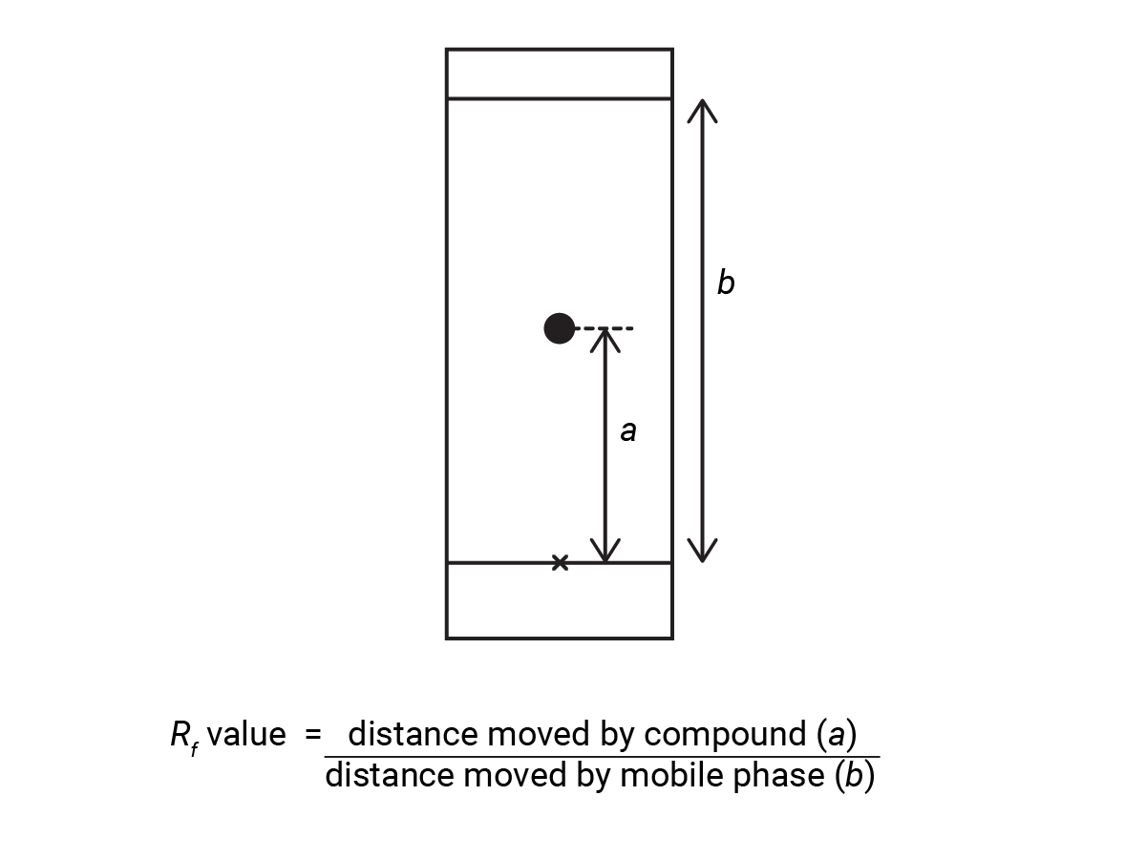
Thin-layer chromatography

TLC starts with a baseline drawn in pencil on the TLC plate near to one end. The scientist dissolves the mixture they plan to analyse in a suitable solvent. They place a spot of this solution on the line. They then place the plate vertically in a tank containing just enough of the mobile phase to keep the liquid level below the baseline.

As the mobile phase moves up the TLC plate, the components in the mixture move different distances depending on how attracted they are to the stationary phase and how soluble they are in the mobile phase. You can vary the relative distances by changing the polarity of the mobile phase.

The components of an organic mixture are often colourless and not visible on the TLC plate, so scientists use specific visualisation techniques:
- Fluorescence – most TLC plates contain an additional substance which fluoresces in the visible region when placed in UV light. If the compound you’re analysing absorbs the UV light, it will not fluoresce and the substance shows up as a dark spot.
- Chemical stains – you can make compounds containing certain functional groups visible by reacting them with chemicals to produce a coloured compound. For example, amino acids and amines can be visualised using ninhydrin, which produces blue spots.

We call the distance a substance moves compared to the mobile phase its R_{f} value. If the stationary and mobile phases are known, we can use this to identify the compound by comparison to a database of known R_{f} values.

Column chromatography

In column chromatography, scientists pack the stationary phase into a glass column and they add the mobile phase continuously to the top. They also add the sample of the mixture to analyse to the top and the components move through the column at different speeds. They collect the successive fractions as the liquid drips out at the bottom.

They can then use TLC to identify the compounds in each fraction. They can combine any fractions containing the same compound and isolate the pure compound by gently evaporating off the mobile phase.

High-performance liquid chromatography

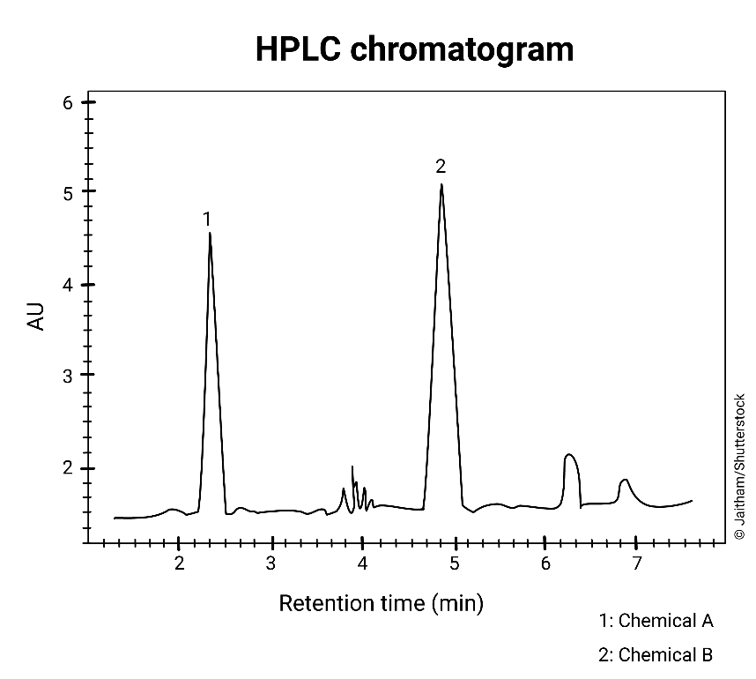
In HPLC, we force the mobile phase under high pressure through a coiled narrow column containing the stationary phase. This makes the process much faster and gives better separation due to the high surface area of the small solid particles. Scientists can use a variety of materials for the stationary phase, including ion-exchange resins that separate components based on their charge, size exclusion resins that separate components based on their size and chiral resins, which can separate optical isomers.

A detector identifies the compounds as they leave the column. The detector the chemists use depends on the properties of the compounds in the mixture. The output from the detector shows as a series of peaks.

We call the time a substance takes to pass through the column its retention time and we can compare with that of known compounds separated under the same conditions (mobile phase, stationary phase, pressure and temperature).

We can use the area under each peak (AU) to determine the relative quantities of compounds in a mixture, as long as they all respond similarly to the detector.

Gas chromatography

In GC, the stationary phase – a coiled tube as narrow as 0.1 mm wide and up to 100 m long – sits within a variable temperature oven. We can use the retention time to identify the compounds but, most commonly, we connect the end of the GC column directly to a mass spectrometer. This allows each compound to be immediately identified as it leaves the column.

This combined technique is known as gas chromatography–mass spectrometry (GC–MS) and has the advantage of being able to detect very small quantities of compounds. Its uses include detecting banned substances in urine samples from athletes, detecting traces of pesticide residues in food and in environmental monitoring to detect pollutants in the air, soil or water.

Did you know …?

The International Space Station uses miniaturised GC–MS devices to monitor the atmosphere. They are just 25 × 25 × 20 cm and have a mass less than 9.5 kg.

