Atoms and ions: knowledge check

Metal ions
- Describe how a metal atom forms an ion.

__________________________________________________________________________________

__________________________________________________________________________________
__________________________________________________________________________________

__________________________________________________________________________________
- Using a periodic table, complete the table to describe metal ions:

Element | Group | No. of electrons in outer shell | No. of electrons removed to give a full outer shell | Ion charge

K

Mg

Al

Na

- Complete the diagram to show how a potassium atom becomes a potassium ion. Use a cross (x) to show the electrons.
 | 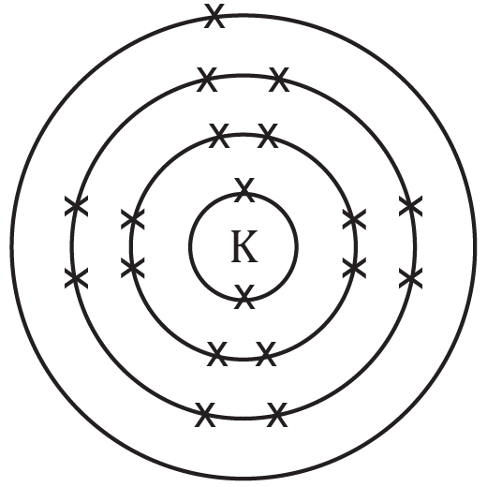 | 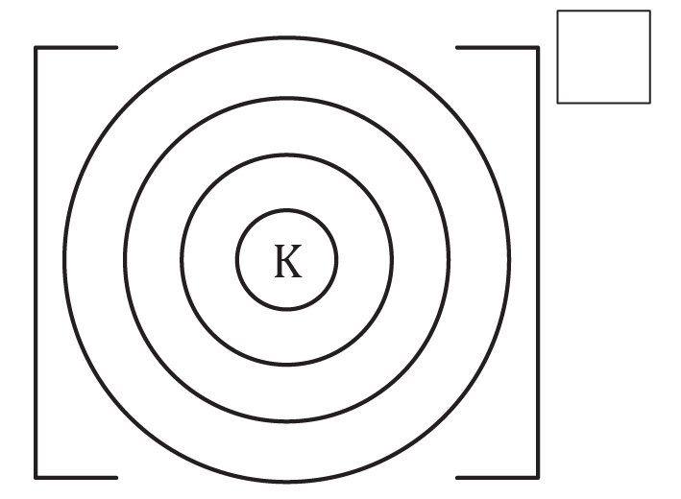
Electronic configuration | ____,____,____,____ | ____,____,____
 | potassium atom | potassium ion

- Explain why a metal ion becomes positive when it loses electrons. Refer to sub-atomic particles in your answer.

__________________________________________________________________________________

__________________________________________________________________________________

__________________________________________________________________________________

__________________________________________________________________________________

Non-metal ions
- Describe how a non-metal atom forms an ion:

__________________________________________________________________________________

__________________________________________________________________________________

__________________________________________________________________________________

__________________________________________________________________________________
- Use a periodic table to complete the table to describe non-metal ions:

Element | Group | No. of electrons in outer shell | No. of electrons added to give a full outer shell | Ion charge

O

Cl

N

- Complete the diagram to show how oxygen becomes an oxide ion. Use a cross (x) to show original electrons and a dot (•) to show any additional electrons.
 | 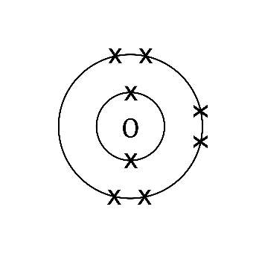 | 
Electronic configuration | ____,____ | ____,____
 | oxygen atom | oxide ion
- Explain why a non-metal ion becomes negative when it gains electrons. Refer to sub-atomic particles in your answer.

__________________________________________________________________________________

__________________________________________________________________________________

__________________________________________________________________________________

__________________________________________________________________________________

Atoms and ions: test myself
- Identify which group the following elements are in using a periodic table. Work out if electrons are lost or gained and what charge ion is made when the atom forms an ion.
Name of element | Group | Number of electrons in the outer shell | Lose or gain electrons, and how many? | Charge on ion

Lithium

Sulfur

Calcium

Aluminium

Fluorine

- Use the information from the table above to complete the electrons and add the charge for the following ions:

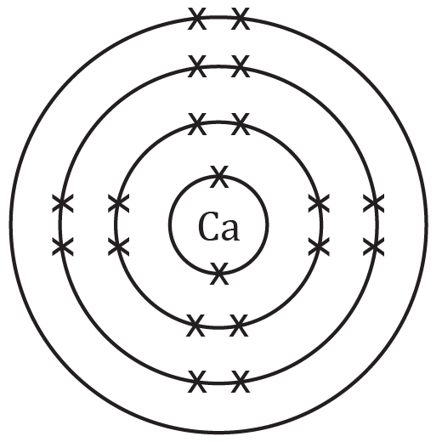 | 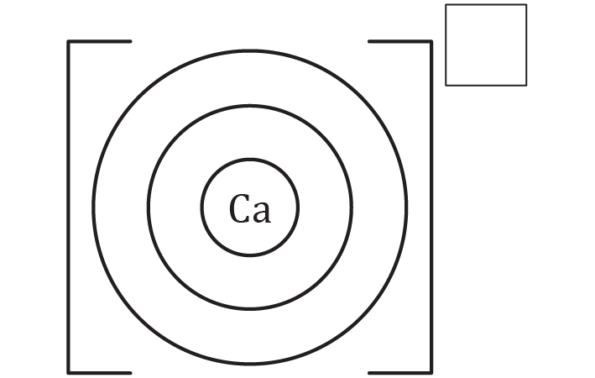
calcium atom | calcium ion

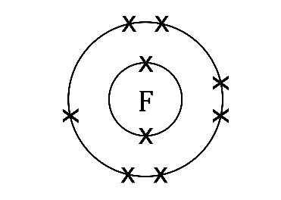 | 
fluorine atom | fluoride ion

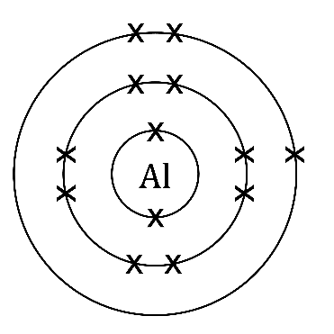
aluminium atom | aluminium ion

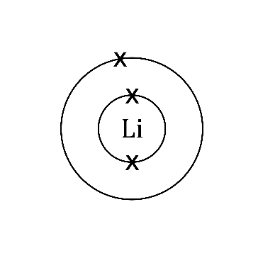
lithium atom | lithium ion

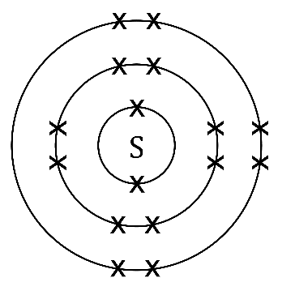
sulfur atom | sulfide ion
- Use the periodic table, and the group number of that the atom is found in, to give the symbol of these ions showing their charge. The first one is completed for you.
Name of ion | Symbol
Calcium ion | $${Ca}^{2+}$$

Chloride ion

Sodium ion

Aluminium ion

Oxide ion

Atoms and ions: feeling confident?
- When a metal atom makes an ion the atom and ion both use the name of the element. When a non-metal atom makes an ion the ending of the element name is changed.
  - What does the non-metal ion name end with?

____________________________________________________________________________
  - Complete the table below to name the metal and non-metal ions:
Ion symbol | Name of atom | Metal or non-metal? | Name of ion

$$N^{3-}$$

$${Li}^{+}$$

$$S^{2-}$$

$${Al}^{3+}$$

$${Cl}^{-}$$
- An ionic compound is made up of positive ions attracted to negative ions to bonds.

  - Complete the electrons and charge to show a sodium ion and a chloride ion side by side. Draw the electrons on the outer shell of the metal as dots and non-metal as crosses. This is called a dot and cross diagram.

sodium ion chloride ion
  - When you draw the ions side by side like this, they represent the compound sodium chloride. Is sodium chloride neutral or charged? Explain.

____________________________________________________________________________

____________________________________________________________________________

____________________________________________________________________________

____________________________________________________________________________
- If you know what group an atom is in (using groups 1, 2, 3, 5, 6, 7) then you can predict the charge of the ion. Complete the table by using a periodic table. The first row is done for you.
Name of atom | Symbol of atom | Group number of atom | Symbol and charge of ion
Rubidium | $$Rb$$ | 1 | $${Rb}^{+}$$

Selenium

Gallium

Iodine

Strontium

Atoms and ions: what do I understand?

Think about your answers and confidence level for each mini-topic. Decide whether you understand it well, are unsure or need more help. Tick the appropriate column.

Mini-topic | I understand  this well | I think I understand this | I need more  help
I can describe how a metal atom and a non-metal atom form ions.
I can use the periodic table to determine how many electrons are in the outer shell of an element.
I can use the group number to work out how many electrons need to be added or removed to give a full outer shell.
I can work out the charges for metal and non-metal ions of the elements in groups 1, 2, 3, 5, 6 and 7.
I can draw ions that have electrons in shells with brackets and charges.
I can write the electron configuration of an atom and an ion.
I can explain why an ion is positive or negative, referring to sub-atomic particles.
Feeling confident? topics | I understand  this well | I think I understand this | I need more  help
I can name metal and non-metal ions.
I can draw a dot and cross diagram for a simple ionic compound.
I can apply my knowledge of the relationship between group number and charge to unfamiliar ions.

