Atoms and ions: knowledge check

Metal ions
- Choose the correct words to complete the sentences to describe how a metal ion reacts.

lose gain positive negative full

When a metal atom forms an ion, it has a ________________ outer shell. Metals ________________ electrons in the outer shell. This makes an ion with a ________________ charge.
- Using a periodic table, complete the following table to describe metal ions.
Element | Group | No. of electrons in outer shell | No. of electrons removed to give a full outer shell | Ion charge
K | 1 | 1 | 1 | +1
Mg |  | 2
Al |  |  | 3
Na | 1
- Complete the diagram to show how a potassium atom becomes a potassium ion. Use a cross (x) to show the electrons
 | 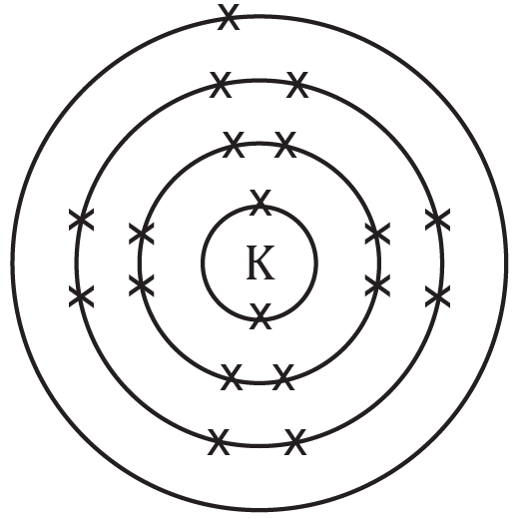 | 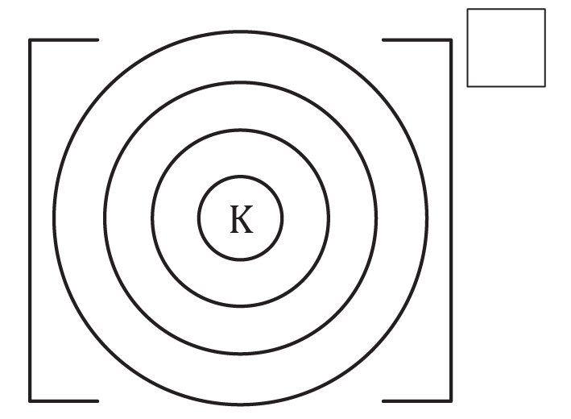
Electronic configuration | 2,8,8,1 | ____,____,____
 | potassium atom | potassium ion
- Choose the correct words to complete the sentences to explain why a metal ion becomes positive when it loses electrons.

more less positive negative electrons protons

When a metal atom becomes an ion it loses electrons. The number of ________________ in the nucleus stays the same. This means that the total number of protons is ________________ than the total number of electrons. The charge on a proton is ________________ so the ion has an overall positive charge.

Non-metal ions
- Choose the correct words to complete the sentences to describe how a non-metal atom forms an ion.

lose gain positive negative full

When a non-metal atom has formed an ion, it has a ________________ outer shell of electrons. Non-metals ________________ electrons on the outer shell. This makes an ion with a ________________ charge.
- Complete the table to describe non-metal ions. The first one is done for you.

Element | Group | No. of electrons in outer shell | No. of electrons added to give a full outer shell | Ion charge
O | 6 | 6 | 2 | –2
Cl |  | 7
N | 5
- Complete the diagram to show how oxygen becomes an oxide ion. Show the original electrons with x and any added electrons with o.
 | 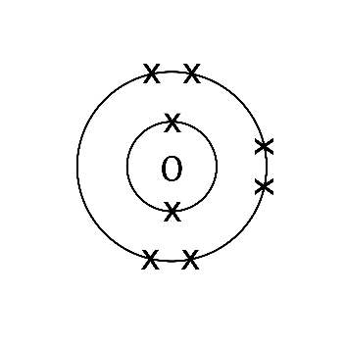 | 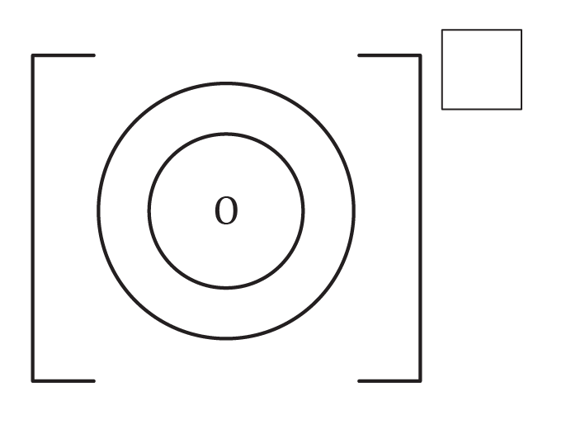
Electronic configuration | 2,6 | ____,____
 | oxygen atom | oxide ion
- Complete the sentences to explain why a non-metal ion becomes negative when it gains electrons.

more less positive
negative electrons protons

When a non-metal atom becomes an ion it gains electrons. The number of ________________ in the nucleus stays the same. This means that the total number of protons is ________________ than the total number of electrons. The charge on an electron is ________________ so the ion has an overall negative charge.

Atoms and ions: test myself
- Identify which group the following elements are in by using a periodic table. Work out if electrons are lost or gained and what charge ion is made when the atom forms an ion. Some answers have been added in.
Name of element | Group | Number of electrons in the outer shell | Lose or gain electrons, and how many? | Charge on ion
calcium | 2 |  |  | +2
fluorine |  |  | gain 1 | –1
aluminium |  | 3
lithium |  |  | lose 1
sulfur |  |  |  | –2
- Use the information from the table above to complete the electrons and add the charge for the following ions:

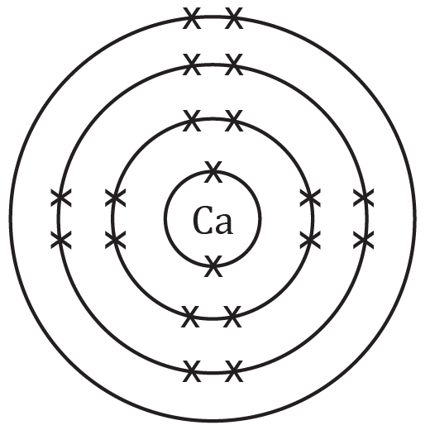 | 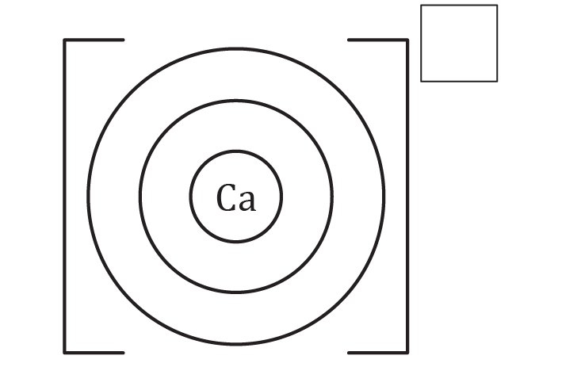
calcium atom | calcium ion (Ca²⁺, lose 2 electrons)

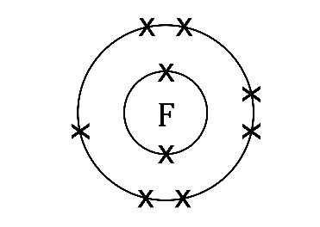 | 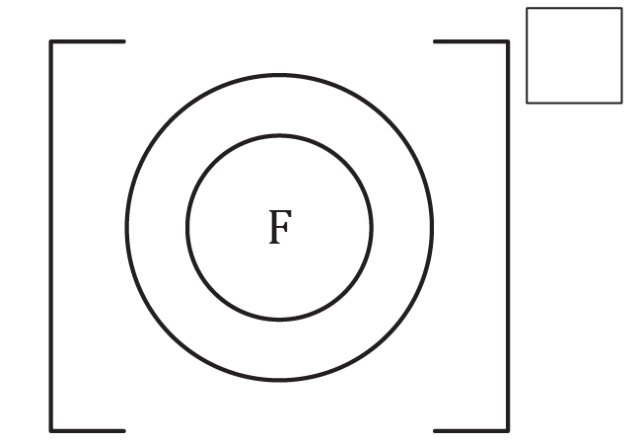
fluorine atom | fluoride ion (F–, gain 1 electron)

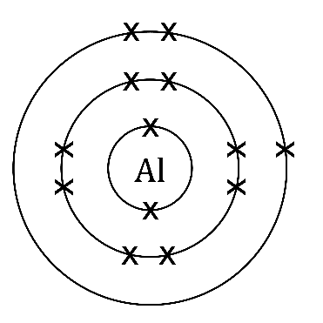 | 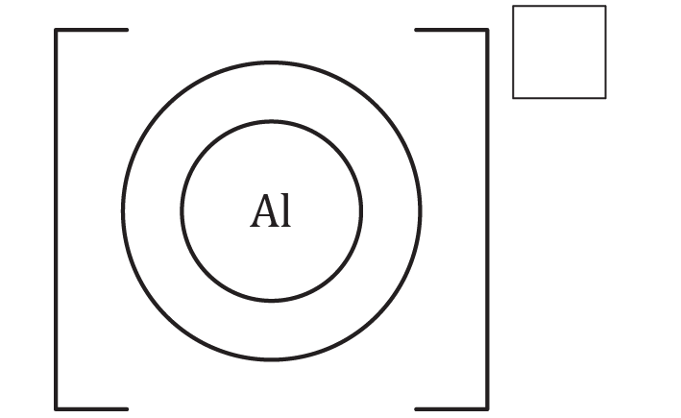
aluminium atom | aluminium ion (Al³⁺, lose 3 electrons)

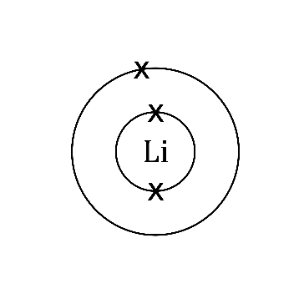 | 
lithium atom | lithium ion (Li⁺, lose 1 electron)

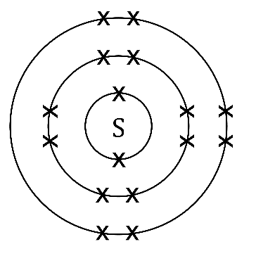
sulfur atom | sulfide ion(S^{2–}, gain 2 electrons)
- Use the periodic table, and the group number of that the atom is found in, to give the symbol of these ions showing their charge. The first row is completed for you.
Name of ion | Group number | Charge of ion | Symbol
calcium ion | 2 | +2 | $${Ca}^{2+}$$
chloride ion | 7 | –1
sodium ion |  |  | $${Na}^{+}$$
aluminium ion |  | +3
oxide ion | 6

Atoms and ions: feeling confident?
- When a metal atom makes an ion the atom and ion both use the name of the element. When a non-metal atom makes an ion the ending of the element name is changed.
  - What does the non-metal ion name end with?

____________________________________________________________________________
  - Complete the table below to name the metal and non-metal ions:
Name of atom | Metal or non-metal? | Name of ion
nitrogen | non-metal | nitride ion
lithium | metal | lithium ion

sulfur

aluminium

chlorine
- An ionic compound is made up from positive metal ions attracted to negative non-metal ions to form an ionic bond. The charges on each ion cancel out to give a neutral compound.
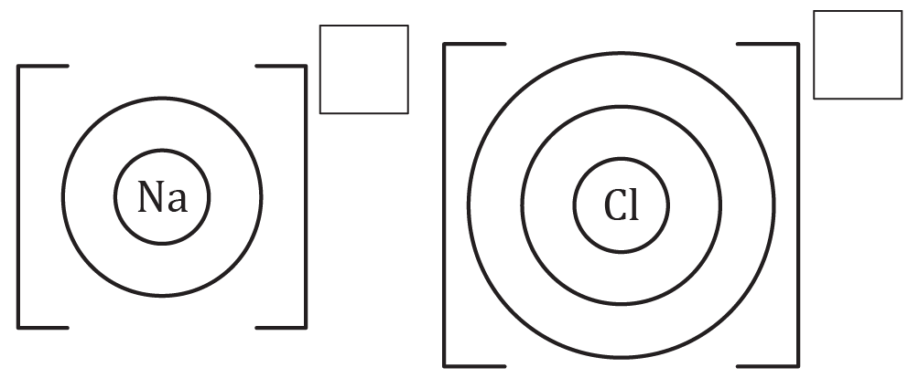
  - Complete the electrons and charge to show sodium chloride. Draw the electrons on the outer shell of the metal as dots and non-metal as crosses to show a dot and cross diagram.
  - When you draw the ions side by side like this, they represent the compound sodium chloride. Is sodium chloride neutral or charged? Explain.

____________________________________________________________________________

____________________________________________________________________________

____________________________________________________________________________

____________________________________________________________________________
- If you know what group an atom is in (using groups 1, 2, 3, 5, 6 and 7) then you can predict the charge of the ion. Complete the table by using a periodic table. The first row is done for you.
Name of atom | Symbol of atom | Group number of atom | Charge of ion
rubidium | $$Rb$$ | 1 | +1
selenium |  |  | +2
gallium | $$Ga$$ | 3
iodine |  |  | –1

strontium

Atoms and ions: what do I understand?

Think about your answers and confidence level for each mini-topic. Decide whether you understand it well, are unsure or need more help. Tick the appropriate column.
Mini-topic | I understand  this well | I think I understand this | I need more  help
I can describe how metal atoms and non-metal atoms form ions.
I can use the periodic table to determine how many electrons are in the outer shell of an element.
I can use the group number to work out how many electrons need to be added or removed to give a full outer shell.
I can work out the charges for metal and non-metal ions of the elements in groups 1, 2, 3, 5, 6 and 7.
I can draw ions that have electrons in shells with brackets and charges.
I can write the electron configuration of an atom and an ion.
I can explain why an ion is positive or negative, referring to sub-atomic particles.
Feeling confident? topics | I understand  this well | I think I understand this | I need more  help
I can name metal and non-metal ions.
I can draw a dot and cross diagram for a simple ionic compound.
I can apply my knowledge of the relationship between group number and charge to unfamiliar ions.

