Atoms and ions: teacher guidance

This resource forms part of the Review my learning series from the Royal Society of Chemistry. The worksheets assess learner’s understanding of content from common 11–14 and 14–16 curriculums. They can be used to identify knowledge gaps and misconceptions once that part of the curriculum has been taught.

The ‘Atoms and ions’ worksheets cover the following topics:
- loss and gain of electrons to make ions
- electronic configuration of atoms and ions
- drawing dot and cross diagrams of ions
- working out formulas of ionic compounds from the ions

If learners successfully answer questions on these topics, they can attempt the extension question (labelled Feeling confident?). These require learners to use information to complete a dot and cross diagram for two more ionic compounds.

Scaffolding

Level 1 (✪) is a scaffolded worksheet which supports learners in a variety of ways, such as selecting words from a word bank, providing answer options to choose from or completed examples. Level 2 (✪✪) is a partially scaffolded worksheet with a reduced level of support, such as partially completed sentences or a wider range of answer options to select from. Level 3 (✪✪✪) is an unscaffolded worksheet in which most of the tasks involve answering questions with a minimum of prompts. Learners will require the use of a periodic table to complete the worksheets. The RSC periodic table is available online, here: periodic-table.rsc.org.

Metacognition

Use the ‘What do I understand?’ page in each level of worksheet to identify areas needing whole class attention and as an indicator for learners to help guide their revision.

Below you will find model answers for each level and guidance on learners’ misconceptions. Learners can use the model answers to self- or peer assess.

When to use

The worksheets can be used in a variety of ways:
- to assess learners’ knowledge at the beginning or end of a period of teaching – match the level of the worksheet used to the ability of the learners
- to assess knowledge during a period of teaching and after learners have completed the relevant section of the specification
- as part of revision
- as a refresher exercise for teachers or non-subject specialists.

There is also scope to increase the level of the worksheets used as learners progress through the curriculum.

Further support

Additional support to address misconceptions identified when using these worksheets can be found at: rsc.li/3KktNTK

Answers

The concept of forming ions is abstract and therefore this can be a difficult topic for learners who are not confident in science. Before attempting the worksheets, it would be a good idea to refresh understanding of atomic structure. You can revisit the worksheets on this topic at: rsc.li/4n8txWQ

Atoms and ions: knowledge check

Metal Ions
- scaffolded/partially scaffolded/unscaffolded

When a metal atom forms an ion, it obtains a full outer shell. Metals lose electrons in the outer shell. This makes an ion with a positive charge.

Guidance: Scaffolded and partially scaffolded word-fill answers are in bold.

Misconceptions with this topic include the understanding of how charge is related to loss and gain of electrons. Learners often think that if you add electrons, it will make a positive charge and vice versa.

Other misunderstandings arise due to the concept of a full outer shell. Making a negative ion is generally easier to understand as you add electrons to get a full outer shell. With a metal ion, this is more difficult because you remove electrons to make a full outer shell.
- scaffolded/partially scaffolded/unscaffolded
Element | Group | No. of electrons in outer shell | No. of electrons removed to give a full outer shell | Ion charge
K | 1 | 1 | 1 | +1
Mg | 2 | 2 | 2 | +2
Al | 3 | 3 | 3 | +3
Na | 1 | 1 | 1 | +1

Guidance: Scaffolded answers are in bold.

This resource has been designed so that learners don't have to use the atomic number to work out how many electrons fill the shells. They do, however, need to use the periodic table to work out which group elements are in.
- scaffolded/partially scaffolded/unscaffolded
 | 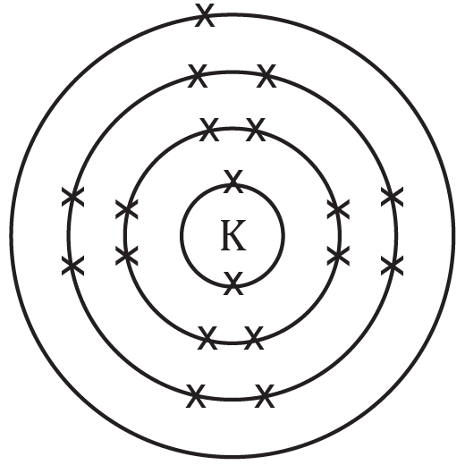 | 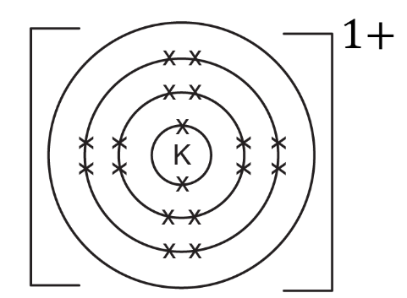
Electronic configuration | 2,8,8,1 | 2,8,8
 | potassium atom | potassium ion

Guidance: Some exam board specifications only require the outer shell of the ions. Making a negative ion is generally easier to understand because you add electrons to get a full outer shell. With a metal ion, this is more difficult to understand because you remove electrons to obtain a full outer shell. Practise showing the complete electronic configuration and thus the empty outer shell and the new full outer shell before moving onto drawing outer shells only.
- scaffolded/partially scaffolded/unscaffolded

When a metal atom becomes an ion it loses electrons. The number of protons in the nucleus stays the same. This means that the total number of protons is more than the total number of electrons. The charge on a proton is positive so the ion has an overall positive charge.

Guidance: Scaffolded and partially scaffolded word-fill answers are in bold.

Misconceptions with this topic include the understanding of how charge is related to loss and gain of electrons. Learners often think that if you add electrons, it will make a positive charge and vice versa. It may help to show learners the positive protons inside the nucleus of the atom as well as the negative electrons in shells when introducing ions. Learners can ‘cancel out’ protons and electrons in pairs until they are left with an excess of either positive protons or negative electrons which will give them the charge.

Non-metal ions
- scaffolded/partially scaffolded/unscaffolded

When a non-metal atom has formed an ion, it has a full outer shell of electrons. Non-metals gain electrons on the outer shell. This makes an ion with a negative charge.

Guidance: See question 1.1.

- scaffolded/partially scaffolded/unscaffolded

Element | Group | No. of electrons in outer shell | No. of electrons added to give a full outer shell | Ion charge
O | 6 | 6 | 2 | –2
Cl | 7 | 7 | 1 | –1
N | 5 | 5 | 3 | –3

Guidance: See question 1.2 .
- scaffolded/partially scaffolded/unscaffolded
 | 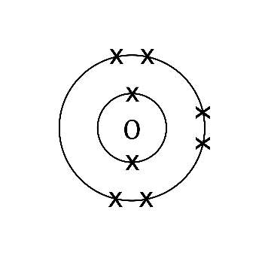 | 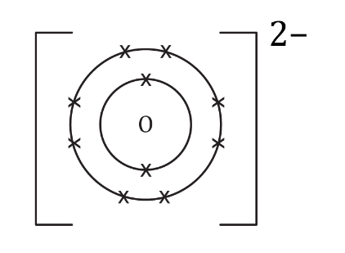
Electronic configuration | 2,6 | 2,8
 | oxygen atom | oxide ion

Guidance: See question 1.3.
- scaffolded/partially scaffolded/unscaffolded

When a non-metal atom becomes an ion it gains electrons. The number of protons in the nucleus stays the same. This means that the total number of protons is less than the total number of electrons. The charge on an electron is negative so the ion has an overall negative charge.

Guidance: See question 1.4.

Atoms and ions: test myself

A periodic table is required for these questions: periodic-table.rsc.org
- scaffolded/partially scaffolded/unscaffolded
Name of element | Group | Number of electrons in the outer shell | Lose or gain electrons, /how many? | Charge on ion
calcium | 2 | 2 | Lose 2 | +2
fluorine | 7 | 7 | Gain 1 | –1
aluminium | 3 | 3 | Lose 3 | +3
lithium | 1 | 1 | Lose 1 | +1
sulfur | 6 | 6 | Gain 2 | –2

Guidance: See question 1.2.
- scaffolded/partially scaffolded/unscaffolded

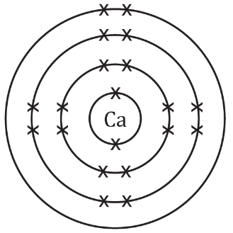 | 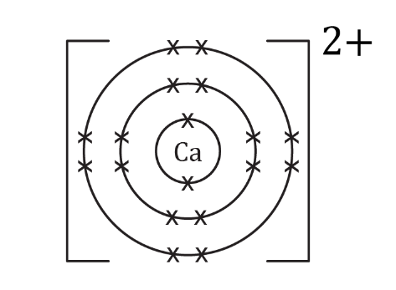
calcium atom | calcium ion

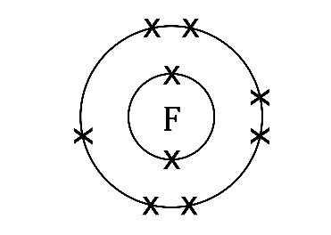 | 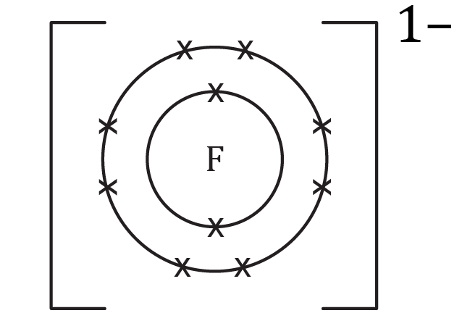
fluorine atom | fluoride ion

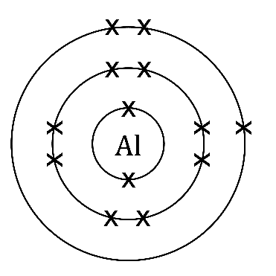 | 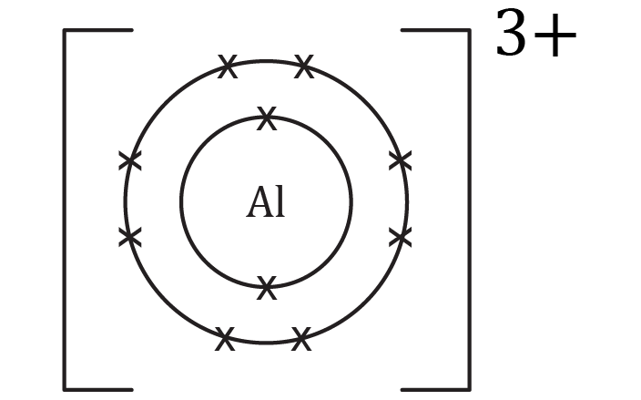
aluminium atom | aluminium ion

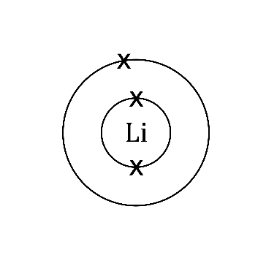 | 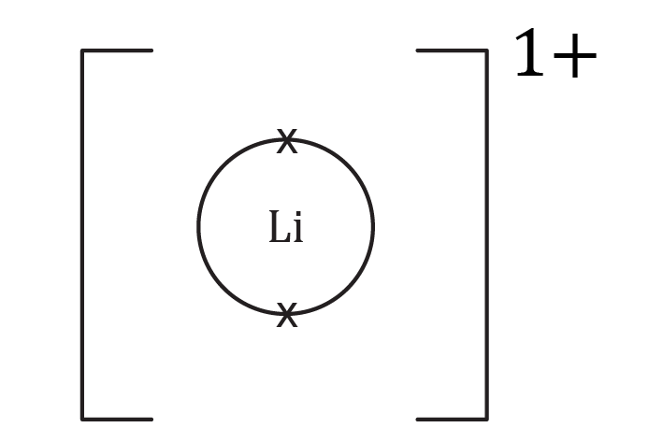
lithium atom | lithium ion

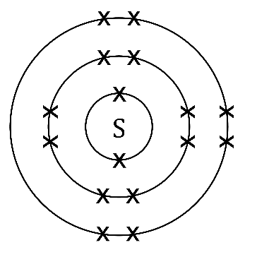 | 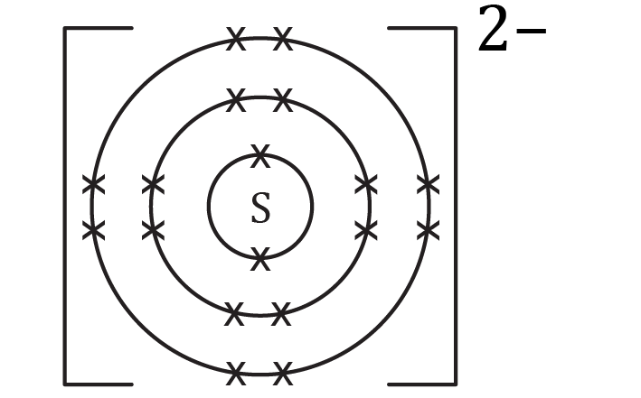
sulfur atom | sulfide ion

Guidance: Drawing out ions has been restricted to the first 20 elements only as this is the requirements for most 14–16 specifications.

Some exam board specifications only require the outer shell of the ions. Making a negative ion is generally easier to understand because you add electrons to get a full outer shell. With a metal ion, this is more difficult to understand because you remove electrons to make a full outer shell. Practise showing the complete electronic configuration and thus the empty outer shell and the new full outer shell before moving onto drawing outer shells only.

- scaffolded/partially scaffolded/unscaffolded
Name of ion | Group number | Charge of ion | Symbol
calcium ion | 2 | +2 | $${Ca}^{2+}$$
chloride ion | 7 | –1 | $${Cl}^{-}$$
sodium ion | 1 | +1 | $${Na}^{+}$$
aluminium ion | 3 | +3 | $${Al}^{3+}$$
oxide ion | 6 | –2 | $$O^{2-}$$

Guidance: See question 1.2.

Atoms and ions: feeling confident?
- scaffolded/partially scaffolded/unscaffolded
  - -ide

Ion symbol | Name of atom | Metal or non-metal? | Name of ion
$$N^{3-}$$ | nitrogen | non-metal | nitride ion
$${Li}^{+}$$ | lithium | metal | lithium ion
$$S^{2-}$$ | sulfur | non-metal | sulfide ion
$${Al}^{3+}$$ | aluminium | metal | aluminium ion
$${Cl}^{-}$$ | chlorine | non-metal | chloride ion

Guidance: Learners may confuse the names for non-metal atoms and ions. Remind learners that the name they see on the periodic table is for a neutral atom. The -ide suffix is only added to non-metals when they become ions. Note: The first column in this table only appears in the non-scaffolded version of the student worksheets.
- scaffolded/partially scaffolded/unscaffolded

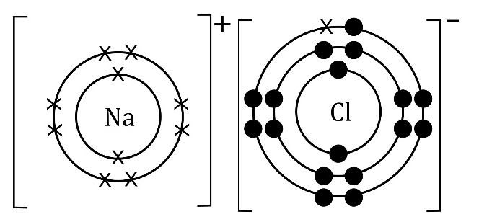
  - Sodium chloride (NaCl) is neutral. Although the individual ions carry an electrical charge, the compound as a whole is neutral because the positive charge on the sodium ion (${Na}^{+}$) is balanced by the equal and opposite negative charge of the chloride ion (${Cl}^{-}$).

Guidance: This is a preview of ionic bonding for learners who have fully grasped the concept of ions and are ready for the next step. The example is specifically chosen not to require balancing of charges. Find a wide selection of resources to plan, deliver, assess and enrich your teaching of ionic bonding at: rsc.li/wheelbarrow

- scaffolded/partially scaffolded/unscaffolded
Name of atom | Symbol of atom | Group number of atom | Symbol and charge of ion
Rubidium | $$Rb$$ | 1 | $${Rb}^{+}$$
Selenium | $$Se$$ | 6 | $${Se}^{2-}$$
Gallium | $$Ga$$ | 3 | $${Ga}^{3+}$$
Iodine | $$I$$ | 7 | $$I^{-}$$
Strontium | $$Sr$$ | 2 | $${Sr}^{2+}$$

Guidance: Once learners are familiar with ions of the first twenty elements they may be able to apply their knowledge to unfamiliar elements. Learners will need access to a periodic table for this question.

Atoms and ions: what do I understand?

Learners have a table to complete the assess how well they feel they understand each concept and their confidence level for each. Decide whether you understand it well, are unsure or need more help. The table below shows which questions address which topic area.
Mini-topic | Assessed via:
I can describe how metal atoms and non-metal atoms form ions. | Questions 1.1 and 1.5
I can use the periodic table to determine how many electrons are in the outer shell of an element. | Questions 1.2 and 1.6 and 2.1
I can use the group number to work out how many electrons need to be added or removed to give a full outer shell. | Questions 1.2 and 1.6 and 2.1
I can work out the charges for metal and non-metal ions of the elements in groups 1, 2, 3, 5, 6 and 7. | Questions 1.2 and 1.6, 2.1 and 3.3
I can draw ions with electrons in shells, brackets and charges. | Questions 1.3 and 1.7, 2.2 and 3.2
I can write the electron configuration of an atom and an ion. | Questions 1.3 and 1.7
I can explain why an ion is positive or negative, referring to sub-atomic particles. | Questions 1.4 and 1.8
Feeling confident? topics | Assessed via:
I can name metal and non-metal ions. | Question 3.1
I can draw a dot and cross diagram for a simple ionic compound. | Question 3.2
I can apply my knowledge of the relationship between group number and charge to unfamiliar ions. | Question 3.3

