Structure of the atom: knowledge check
- Label the subatomic particles on this diagram of an atom and add where they are found.

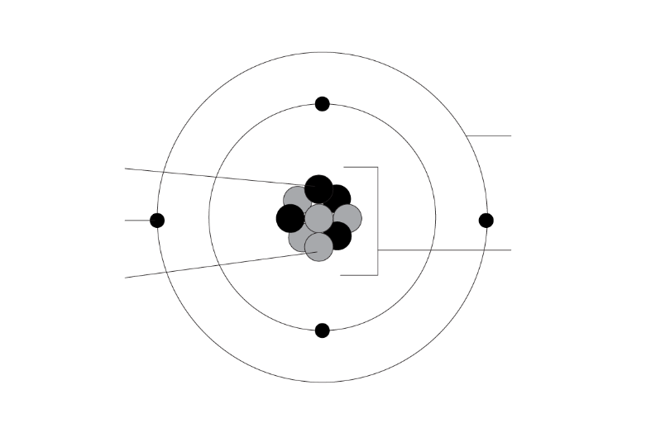
- Complete the following sentences.

The positive __________________ are found inside the __________________.

The neutral __________________ are found inside the __________________.

The negative __________________ are found in the __________________.

The relative mass of the protons and neutrons is __________________.

The relative mass of an electron is __________________.

- Complete the table using the information from question 1.2.
Name of subatomic particle | Charge | Relative mass | Location

- The periodic table contains enough information to allow us to work out the numbers of subatomic particles in each atom of the elements. Complete the diagram below by filling in the gaps.

Name of number |  | Subatomic particles
________________ number  ________________ number | 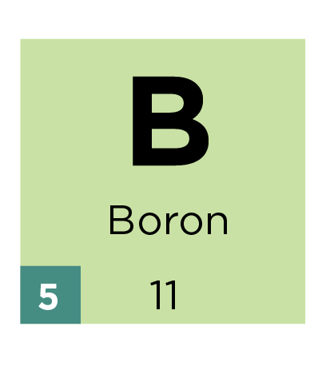 | __________________ and __________________  ______________________
- A neutral atom will have the same number of protons and electrons. Compete the number of protons, neutrons and electrons in each element below:

 | 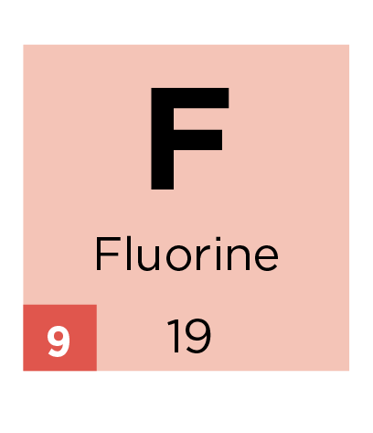 | 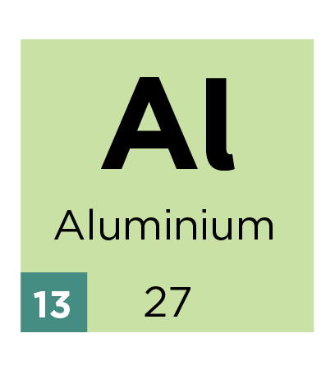 | 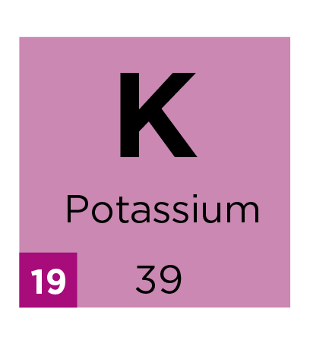
protons: | __________ | __________ | __________
neutrons: | __________ | __________ | __________
electrons: | __________ | __________ | __________
- Use the information from question 1.5 to add the electrons to the diagrams below using an X and write the electron configuration for each atom.
 | 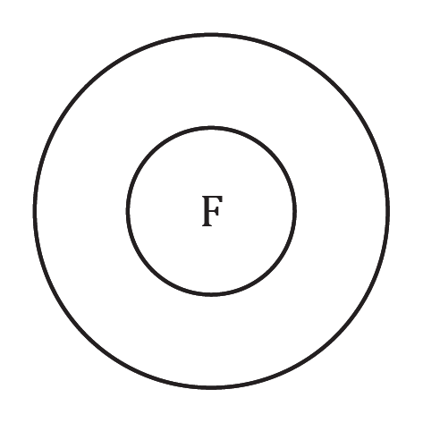 | 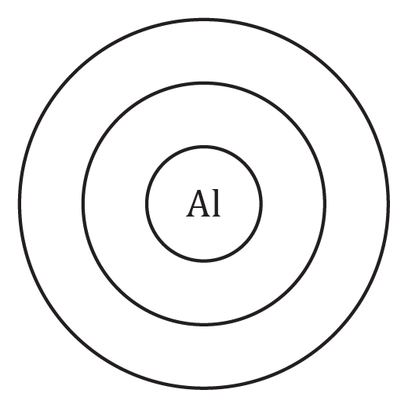 | 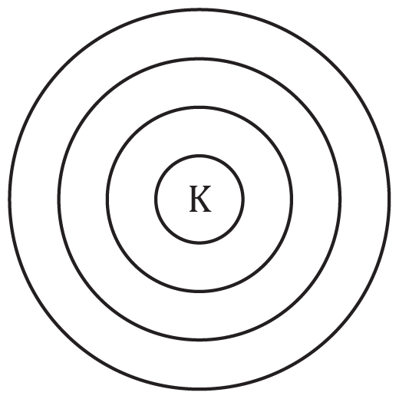
Electron configuration: | _____ , _____ | _____ , _____ , _____ | ____ , ____ , ____ , ____

Structure of the atom: test myself
- State the charge of the following subatomic particles:
- proton charge: _______________
- neutron charge: _______________
- electron charge: _______________
- Name the particles that are found in:
- the nucleus: ______________________________________________________________
- shells/energy levels: ______________________________________________________

- State which subatomic particle can be found by knowing the atomic number of an atom.

__________________________________________________________________________________
- State which subatomic particles are described by the mass number of an atom.

__________________________________________________________________________________
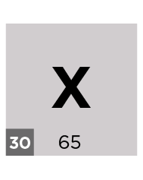
- This is information from the periodic table for element X. Give:

the atomic number = ______________

the mass number = ______________

- Using the information given, determine the number of protons, neutrons and electrons in boron:
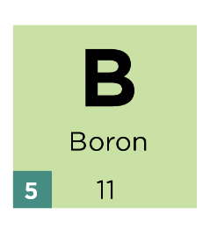

protons = ____________________________________________________

neutrons = ___________________________________________________

electrons = ___________________________________________________

- Using the information from Q2.6, complete the diagram below to show the electronic structure of boron.

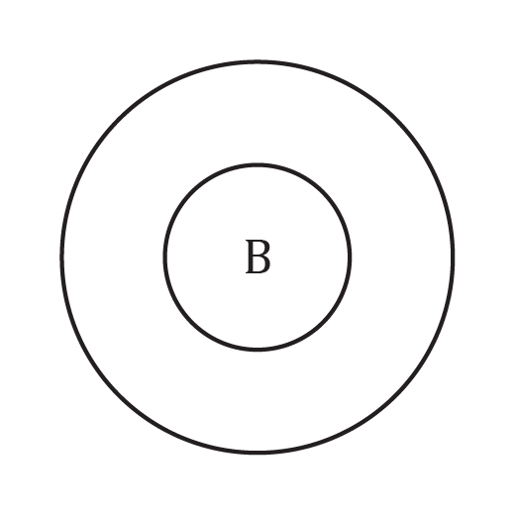
- Using the information from Q2.7, write the electron configuration for boron.

__________________________________________________________________________________
- A neutral atom has 20 protons. Determine the number of electrons it has. Explain your answer.

Number of electrons: _____________________________________________________________

Explanation: _____________________________________________________________________

__________________________________________________________________________________

__________________________________________________________________________________
- A student stated: ‘mass is concentrated in the nucleus of the atom’.
Do you agree or disagree? Explain your answer.

__________________________________________________________________________________

__________________________________________________________________________________

__________________________________________________________________________________

__________________________________________________________________________________

__________________________________________________________________________________

Structure of the atom: feeling confident?
- Using a periodic table, work out the number of subatomic particles in the atoms below. Add in the electron configuration for the elements indicated.

For the purposes of this table elements are written as follows:
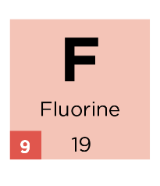
19
$$F$$9
Element | Atomic Number | Mass number | Protons | Electrons | Neutrons | Electron configuration
1
$$H$$

$$Be$$ |  | 9
$$N$$ |  |  | 7 |  | 7
24
$$Mg$$

$$P$$ |  |  |  |  | 16 | 2,8,5
$$Fe$$ |  | 56
 |  |  | 47 |  | 61
208
$$Pb$$
82
$$Hg$$ |  |  |  |  | 122

Take it further
- In 1913, Neils Bohr proposed his model of the atom. Why have scientists named this the ‘solar system’ atom?

__________________________________________________________________________________

__________________________________________________________________________________

__________________________________________________________________________________

Structure of the atom: what do I understand?

Think about your answers and confidence level for each mini-topic. Decide whether you understand it well, are unsure, or need more help. Tick the appropriate column.
Mini-topic | I understand  this well | I think I understand this | I need more  help
I can name the subatomic particles.
I can describe the following properties of the subatomic particles:
- charge
- relative mass
- where they are found
I know which particles are described by the:
- atomic number
- mass number
I can use the information from the periodic table to work out the number of protons, neutrons and electrons for a neutral atom.
I draw the correct number of electrons on the shells of an atom for elements 1–20 on the periodic table.
I can write the electron configuration for an atom of elements 1–20, if I know the number of electrons.
Feeling confident? topics | I understand  this well | I think I understand this | I need more  help
I can use the periodic table to work out the number of subatomic particles for any element.

