Structure of the atom: teacher guidance

This resource forms part of the Review my learning series from the Royal Society of Chemistry. The worksheets assess learner’s understanding of content from common 11–14 and 14–16 curriculums. They can be used to identify knowledge gaps and misconceptions once that part of the curriculum has been taught.

The Structure of the atom worksheets cover the following topics:
- subatomic particles, their charge, mass and where they are found in the atom
- atomic (proton) number and mass number from the periodic table
- identifying the number of protons, neutrons and electrons of an atom using the periodic table
- placing electrons into shells (first 20 elements only)
- electron configuration

If learners successfully answer questions on these topics, ask them to attempt the extension question labelled ‘Feeling confident?’. This requires learners to use information to complete a table identifying the number of protons, electrons and neutrons in a list of elements. An additional ‘Take it further’ question is also included on the Level 3 (unscaffolded) worksheet to ask learners to consider the analogy of an atom to the solar system.

Scaffolding

Level 1 (✪) is a scaffolded worksheet which supports learners in a variety of ways, such as selecting words from a word bank, providing answer options to choose from or completed examples. Level 2 is a partially scaffolded worksheet with a reduced level of support, such as partially completed sentences or a wider range of answer options to select from. Level 3 (✪✪✪) is an unscaffolded worksheet where most of the tasks involve answering questions with a minimum of prompts. Learners will require the use of a periodic table to complete the worksheets. The RSC periodic table is available online, here: periodic-table.rsc.org.

Metacognition

Use the ‘What do I understand?’ page in each level of worksheet to identify areas needing whole class attention and as an indicator for learners to help guide their revision.

Below you will find model answers for each level and guidance on learners’ misconceptions. Learners can use the model answers to self- or peer assess.

When to use

You can use the worksheets in a variety of ways:
- to assess learners’ knowledge at the beginning or end of a period of teaching – match the level of the worksheet used to the ability of the learners
- to assess knowledge during a period of teaching and after learners have completed the relevant section of the specification
- as part of revision
- as a refresher exercise for teachers or non-subject specialists.

There is also scope to increase the level of the worksheets used as learners progress through the curriculum.

Specification differences

Different specifications have different names for the atomic number, which can be called the proton number. There is an editable version of the worksheets so you can alter this to match the specification you are using.

Most periodic tables will have a key that calls the larger number the relative atomic mass. We have used mass number instead, for ease of working out the number of protons and neutrons and to reduce confusion for this core understanding. You can introduce this number as the relative atomic mass when delivering a further lesson on isotopes.

Further support

You can find additional support for addressing misconceptions identified using these worksheets at: rsc.li/4n8txWQ For more assessment questions on this topic use our Knowledge check (rsc.li/3VorKQy) and Stretch and challenge (rsc.li/3RpZ4Wq) worksheets on atomic structure.

Answers

Structure of the atom: knowledge check
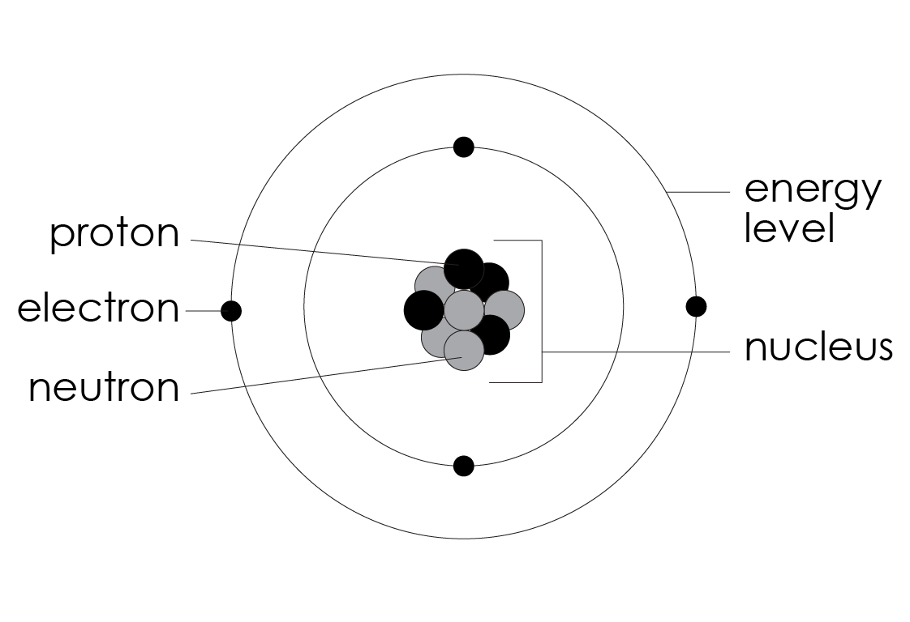
- scaffolded/partially scaffolded/unscaffolded
Guidance: learners may refer to either energy levels or electron shells for the different orbits around the nucleus. Most 14–16 specifications use the word shell but will usually accept a label of energy level.
shell or energy level

- scaffolded/partially scaffolded/unscaffolded

The positive protons are found inside the nucleus.

The neutral neutrons are found inside the nucleus.

The negative electrons are found in the shells/energy levels.

partially scaffolded/unscaffolded

The relative mass of the protons and neutrons is one.

The relative mass of an electron is negligible/0.0005 (1/1840).

Guidance: it may help learners to associate P with protons and positive and N with neutrons and neutral. This doesn't work for electrons, but it is the only one left that can be negative. Specifications differ in terms of how they refer to the mass of an electron. When using the fully scaffolded version of the worksheet, edit the word bank options to match the specification you are teaching.

- scaffolded/partially scaffolded/unscaffolded
Name of subatomic particle | Charge | Relative mass | Location
proton | positive | 1 | nucleus
neutron | neutral (zero) | 1 | nucleus
electron | negative | negligible (0.0005) | shells/energy levels

Guidance: some specifications expect learners to know that an electron has a relative mass of zero. Other values such as 1/1836 and 1/1840 may be used. When using the scaffolded versions of the worksheet, edit the pre-filled cells in the table to match the specification you are teaching.

- scaffolded/partially scaffolded/unscaffolded

Name of number |  | Subatomic particles
mass number  atomic number | 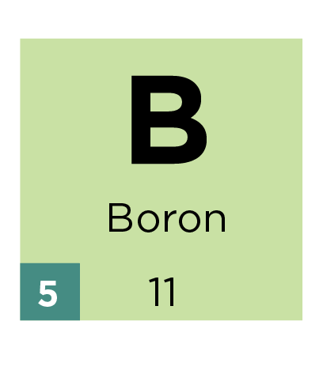 | protons and neutrons  protons

Guidance: some learners will have the misconception that the atomic number is the number of electrons. This number is the same as the number of electrons in a neutral atom but the definition is the number of protons only.

- scaffolded/partially scaffolded/unscaffolded
 | 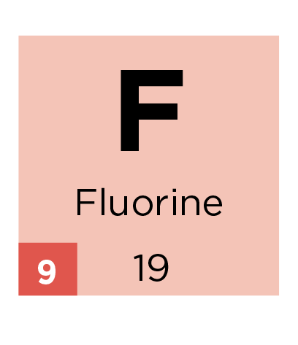 | 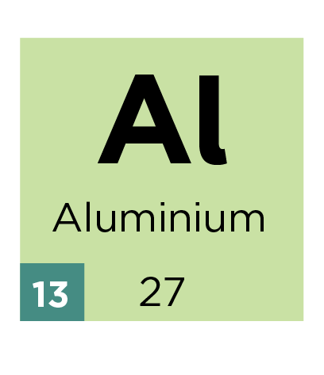 | 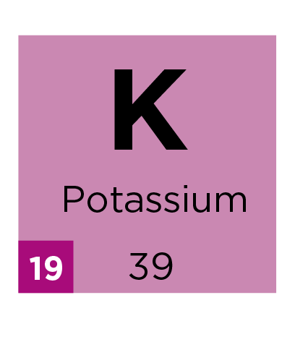
protons: | 9 | 13 | 19
neutrons: | 19 $-$ 9 = 10 | 27 $–$ 13 = 14 | 39 $-$ 19 = 20
electrons: | 9 | 13 | 19
- scaffolded/partially scaffolded/unscaffolded
 | 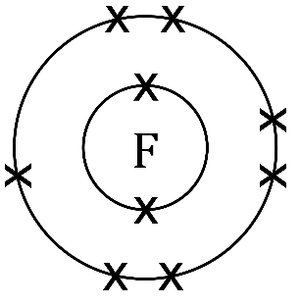 | 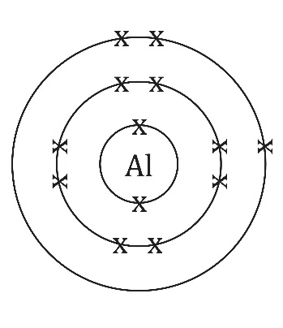 | 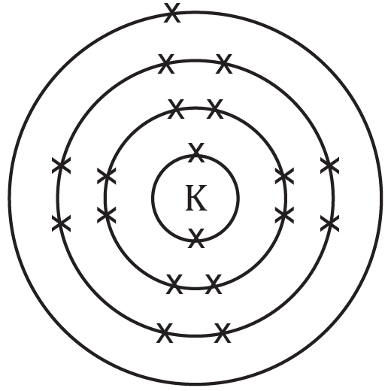
Electron configuration: | 2 , 7 | 2 , 8 , 3 | 2 , 8 , 8 , 1

Structure of the atom: test myself
- scaffolded
proton |  | negative
neutron |  | positive
electron |  | neutral

partially scaffolded/unscaffolded
- proton charge: positive
- neutron charge: neutral
- electron charge: negative
- scaffolded

proton

shells

neutron

nucleus

electron

partially scaffolded/unscaffolded
- nucleus: protons, neutrons
- shells: electrons

Guidance: learners may refer to either energy levels or electron shells for the different orbits around the nucleus. When using the scaffolded versions of the worksheet, edit the words in the matching exercise to represent the specification you are teaching.
- scaffolded/partially scaffolded/unscaffolded
Subatomic particle described by atomic number = protons
- scaffolded/partially scaffolded/unscaffolded
Subatomic particles described by mass number = protons and neutrons
- scaffolded/partially scaffolded/unscaffolded
The atomic number = 30

The mass number = 65
- scaffolded/partially scaffolded/unscaffolded

Protons = 5

Neutrons = 6

Electrons = 5
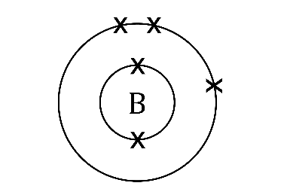
- scaffolded/partially scaffolded/unscaffolded

Guidance: when adding the electrons into the shells, many teachers will put the electrons in singly then as pairs, representing the orbitals learned at post-16 level. Most 14–16 specifications, however, will not deduct marks if the electrons are simply spread around the ring as long as the number of electrons is correct.
- scaffolded/partially scaffolded/unscaffolded
Electron configuration: 2,3
- scaffolded/partially scaffolded/unscaffolded
Number of electrons = 20 (allow the same)

Explanation: Protons have a positive charge. If an atom has 20 protons then it will need to have an equal number of electrons in order to be neutral overall. This is because the electrons have an equal and opposite negative charge to the positive protons. The opposite charges cancel out to give a neutral atom.

Guidance: scaffolded and partially scaffolded answers are given in bold.

- scaffolded/partially scaffolded/unscaffolded

Explanation: I agree with the student because protons and neutrons, which are located in the nucleus, each have a relative mass of one. Electrons, which orbit the nucleus, have a mass that is so small it is considered to be negligible when calculating the mass of an atom. The majority of an atom is empty space.

Guidance: scaffolded and partially scaffolded answers are given in bold. Many learners will have no concept of the fact that most of the atom is empty space with all the mass concentrated in the middle. This is because they are used to drawing atoms as spheres.

Structure of the atom: feeling confident?
- The different worksheets have different numbers in this chart to give more or less help. This chart gives all answers.

Guidance: many learners think that all atoms contain neutrons and will often put a neutron in protium H-1. Some of the mass numbers may not agree with what is written on a learner’s periodic table due to isotopes. This is common in examination questions at this level and learners must use the information in front of them and not the mass number written on the periodic table.
Element | Atomic Number | Mass number | Protons | Electrons | Neutrons | Electron configuration
1  H  1 | 1 | 1 | 1 | 1 | 0 | 1,0
9  Be  4 | 4 | 9 | 4 | 4 | 5 | 2,2
14  N  7 | 7 | 14 | 7 | 7 | 7 | 2,5
24  Mg  12 | 12 | 24 | 12 | 12 | 12 | 2,8,2
31  P  15 | 15 | 31 | 15 | 15 | 16 | 2,8,5
56  Fe  26 | 26 | 56 | 26 | 26 | 30
108  Ag  47 | 47 | 108 | 47 | 47 | 61
208  Pb  82 | 82 | 208 | 82 | 82 | 126
202  Hg  80 | 80 | 202 | 80 | 80 | 122

Take it further (no scaffold)
  - The electrons are like planets orbiting the sun. The sun is the nucleus containing protons and neutrons.

Structure of the atom: what do I understand?
Mini-topic | Assessed via:
I can name the subatomic particles. | Q1.1, Q1.2
I can describe the following properties of the subatomic particles:  - charge  - relative mass  - where they are found | Q1.1, Q1.2, Q1.3, Q2.1, Q2.2, Q2.8
I know which particles are described by the:  - atomic number  - mass number | Q1.4, Q2.9, Q2.10
I can use the information from the periodic table to work out the number of protons, neutrons and electrons for a neutral atom. | Q1.5, Q2.4, Q2.7, Q3.1
I draw the correct number of electrons on the shells of an atom. | Q1.6, Q2.5,
I can write the electron configuration for an atom if I know the number of electrons. | Q1.6, Q2.6, Q3.1
Feeling confident? topics | Assessed via:
I can use the periodic table to work out the number of subatomic particles for any element. | Q3.1

