Structure of the atom: knowledge check
- Label the subatomic particles on this diagram of an atom using the key words provided.

protons electrons neutrons

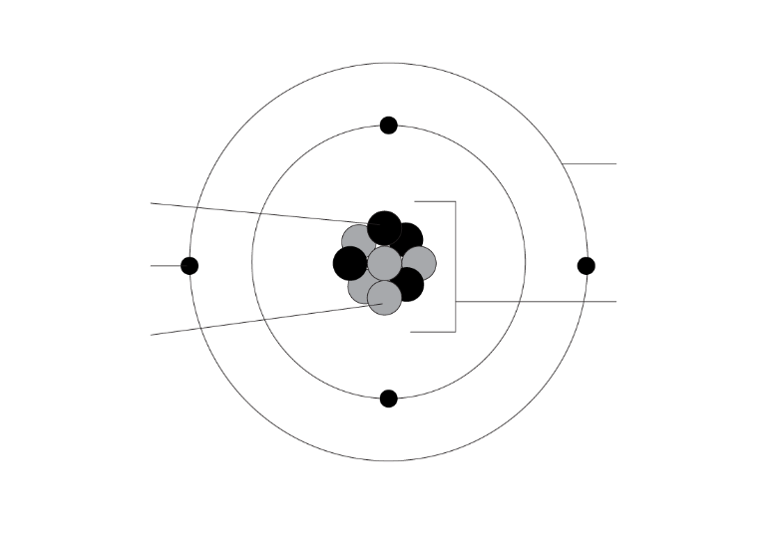
shell or energy level
nucleus
nucleus
- Use the words to complete the sentences. Words can be used more than once.

nucleus shells protons electrons neutrons

The positive __________________ are found inside the __________________.

The neutral __________________ are found inside the __________________.

The negative __________________ are found in the __________________.
- Complete the table using the information from question 1.2.
Name of subatomic particle | Charge | Relative mass | Location
proton |  | 1
neutron |  | 1
electron |  | negligible (0.0005)

- The periodic table contains enough information to allow us to work out the numbers of subatomic particles in each atom of the elements.

Complete the diagram by filling in the gaps. Words can be used more than once.

atomic number mass number protons neutrons

Name of number |  | Subatomic particles
________________ number  ________________ number | 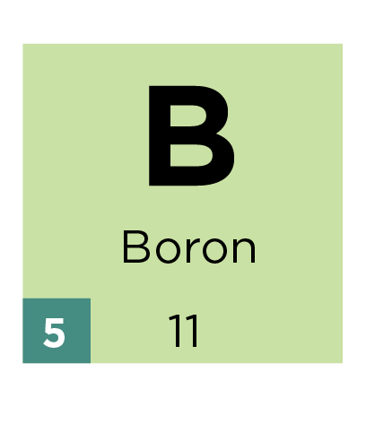 | __________________ and __________________  ______________________
- A neutral atom will have the same number of protons and electrons.

Compete the number of protons, neutrons and electrons in each element below. The first one is done for you.
 | 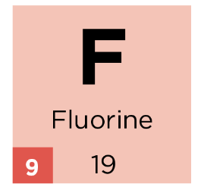 | 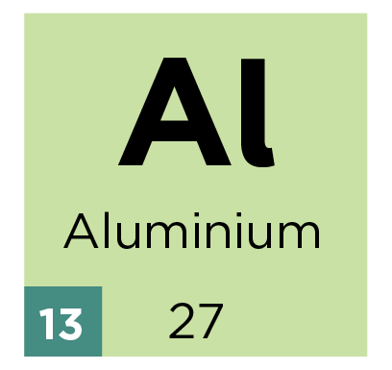 | 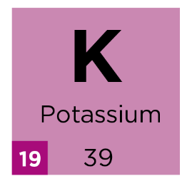
protons: | 9 | __________ | __________
neutrons: | 19 $-$ 9 = 10 | 27 – 13 = _________ | __________
electrons: | 9 | __________ | __________
- Use the information from question 1.5 to add the electrons to the diagrams below and write the electron configuration for each atom. The first one is done for you.
Hint: For the first twenty elements in the periodic table there are two electrons in the first shell and eight electrons in the second and third shells.
 | 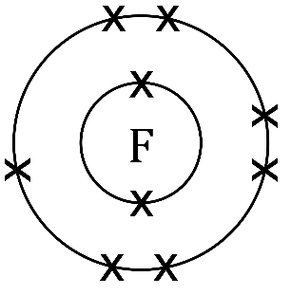 | 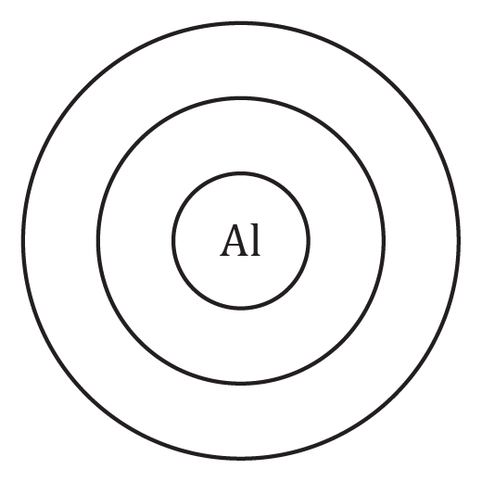 | 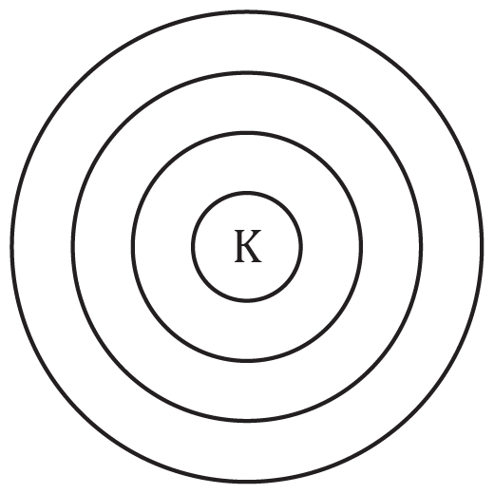
Electron configuration: | 2 , 7 | 2 , _____ , _____  Hint: 13 electrons | 2 , ____ , ____ , ____  Hint: 19 electrons

Structure of the atom: test myself
- Draw a line to match the subatomic particle to its charge:
proton |  | negative
neutron |  | positive
electron |  | neutral
- Draw a line to match the subatomic particle to where it is found:

proton

shells

neutron

nucleus

electron
- State which subatomic particle can be found by knowing the atomic number of an atom.

Subatomic particle described by atomic number = ________________
- State which subatomic particles are described by the mass number of an atom.

Hint: what particles are in the nucleus?

Subatomic particles described by mass number = ______________and ______________
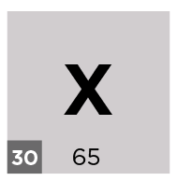
- This is information from the periodic table for element X. Give:

the atomic number = ________

the mass number = ________

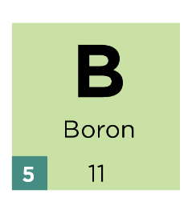
- Using the information given, complete the number of protons, neutrons and electrons in boron:

protons = ________

neutrons = ________

electrons = ________
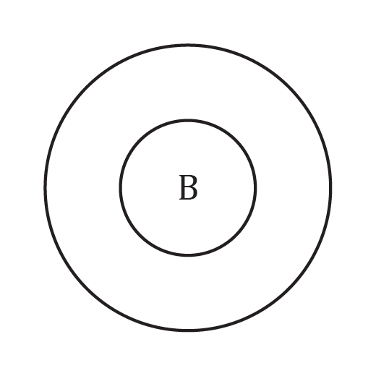
- Using the information from Q2.6, add the electrons to the shells in this diagram of boron.
- Using the information from Q2.7, write the electron configuration for boron.

Electron configuration: 2 , _____
- A neutral atom has 20 protons. Determine the number of electrons it has. Complete the sentences to explain your answer.

Number of electrons = _____

opposite positive neutrons masses equal
neutral electrons negative charges protons

Protons have a __________________ charge. If an atom has 20 protons then it will need to have an __________________ number of electrons in order to be __________________ overall. This is because the __________________ have an equal and opposite __________________ charge to the positive protons. The opposite __________________ cancel out to give a neutral atom.

- A student stated: ‘mass is concentrated in the nucleus of the atom’.
Do you agree or disagree? Complete the sentences to explain your answer.

charge agree nucleus protons small disagree atom large empty space neutrons mass electrons

I ____________________ with the student because protons and ______________________, which are located in the nucleus, each have a relative ______________________ of one. Electrons, which orbit the nucleus, have a mass that is so ______________________ it is considered to be negligible when calculating the mass of an ______________________. The majority of an atom is ______________________.

Structure of the atom: feeling confident?
- Using a periodic table, complete the information about the number of subatomic particles in the atoms below. Add the electron configuration for the elements indicated. The first one is completed for you.

For the purposes of this table elements are written as follows:
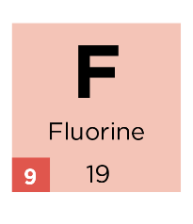
19
$$F$$9

Element | Atomic Number | Mass number | Protons | Electrons  Same as protons | Neutrons  Mass number – atomic number | Electron configuration
1  $$H$$  1 | 1 | 1 | 1 | 1 | 1 – 1 = 0 | 1,0
9  $$Be$$  4 | 4 | 9 |  |  |  | 2,___
14  $$N$$  7 |  | 14 | 7 |  | 7
24  $$Mg$$  12 | 12 | Protons + neutrons = |  | 12 | 24 -12 = | 2,8,____
31  $$P$$  15 | 15 |  | 15 |  | 16 | 2,8,5
56  $$Fe$$  26 |  | 56 | 26
108  $$Ag$$  47 | 47 |  | 47 |  | 61
208  $$Pb$$  82 |  | 208 |  | 82
202  $$Hg$$  80 | Same as protons = |  | 80 |  | 122

Structure of the atom: what do I understand?

Think about your answers and confidence level for each mini-topic. Decide whether you understand it well, are unsure, or need more help. Tick the appropriate column.
Mini-topic | I understand  this well | I think I understand this | I need more  help
I can name the subatomic particles.
I can describe the following properties of the subatomic particles:
- charge
- relative mass
- where they are found
I know which particles are described by the:
- atomic number
- mass number
I can use information from the periodic table to work out the number of protons, neutrons and electrons for a neutral atom.
I draw the correct number of electrons on the shells of an atom for elements 1–20 on the periodic table.
I can write the electron configuration for an atom of elements 1–20, if I know the number of electrons.
Feeling confident? topics | I understand  this well | I think I understand this | I need more  help
I can use the periodic table to work out the number of subatomic particles for any element.

