Alkenes: teacher guidance
This resource forms part of the Review my learning series from the Royal Society of Chemistry. The worksheets assess learner’s understanding of content from common 11–14 and 14–16 curriculums. They can be used to identify knowledge gaps and misconceptions once that part of the curriculum has been taught.
The Alkenes worksheets cover the following topics:
- alkenes as a homologous series
- general formula and functional group of alkenes
- displayed formulas of alkenes
- combustion reactions of alkenes
- addition reactions of alkenes with hydrogen, water and halogens
- conditions for the addition reactions.
If learners successfully answer questions on these topics, they can attempt the extension questions. This requires learners to answer questions on the reaction of ethene with bromine water.
Scaffolding
Level 1 (✪) is a scaffolded worksheet which supports learners in a variety of ways, such as selecting words from a word bank, providing answer options to choose from or completed examples. Level 2 (✪✪) is a partially scaffolded worksheet with a reduced level of support, such as partially completed sentences or a wider range of answer options to select from. Level 3 (✪✪✪) is an unscaffolded worksheet in which most of the tasks involve answering questions with a minimum of prompts.
Metacognition
The ‘What do I understand?’ page is common to all levels of worksheet and can be used both to identify areas needing whole class attention and as an indicator for learners to help guide their revision.
Below you will find model answers for each level and guidance on learners’ misconceptions. Learners can use the model answers to self- or peer assess.
When to use
The worksheets can be used in a variety of ways:
- to assess learners’ knowledge at the beginning or end of a period of teaching. Match the level of the worksheet to the support needs of the learners,
- to assess knowledge during a period of teaching and once learners have completed the relevant section of the specification,
- as part of revision,
- as a refresher exercise for teachers or non-subject specialists.
There is also scope to increase the level of the worksheets used as learners progress through their curriculum.
Further support
For more resources to support teaching of this topic and address any misconceptions identified, go to rsc.li/3VimHTj.

Answers

Alkenes: knowledge check
- Level 1, 2 and 3
ball and stick model  carbon atom  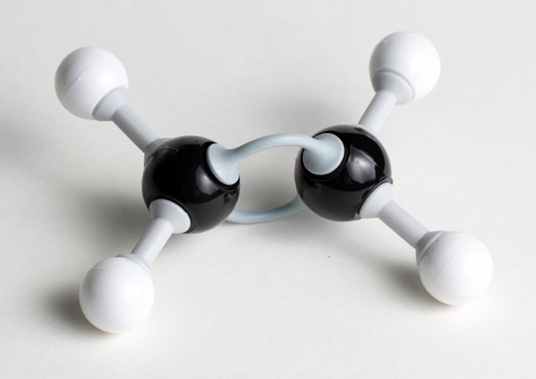  hydrogen atom double covalent  bond | dot and cross diagram  carbon atom  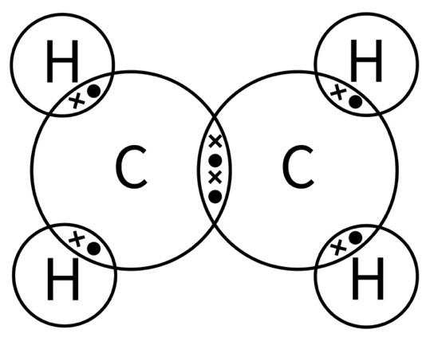  hydrogen atom double covalent  bond
Guidance: This question should remind learners about two ways of representing a compound and the shared electrons in a double covalent bond.
Learners might note that an ethene molecule has a planar (flat) shape, compared to tetrahedral shape around each carbon atom in ethane.

- (Level 1, 2 and 3)
Suffix used for the names of alkenes | -ene
General formula for the alkenes homologous series | $$C_{n}H_{2n}$$
Functional group of alkenes | C=C
Number of carbon atoms in a molecule of propene | three
Name of the alkene containing four carbon atoms | butene
Molecular formula of ethene | $$C_{2}H_{4}$$
Guidance: Misconceptions may include:
- confusing alkenes with alkanes
- misunderstanding terminology such as homologous series and functional group.
- (Level 1, 2 and 3)
Name | Molecular formula | Displayed formula
ethene | $$C_{2}H_{4}$$ | 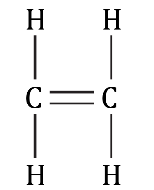
propene | $$C_{3}H_{6}$$ | 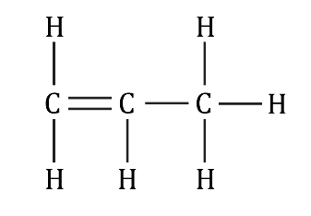
butene | $$C_{4}H_{8}$$ | 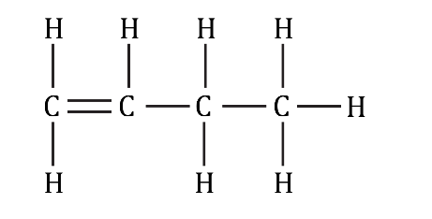
pentene | $$C_{5}H_{10}$$ | 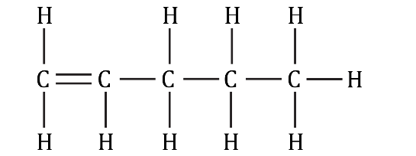
Guidance: Misconceptions may include:
- not calculating molecular formulas correctly
- not attaching the correct number of hydrogen atoms to each carbon atom, especially carbons with a double bond.

The displayed formulas show but-1-ene and pent-1ene (the 1 indicating that the double bond is between the first and second carbons) but at this level learners are not expected to distinguish between structural isomers.

- (Level 1, 2 and 3)

combustion; incomplete; more; C–C; addition; ethane;
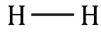
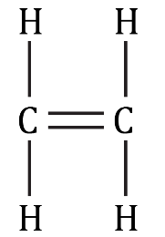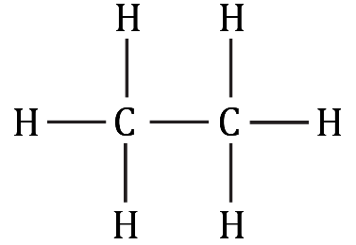
+
→
hydrogen ethene ethane
Guidance: Terminology may be a problem for some learners. Keeping a science vocabulary list may help.
Learners may think that because the C=C bond is stronger than the C–C bond, alkenes must be less reactive than alkanes.

Alkenes: test myself
- (Level 1)

pentene
(Level 2 and 3)

pentene and ethene

Guidance: Learners need to know the suffix used in alkene names. For Level 2 and 3, learners may mistakenly select methene forgetting that methene cannot exist as alkenes must contain at least two carbon atoms.
- (Level 1, 2 and 3)
$$C_{6}H_{12}$$

Guidance: Learners may not substitute in to the general formula correctly.
- (Level 1, 2 and 3)

nickel catalyst at 150°C

Guidance: Adding reaction conditions to a science vocabulary list may help learners to remember these conditions.
- (Level 1, 2 and 3)

B The displayed formula of the product is:

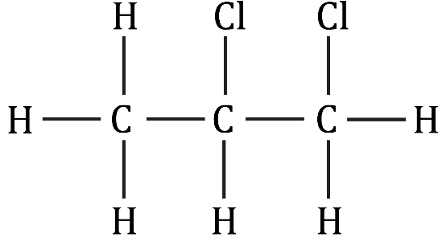

Guidance: As long as the chlorine atoms are attached to two adjacent carbon atoms, they can be shown in any position.

Errors include not showing the correct number of hydrogen or chlorine atoms and including a double bond in the product.

- (Level 1, 2 and 3)

1,1-dichloropentane

Guidance: Errors include:
- not using numbers to show the position of the chlorine atoms
- using the commas and dashes incorrectly in the name
- retaining the suffix ‘-ene’.
- (Level 1, 2 and 3)
  - addition reaction

Guidance: See guidance for question 1.4.
  - ethanol

Guidance: Learners need to recognise the functional group of the alcohols and how they are named.
- The conditions are 300°C, high pressure and an acid catalyst.

Guidance: See guidance for question 2.3.
- $C_{3}H_{6}$ + 3$O_{2}$ → 3CO + $3H_{2}O$

Guidance: Learners may have problems balancing the equation and may forget that water is always produced in incomplete combustion.

Alkenes: feeling confident?
- (Level 1, 2 and 3)

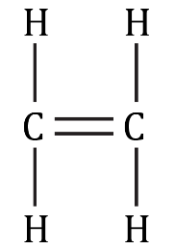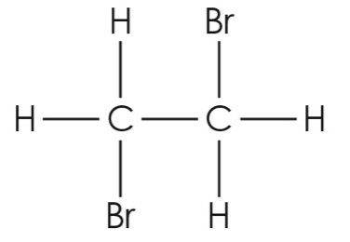
Br – Br
+
→
  - The product is 1,2-dibromoethane.

Guidance: As long as a bromine atom is attached to each carbon atom, there are alternative ways of writing the displayed formula.

Misconceptions include attaching the two bromine atoms to the same carbon atom and retaining the double bond.

See guidance for question 2.5 for naming.
- (Level 1, 2 and 3)
Alkanes do not decolourise bromine water because they do not contain double C=C bonds to form addition compounds with.

Guidance: Bromine water can be used to differentiate between an alkane and an alkene. Learners need to relate the structures of alkanes and alkenes to their reactivity.

Alkenes: what do I understand?
Mini-topic | Assessed via:
I can describe alkenes as a homologous series. | 1.2, 2.1
I can identify the general formula and functional group of alkenes. | 1.1, 1.2
I can write molecular formulae and draw displayed formulae of alkenes. | 1.3, 2.2
I can describe and write equations to represent the combustion reactions of alkenes. | 1.4, 2.8
I can describe the addition reactions of alkenes with hydrogen, water and halogens. | 1.4, 2.4, 2.5, 2.6
I can state the conditions needed for the addition reactions of alkenes. | 2.3, 2.7
Feeling confident? topics | Assessed via:
I can write an equation to represent the decolourisation of bromine water. | 3.1
I can explain why alkanes do not decolourise bromine water. | 3.2

