Alkenes: knowledge check
- The images show two different ways of representing an ethene molecule.

Add headings to identify each image as the ball and stick model or the dot and cross diagram.

Add labels on the two diagrams to identity a carbon atom, a hydrogen atom and the double covalent bond.
__________________  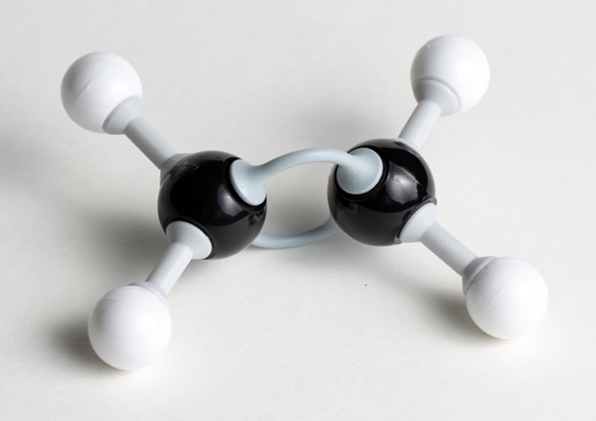 | __________________  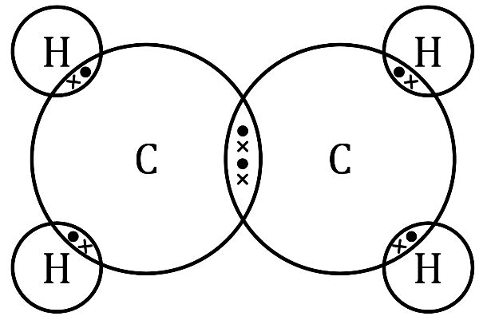

- Add the correct term into the box provided for each of the statements in the table.
Suffix used for the names of alkenes
General formula for the alkenes homologous series
Functional group of alkenes
Number of carbon atoms in a molecule of propene
Name of the alkene containing four carbon atoms
Molecular formula of ethene

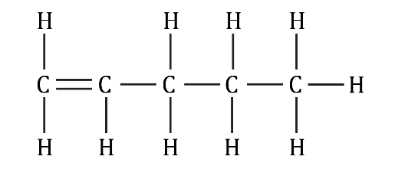
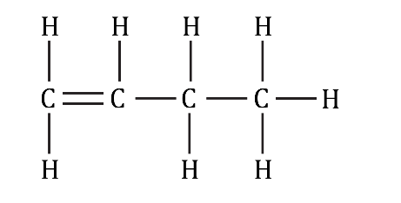
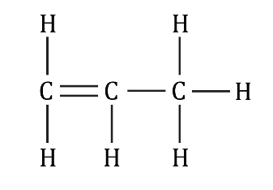
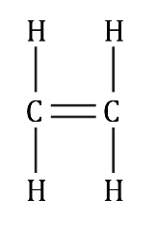
- Complete the table by using the displayed formulas provided and adding the molecular formula.
Name | Molecular formula | Displayed formula
ethene
propene
butene
pentene

- Add the correct terms to complete the gaps in the sentences.
Like alkanes, alkenes react with oxygen in __________________ reactions.
Unlike alkanes, alkenes tend to combust with smoky flames due to __________________ combustion.
The double C=C bond in alkenes makes them __________________ reactive than alkanes.
Atoms can be added across the C=C bond, so that the C=C bond becomes a __________________ bond. These are called __________________ reactions.
For example, hydrogen gas reacts with ethene to produce __________________, as shown in the equation:
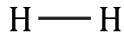
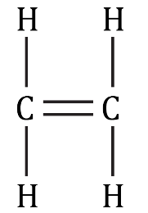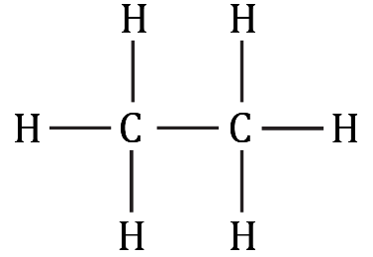
+
→
hydrogen __________________ ethane

Alkenes: test myself
- Which two compounds are real alkenes?
propane butane pentene
ethane methene ethene
- What is the molecular formula of the alkene that contains six carbon atoms?

- What conditions are required for an addition reaction between ethene and hydrogen?

- Chlorine gas reacts with propene in an addition reaction. Draw the displayed formula of the product formed in this reaction.

- What is the name of the product formed in question 2.4?

- The equation represents ethene reacting with water.
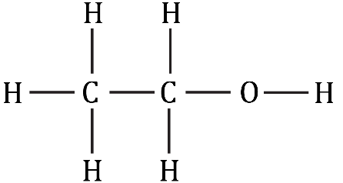
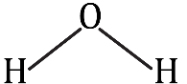
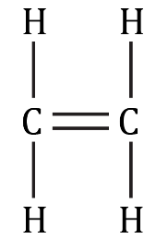
+
→
  - What type of reaction is represented by this equation?

  - What is the name of the product formed in this reaction?

- What conditions are required when ethene reacts with water?

- Complete the balanced symbol equation representing the incomplete combustion of propene, $C_{3}H_{6}$.

____________ + ____________ $O_{2}$ → ____________ CO + ____________

Alkenes: feeling confident?
- When ethene gas, $C_{2}H_{6}$, is bubbled into bromine water, ${Br}_{2}$, an addition reaction happens and the bromine water turns colourless.
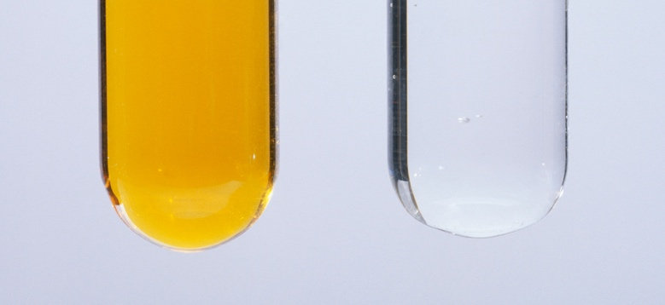
© Andrew Lambert Photography/Science Photo Library

  - Use displayed formulas to produce the equation representing this reaction.
  - Name the product formed in this reaction.

- Describe and explain what happens when alkanes, such as ethane, are added to bromine water.
In your answer you should state whether the alkanes will decolourise bromine water and explain why/why not.

Alkenes: what do I understand?
Think about your answers and confidence level for each mini-topic. Decide whether you understand it well, are unsure or need more help. Tick the appropriate column.
Mini-topic | I understand  this well | I think I understand this | I need more  help
I can describe alkenes as a homologous series.
I can identify the general formula and functional group of alkenes.
I can write molecular formulae and draw displayed formulae of alkenes.
I can describe and write equations to represent the combustion reactions of alkenes.
I can describe the addition reactions of alkenes with hydrogen, water and halogens.
I can state the conditions needed for the addition reactions of alkenes.
Feeling confident? topics | I understand  this well | I think I understand this | I need more  help
I can write an equation to represent the decolourisation of bromine water.
I can explain why alkanes do not decolourise bromine water.

