Alkenes: knowledge check
- The images show two different ways of representing an ethene molecule.
Use the terms provided to label the two diagrams. Some of the terms may be used more than once.
double covalent bond carbon atom hydrogen atom
ball and stick dot and cross
__________________ model  __________________  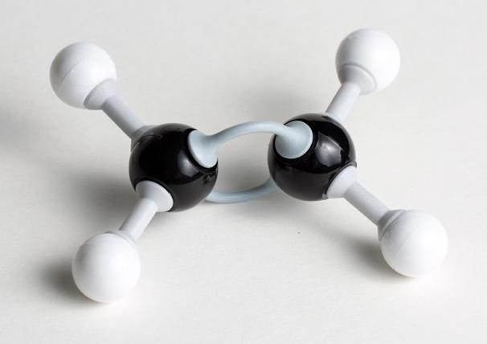  _______________ _______________ | __________________ diagram  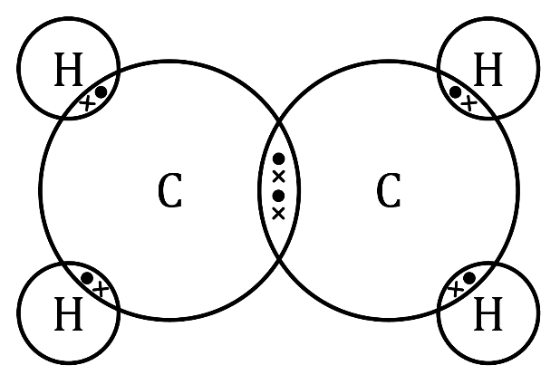  __________________  _______________ _______________

- Some of the terms listed match to the statements in the table.
C=C C=O $C_{2}H_{4}$ two $C_{n}H_{2n+2}$
-ene butene $C_{3}H_{6}$ three $C_{n}H_{2n}$
Add the correct term into the box provided for each statement. Some terms will not be used.
Suffix used for the names of alkenes
General formula for the alkenes homologous series
Functional group of alkenes
Number of carbon atoms in a molecule of propene
Name of the alkene containing four carbon atoms
Molecular formula of ethene

- Complete the table using the molecular formulas and displayed formulas provided.
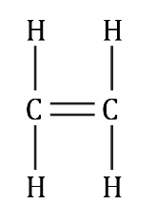
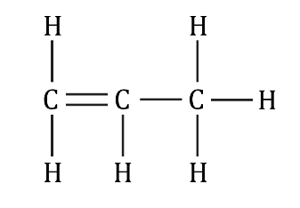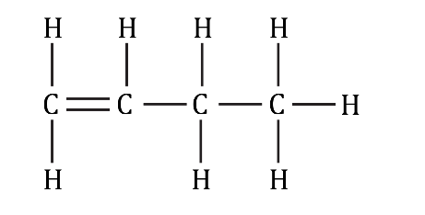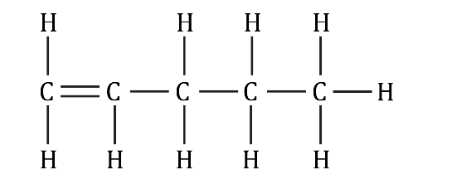
$C_{4}H_{8}$ $C_{2}H_{4}$ $C_{3}H_{6}$ $C_{5}H_{10}$
Name | Molecular formula | Displayed formula
ethene
propene
butene
pentene

- Use some of the words provided to complete the gaps in the sentences.
ethane incomplete C–O addition
more combustion C–C ethanol less
complete ethene
Like alkanes, alkenes react with oxygen in __________________ reactions.
Unlike alkanes, alkenes tend to combust with smoky flames due to __________________ combustion.
The double C=C bond in alkenes makes them __________________ reactive than alkanes.
Atoms can be added across the C=C bond, so that the C=C bond becomes a __________________ bond. These are called __________________ reactions.
For example, hydrogen gas reacts with ethene to produce __________________, as shown in the equation:
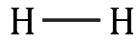
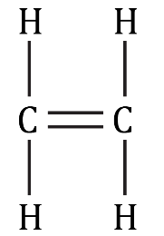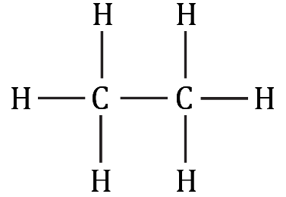
+
→
hydrogen __________________ ethane

Alkenes: test myself
- Which two compounds are real alkenes?
propane butane pentene
ethane methene ethene
- What is the molecular formula of the alkene that contains six carbon atoms? Hint: Remember, alkenes are hydrocarbons.

- What conditions are required for an addition reaction between ethene and hydrogen?
Hint: Think about what has to happen to the ethene during the addition reaction.

- Chlorine gas reacts with propene in an addition reaction. Which of the images shows the correct displayed formula of the product formed in this reaction?
A  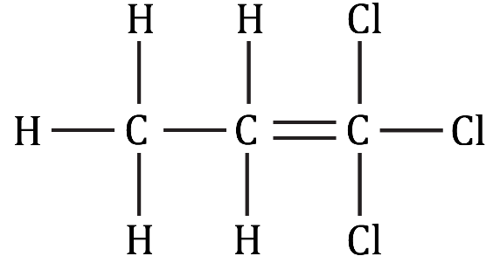 | B  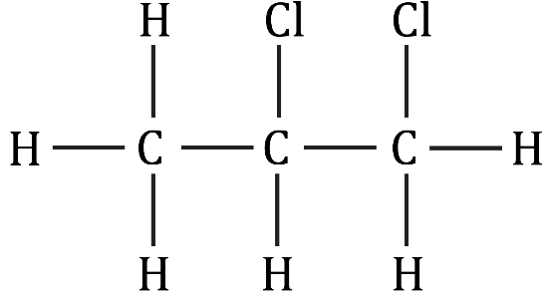
C  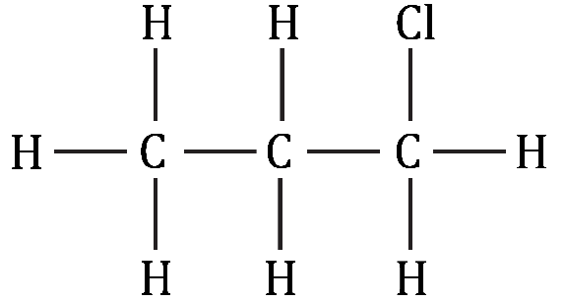 | D  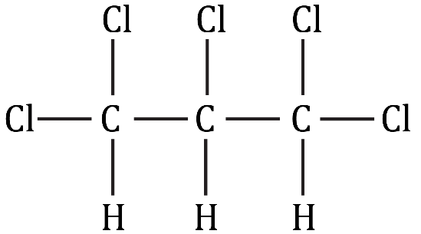
- What is the name of the product formed in question 2.4?

- The equation represents ethene reacting with water.
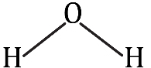
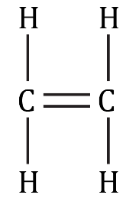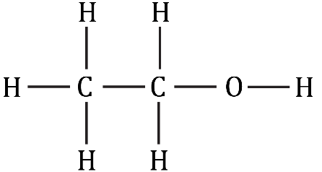
+
→
  - What type of reaction is represented by this equation?
Hint: Think about the number of products formed.

  - What is the name of the product formed in this reaction?
Hint: Look for any functional groups present.

- What conditions are required when ethene reacts with water?
Hint: Think about temperature, pressure and whether a catalyst is used.

- Use some of the numbers and formulas provided to complete the balanced symbol equation representing the incomplete combustion of propene.
The numbers may be used more than once.
3 $CO_{2}$ 4 $H_{2}O$ OH C $H_{2}$ 6
$C_{3}H_{6}$ + ____________ $O_{2}$ → ____________ CO + ____________

Alkenes: feeling confident?
- When ethene gas is bubbled into bromine water, an addition reaction happens and the bromine water turns colourless.
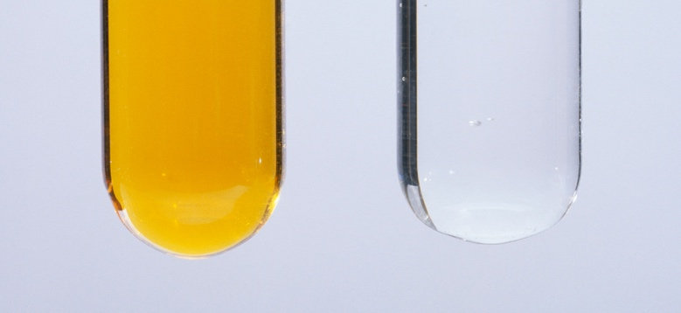
© Andrew Lambert Photography/Science Photo Library

  - Use displayed formulas to produce the equation representing this reaction.
→
+
Br – Br

  - Name the product formed in this reaction.

- Describe and explain what happens when alkanes, such as ethane, are added to bromine water.
In your answer you should state whether the alkanes will decolourise bromine water and explain why/why not.

Alkenes: what do I understand?
Think about your answers and confidence level for each mini-topic. Decide whether you understand it well, are unsure or need more help. Tick the appropriate column.
Mini-topic | I understand  this well | I think I understand this | I need more  help
I can describe alkenes as a homologous series.
I can identify the general formula and functional group of alkenes.
I can write the molecular formulae and draw displayed formulae of alkenes.
I can describe and write equations to represent the combustion reactions of alkenes.
I can describe the addition reactions of alkenes with hydrogen, water and halogens.
I can state the conditions needed for the addition reactions of alkenes.
Feeling confident? topics | I understand  this well | I think I understand this | I need more  help
I can write an equation to represent the decolourisation of bromine water.
I can explain why alkanes do not decolourise bromine water.

