Thin-layer chromatography and analgesics

Learning objectives
- Use thin-layer chromatography (TLC) to separate and identify the components in over-the-counter analgesics.
- Apply an understanding of the relative polarities of functional groups and how this affects their attraction to the stationary and mobile phases to predict how the R_{f} values of different compounds compare.

This activity is suitable for 16–18-year-old learners who are studying modern analytical techniques. It provides an opportunity for them to develop the experimental skills associated with TLC set within a familiar context; the ingredients in over-the-counter analgesics.

Follow-up questions 1–3 assess learners’ understanding of the experimental technique. Question 4 and the extension task require learners to be familiar with the common organic functional groups. Learners are challenged to consider the properties of the groups, specifically their effect on the overall polarity of the molecule and the impact this has on the molecule’s R_{f} value.

Use this activity either as a stand-alone experiment on the technique of chromatography or towards the end of a 16–18 organic course as a synoptic activity introducing how organic molecules are used in medicinal chemistry.

Introduction

Introduce the activity by discussing the use of painkillers and their other effects: antipyretic, anti-inflammatory and antirheumatic.

Establish which brands are most commonly used and use these in the analysis.

To get the most from the practical it is recommended that one of the analgesics for analysis is one that is known to contain either caffeine or aspirin or is a mixture of both.

Apparatus
- TLC plate – if the spots are to be viewed under a UV light, the coating must include a fluorescent indicator
- Pencil
- Test tubes in a stand along with a method of labelling the test tubes
- Capillary tubes for use as micropipettes
- Chromatography chamber; either a screw top jar tall enough to take the TLC plate, a small beaker with a Petri dish for a lid or a commercial tank
- Access to a fume cupboard or short wavelength UV lamp (around 254 nm) and UV safety screens

Chemicals
- Dissolving solvent (1:1 mixture of ethanol and dichloromethane)
- Aspirin reference solution: 1 g aspirin in 20 cm³ dissolving solvent
- Caffeine reference solution: 1 g caffeine in 20 cm³ dissolving solvent
- Sample analgesic tablets to be analysed
- Ethyl ethanoate as the mobile phase
- Iodine crystals (if using as alternative to UV lamp)

Safety and hazards
- Read our standard health and safety guidance rsc.li/4411Q9b.
- Wear safety goggles
- Ethanol – DANGER highly flammable liquid and vapour, make sure there are no naked flames of other sources of ignition (see CLEAPSS Hazcard HC040a)
- Dichloromethane – WARNING causes skin and serious eye irritation, may cause respiratory irritation, may cause drowsiness or dizziness. Avoid breathing vapour and avoid contact with skin and eyes, ensure laboratory is well ventilated (see CLEAPSS Hazcard HC028)
- Ethyl ethanoate – DANGER highly flammable liquid and vapour; causes serious eye irritation; the vapour may cause drowsiness or dizziness and may irritate the eyes and respiratory system (see CLEAPSS Hazcard HC043a)
- Iodine – WARNING harmful in contact with the skin and by inhalation. Very harmful to aquatic organisms. Avoid breathing vapour and avoid contact with the skin and eyes – use a fume cupboard if possible (see CLEAPSS Hazcard HC054)
- Short wave UV may cause skin cancer and eye damage. Ensure the aperture is fixed and directed away from eyes and skin. Avoid reflections from shiny surfaces. Use ultraviolet safety screens to screen the viewer from direct radiation. Consult CLEAPSS (GL127) or your local science safety advisory service for more details.

Conclusions

Analgesics containing aspirin should produce a spot corresponding to the known aspirin reference.

Analgesics containing caffeine should produce a spot corresponding to the known caffeine reference.

Any spots not corresponding to aspirin or caffeine represent other medicines such as ibuprofen and paracetamol.

Answers to questions
- The TLC plate must be handled only by the edges to prevent contamination. Touching the coated surface may introduce unwanted substances or oils from fingers which can interfere with the separation process and compromise the analysis.

- It is necessary to place a lid on the chromatography chamber to prevent the mobile phase from evaporating and to create a saturated atmosphere within the chamber of the solvent vapour.

To help create the saturated atmosphere it is good practice to place a piece of filter paper around the inside edge of your chromatography chamber. When the mobile phase is first added, swirl the mobile phase within the chamber to soak the filter paper.

- The R_{f} value is a measure of how far the compound has travelled relative to the solvent front. This varies depending on the stationary and mobile phases. Therefore, if an R_{f} value is to be used to identify an unknown by comparison to data book values, the nature of the stationary and mobile phase must be known.

- Similarities; both contain a benzene ring, both contain a carbonyl group

Differences; Aspirin contains a carboxylic acid and an ester group whereas paracetamol contains a hydroxyl group and an amide. These differences in the structures of the two molecules mean that they act on different systems in the body.

- The hydroxyl group and the amide group are responsible for the polarity of paracetamol. Both can form hydrogen bonds. In comparison, in aspirin only the carboxylic acid group can form hydrogen bonds.
- Since paracetamol is a more polar compound than aspirin it will have a stronger attraction to the stationary phase, the spot will be lower than aspirin and hence will have a lower R_{f} value.

Extension

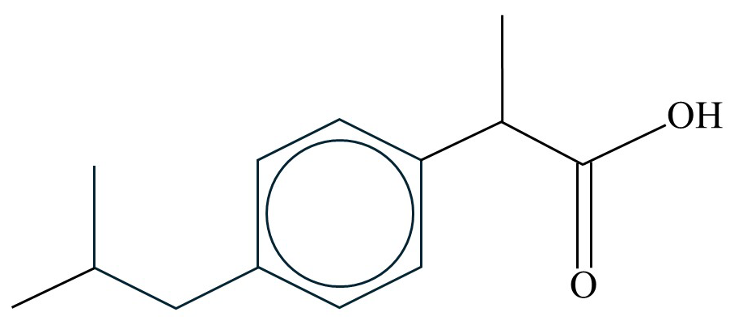

Ibuprofen

(±)-2-(4-isobutylphenyl)propionic acid

The only polar group in ibuprofen is the carboxylic acid. It also has a large non-polar group in the 2-methylpropyl group attached to the benzene ring. This means it is a less polar compound than both aspirin and paracetamol. As a result, it will travel further on a TLC plate and have a larger R_{f} value.

