Thin-layer chromatography and analgesics

Learning objectives
- Use thin-layer chromatography (TLC) to separate and identify the components in over-the-counter analgesics.
- Apply an understanding of the relative polarities of functional groups and how this affects their attraction to the stationary and mobile phases to predict how the R_{f} values of different compounds compare.

Introduction

The range of over-the-counter analgesics (painkillers) is extensive. Although some analgesics such as paracetamol contain just one active ingredient, others contain a mixture of two or more active ingredients for greater efficacy (the desired effect of pain relief).

Many analgesics contain functional groups that you will be familiar with from your studies. The shape and polarity of these functional groups affects how each analgesic interacts with the stationary and mobile phases in chromatography.

In this activity you will use TLC to separate and identify the components in two over-the-counter analgesics.

Apparatus
- A TLC plate and a pencil
- Test tubes in a stand, along with a method of labelling the test tubes
- Capillary tubes for use as micropipettes
- Chromatography chamber; either a screw top jar tall enough to take the TLC plate, a small beaker with a Petri dish for a lid or a commercial tank
- Access to a fume cupboard and/or short wavelength UV lamp.

Chemicals
- Dissolving solvent – 1:1 mixture of ethanol (DANGER highly flammable liquid and vapour) and dichloromethane (WARNING causes skin and serious eye irritation, may cause respiratory irritation, may cause drowsiness or dizziness)
- Reference solutions of aspirin and caffeine
- Sample analgesic tablets to be analysed
- Ethyl ethanoate as the mobile phase (DANGER highly flammable liquid and vapour; causes serious eye irritation; the vapour may cause drowsiness or dizziness and may irritate the eyes and respiratory system)
- Iodine crystals (WARNING harmful in contact with the skin and by inhalation. Very harmful to aquatic organisms)

Safety and hazards
- Wear safety goggles
- Make sure there are no naked flames or other sources of ignition
- Avoid inhaling fumes – ensure laboratory is well ventilated
- Handle all chemicals with care to avoid skin contact
- When viewing the TLC plate in UV light, make sure this is through a UV safety screen, taking care that the light is fixed and directed away from eyes and skin, and to avoid reflections from shiny surfaces before it is turned on

Method

Make sure that you do not touch the surface of the TLC plate with your fingers during this activity. Handle the plate only by the edges and use tweezers if possible.

Preparation of analgesic samples to be analysed

- Place half a tablet of each of the samples to be analysed on a piece of paper and crush it with a spatula.

- Transfer the sample to a small, labelled test tube and add 5 cm³ of the dissolving solvent.

- Warm gently in a warm water bath (35°C) to dissolve as much of the tablet as possible. Any residue is likely to be a binding agent: allow it to settle for a few minutes and use the clear solution from above any residue for sampling.

Analysis
- Take a TLC plate and place it powder side up on a clean flat surface. Using a pencil (not a biro or felt tip pen) lightly draw a line across the plate about 1 cm from the bottom. Mark off four equally spaced points, leaving an equal space between the end points and edge of the plate.
- You are provided with reference solutions which contain aspirin and caffeine respectively. Use two of the capillary tubes to spot samples of these reference solutions onto the first two points on the TLC plate. Allow the spots to dry and then repeat three more times. The spots should be about 1–2 mm in diameter. Label the spots ‘aspirin’ and ‘caffeine’.
- Using the same procedure described in step 2, spot a sample of each of the analgesic samples to be analysed onto the remaining two points on your TLC plate. Label each spot with the name of the analgesic.
- When all the spots are dry, place the TLC plate in the chromatography chamber, making sure that the original pencil line is above the level of the mobile phase – ethyl ethanoate. Put a lid on the tank and allow it to stand until the solvent front has risen to within a few millimetres of the top of the plate.
- Remove the plate from the chamber and quickly mark the position of the solvent front. Allow the plate to dry.
- Observe the plate under a short wavelength UV lamp through a UV safety screen and record the result by photographing or pencil.
- Place the TLC plate in a jar or beaker containing a few iodine crystals. Put a cover on the jar and warm gently on a steam bath until spots begin to appear. Do this in a fume cupboard if possible.

Conclusions

Draw an accurate diagram of your TLC plate to show how your results appear under UV light and in iodine. Write the name of the stationary phase and mobile phase alongside your diagram. Record the R_{f} values of aspirin and caffeine to two decimal places.

Which of the analgesic tablets tested contain aspirin, which contain caffeine and which, if any, contain other compounds?

Reflect on your analysis. Did you include the correct amount of each sample for it to be visible on the plate? Were your spots distinct? How might you change your experimental technique if you were to repeat the analysis?

Questions
- Why was it important to handle the TLC plate only by its edges throughout this activity?

- What was the purpose of the lid on the chromatography chamber?

- Why is it important to always record the stationary and mobile phases used when recording R_{f} values?

- Another common over-the-counter analgesic is paracetamol.

The structures of aspirin and paracetamol are shown overleaf:

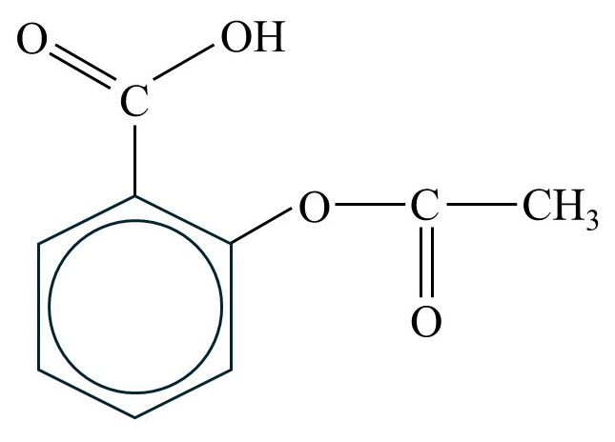 | 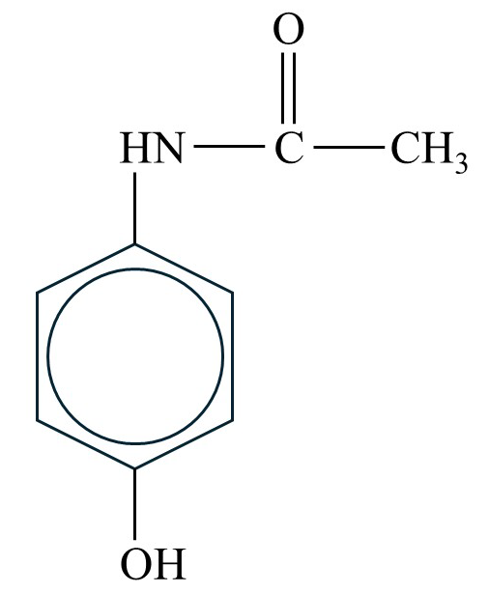
Aspirin  2-ethanoyloxybenzenecarboxylic acid | Paracetamol  N-(4-hydroxyphenyl)ethanamide

- Look at the chemical structures of aspirin and paracetamol. How are they similar? How are they different?
- Paracetamol is a more polar compound than aspirin.
- Which functional group(s) in its structure makes it polar?
- In TLC, the stationary phase is more polar than the mobile phase. A sample of aspirin and a sample of paracetamol were analysed next to each other on the same TLC plate. Predict where the spot containing paracetamol would appear on the TLC plate compared to aspirin and therefore how the R_{f} value for paracetamol would compare to that for aspirin. Explain your answer.

Extension

Another common analgesic is ibuprofen.

Draw the skeletal formula for ibuprofen and identify the functional group(s) in the molecule.

How do you think its polarity compares to that of aspirin and paracetamol? How would you expect the R_{f} value of ibuprofen to compare with (i) aspirin and (ii) paracetamol?

