What happens when something dissolves?

Learning objectives
- Recall the structure of particle diagrams for solids and liquids.
- Describe how particles of the solid are dispersed throughout the liquid during dissolving.
- Describe the process of diffusion during dissolving and explain why this is evidence of the movement of particles in a liquid.

Introduction

If a solid (solute) is soluble in a liquid (solvent) it can dissolve to form a solution. An example of this is a saltwater solution, where salt has dissolved in water. This forms a colourless solution.

On a particle level, when a solution is created, the soluble particles fit into the gaps between the solvent particles.

Starter activity

Write a brief description of the arrangement of particles in a liquid (water) and in a solid (salt).

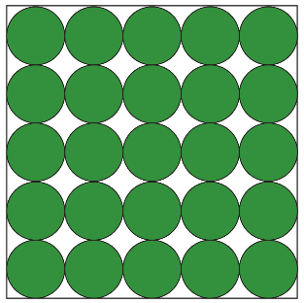
In a solid, the particles are:
____________________________________________________________________________________________________________________________________________________________________________________________________________________________________

In a liquid, the particles are:
____________________________________________________________________________________________________________________________________________________________________________________________________________________________________

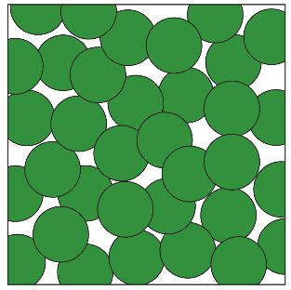

Teacher demonstration

You will observe your teacher adding potassium manganate(VII) crystals to a beaker of water. As you observe this, complete the table below to record your observations.
Chemical | Observations
Chemical | Before | During | After
Water
Potassium manganate

Class practical

You will work in pairs for this practical.

Equipment

- 3 x test tubes
- Test tube rack
- Water
- Spatula
- White card to provide a background
- A pea-size quantity of each of the following:
- salt
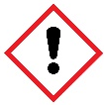
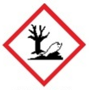
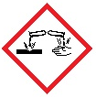
- sugar
- copper(II) sulfate crystals

Safety and hazards
- Wear eye protection – safety glasses.
- Copper(II) sulfate is harmful if swallowed, causes skin irritation and causes serious eye damage.
- Do not remove crystals of hydrated copper(II) sulfate from the laboratory.
- Copper(II) sulfate is very toxic to aquatic life with long lasting effects. Follow instructions for disposal very carefully.

Method
- Fill the test tubes one-third full of water.
- Carefully add the sugar to one test tube.
- Carefully add the salt to the second test tube.
- Carefully add the copper(II) sulfate to the third test tube.
- Shake each test tube gently and observe any changes.

Diagram
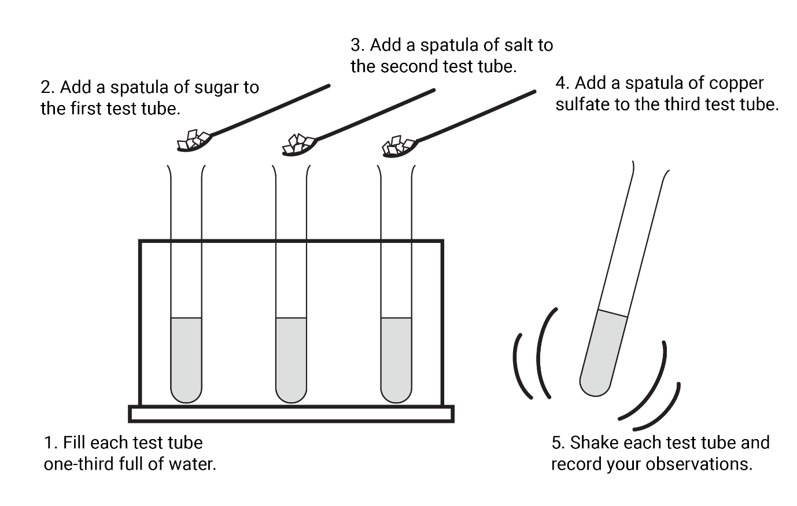

When sugar is added to water and shaken gently
Chemical | Observations
Chemical | Before | During | After
Water
Sugar

When salt is added to water and shaken gently
Chemical | Observations
Chemical | Before | During | After
Water
Salt

When copper(II) sulfate crystals are added to water and shaken gently
Chemical | Observations
Chemical | Before | During | After
Water
Copper(II) sulfate crystals

Describing your observations

When salt or sugar is added to water and shaken gently
- Draw particle diagrams to show what happens when a soluble solid (salt or sugar) dissolves in this liquid (water). 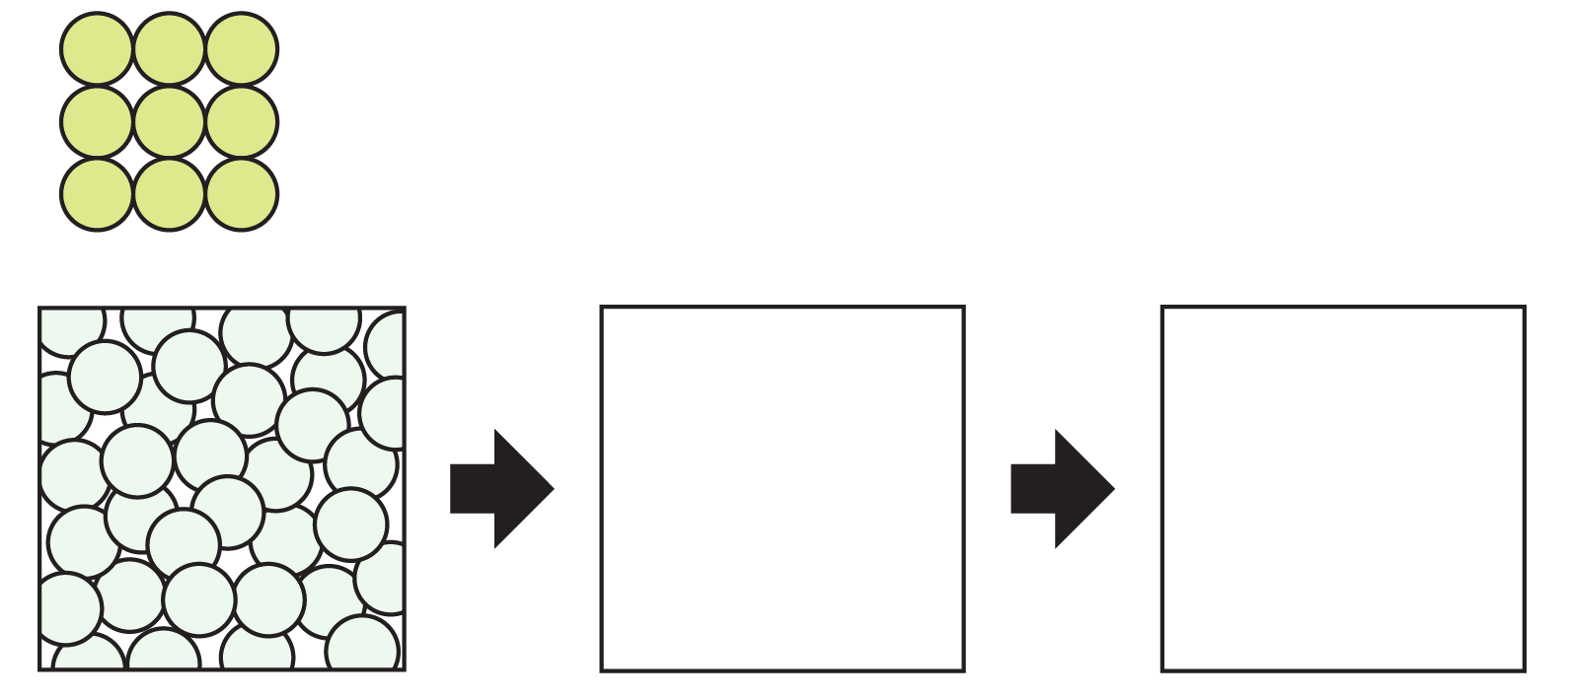

- Explain your observations of salt and water in terms of particles.

__________________________________________________________________________________________________________________________________________________________________________________________________________________________________________

When copper sulfate crystals are added to water and shaken gently
- Using the information above to support you, explain your observations of copper sulfate crystals and water in terms of particles.

________________________________________________________________________________

________________________________________________________________________________

________________________________________________________________________________

________________________________________________________________________________

________________________________________________________________________________

________________________________________________________________________________

Challenge – extension task

The diagrams below show particle diagrams for two different solids, A and B, when they are added to water.

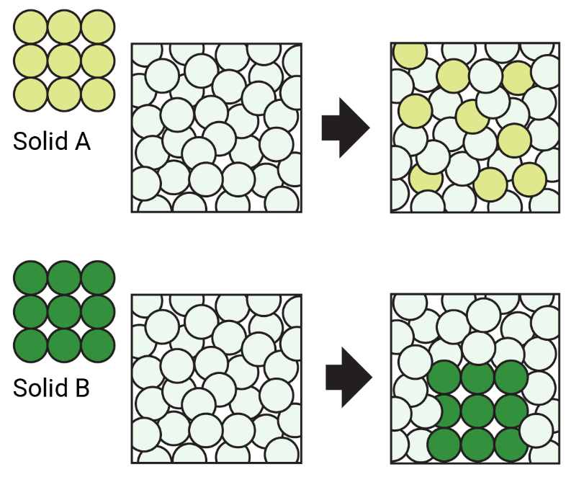

Explain what is happening based on the particle diagrams and describe what you might see if you completed this practical in your classroom.

________________________________________________________________________________

________________________________________________________________________________

________________________________________________________________________________

________________________________________________________________________________

________________________________________________________________________________

________________________________________________________________________________

________________________________________________________________________________

