What happens when something dissolves?

This resource is from the Assessment for learning series which can be viewed at: rsc.li/44jTX18. This series contains lesson plans and associated resources that include formative assessment to actively involve students in their learning.

Resource components
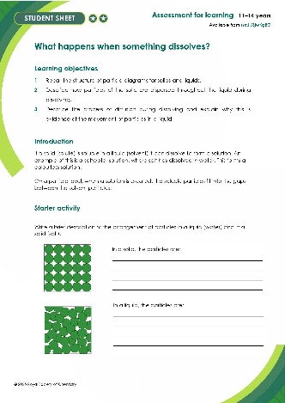 | 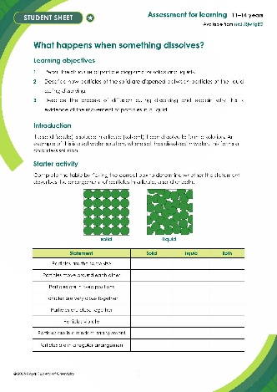 | 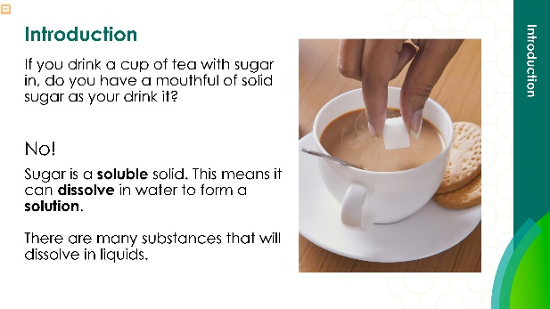
Student sheet: a worksheet including the method, tables to record observations and follow-up questions | Scaffolded student sheet: a worksheet containing additional prompts and scaffolded questions including word-fill | Presentation: lesson slides to guide learners through the demonstration, class practical and follow-up questions, including answers for self-assessment

Learning objectives
- Recall the structure of particle diagrams for solids and liquids.
- Describe how particles of the solid are dispersed between particles of the liquid during dissolving.
- Describe the process of diffusion during dissolving and explain why this is evidence of the movement of particles in a liquid.

Learners should be able to link observations from a practical to the theory of dissolving using particle models to support them (student activity 1 and 2).

Introduction

In this lesson, learners will interpret the information they gain from practical work. They will observe some simple practical demonstrations and use a question sheet to help them think about the process of dissolving, dispersal and diffusion.

The lesson provides an opportunity for learners to:
- observe some physical changes and describe them fully
- think about the process of dissolving, dispersal and diffusion and use their knowledge of the particle model to explain their observations

Scaffolding

The scaffolded worksheet () provides extra support for learners, giving them hints for the observations, opportunities to select answers from a range of given responses and completion of a gap fill task.

At the end of the unscaffolded () sheet there is a challenge/extension task looking at the difference between soluble and insoluble substances to stretch learners’ understanding.
Integrated instructions are available in the PowerPoint presentation. Use these as an alternative to written instructions to reduce cognitive load.

If necessary, spend some time recapping the particle model for solids, liquids and gases. You can find resources to prepare, deliver, assess and enrich the Particle model topic for 11–14 learners here: rsc.li/3jwKgBO

Depending on when you use this activity, learners may be familiar with the terms, solvent, solute and solution, in which case you could use them here. A list of some key terms is included in the PowerPoint presentation. You can find more support for literacy and vocabulary in our Key terms support bundle for the Particle model topic (11–14), available to download from: rsc.li/4cmvSbS

Sequence of activities

Introduction (slides 2–5)
- Introduce the idea of dissolving with the discussion question ‘If you drink a cup of tea with sugar in, do you have a mouthful of solid sugar as your drink it?’ (slide 2)
- In pairs, ask learners to write a brief description of the arrangement of particles in a solid (salt) and in a liquid (water)(slide 4). Learners can also answer this question on the student sheet using either the scaffolded (tick boxes) or unscaffolded version.
- Self-assess the answers to the starter question using the answers on slide 5.

Teacher demonstration (slides 7–10)
- Demonstrate what happens when crystals of potassium manganate(VII) are added to water using the teacher demonstration outlined on page 4 of this document.
- Tell learners that they should make notes about what the mixture looks like and how it changes before, during and after dissolving is complete.
- Allow learners to share their ideas in pairs. Person 1 presents their ideas. Person 2 actively listens and responds by agreeing, disagreeing or building on this point.
- Select a few groups to give feedback to the class. Write down any ideas and/or misconceptions learners have and save these for later reference.

Class practical (slides 11–17)
- Give each learner a copy of the student sheet which includes the method, tables for observations and follow-up questions.
- Supervise learners as they:
- work in pairs to follow the practical instructions
- record their results in the table on the worksheet
- When the practical has finished, prior to starting the next task, make sure that all learners have the correct answers in their table. Take answers from learners to fill out the table on the PowerPoint. This will ensure that all learners are starting a written task with the same information.

Follow-up questions (slides 18–22)
- Circulate and support learners as they work in pairs to draw particle diagrams to show what happens when a soluble solid (salt) dissolves in this liquid (water) and write an explanation of their observations from salt and water in terms of particles.
- Ask learners to work individually to explain their observations for copper sulfate and water.
- Circulate to support learners and check their answers before allowing them to self-assess or peer-assess using the answers from the PowerPoint slide. Remind learners to tick key points and note or highlight any missing ideas following your own marking policy.

Worksheet: mass and dissolving (slide 23)
- Give each learner a copy of the Chemical misconceptions worksheet ‘Mass and dissolving’. Available from: rsc.li/3Nsm7wF
- This can be completed in class or as a homework activity.

Technician notes

In this resource there is a teacher demonstration of potassium manganate(VII) dissolving in water and a whole class practical where learners dissolve small quantities of salt, sugar and copper sulfate in water and record their observations.

Read our standard health and safety guidance (rsc.li/3iFPxff) and carry out a risk assessment before running any live practical.

Teacher demonstration

Equipment
- A 1000 ml beaker
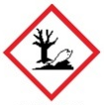
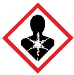
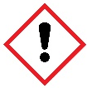
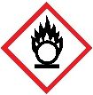
- Water
- Several crystals of potassium manganate(VII).
DANGER Irritant, oxidiser, harmful if swallowed.
Very toxic to aquatic life with long-lasting effects.
Members should refer to CLEAPPS Hazcard HC081, SSERC or your local science safety advisory service.
- White card to provide a background

Safety and hazards
- Wear eye protection even when dilute solutions are used
- Avoid raising dust when using the solid
- Take particular care to avoid skin contact. If spilt on skin/clothes, quickly brush off as much dry solid as possible. Irrigate with plenty of water
- Solid/solutions stain skin brown. Skin stains gradually fade over time

Procedure
- Fill the beaker two-thirds full of water.
- Carefully add the crystals of potassium manganate(VII).
- Leave and observe at regular intervals during the lesson.

Disposal

Dissolve no more than 5 g of the solid in 1 litre of water.

Then, add one of the following reducing agents, in portions while stirring, until the solution becomes colourless:
- sodium metabisulfite (approx 10 g), use a fume cupboard as sulfur dioxide gas may be produced
- iron(II) sulfate-7-water (approx 40 g)

Pour the resulting mixture down a foul-water drain with further dilution

Student practical

Equipment (per pair)
- 3 x test tubes
- Test tube rack
- Water
- Spatula
- Half a spatula of each of the following:
  - sugar
  - salt (sodium chloride)
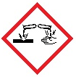
- copper(II) sulfate crystals.
DANGER
Irritant (skin), corrosive (eyes), harmful if swallowed.
Very toxic to aquatic life with long-lasting effects.
Members should refer to CLEAPPS Hazcard HC027c, SSERC or your local science safety advisory service.
- White card to provide a background

Safety and hazards

Wear safety glasses even when dilute solutions are used.

Procedure
- Fill the test tubes one-third full of water.
- Carefully add the sugar to one test tube.
- Carefully add the salt to the second test tube.
- Carefully add the copper(II) sulfate to the third test tube.
- Shake each test tube gently and observe any changes.

Answers: Describing your observations

When salt (or sugar) is added to water and shaken gently
- Solid: particles are the same size, fixed position, vibrate, regular pattern, particles are touching. Liquid: particles are the same size, move around each other, irregular pattern/randomly arranged, particles are touching.

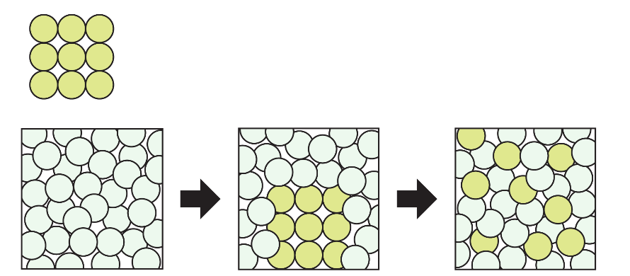
- As a solid, there are enough particles of salt packed close together to see as a white solid.

When salt is added to water, the salt particles move apart from each other and disperse, as the water particles move into the space between them. This can be seen as the crystals get smaller.

The particles then spread out through the water by diffusion. This can be seen as we can no longer see white crystals.

When copper sulfate crystals are added to water and shaken gently
- As a solid, there are enough particles of copper sulfate packed close together to see as blue crystals.

When copper sulfate is added to water, the particles in copper sulfate move apart from each other and disperse. This can be seen through the movement of blue colouring into the water as it dissolves and by the crystals getting smaller.

The particles then spread out through the water by diffusion. This can be seen through the solution turning blue.

Challenge – extension task

For solid A, there are enough particles of solid packed closely together to see prior to addition to the water. When it is added to water, the space between the particles in solid A grows as they are separated into smaller pieces. This can be seen as the crystals get smaller. The particles then spread out through the water by diffusion. This can be seen as we would no longer be able to see solid A in the water. This means that solid A is soluble.

For solid B, there are enough particles of solid packed closely together to see prior to addition to the water. When it is added to water, the particles remain together and the space between them does not increase. This is because solid B doesn’t dissolve in water. It is insoluble.

For answers to the worksheet ‘Mass and dissolving’, please visit: rsc.li/3Nsm7wF

