Viscosity

This resource is part of our extensive collection of practical chemistry experiments edu.rsc.org/resources/practical. Student sheets and classroom slides are also available from rsc.li/3VP1KMT

Resource components
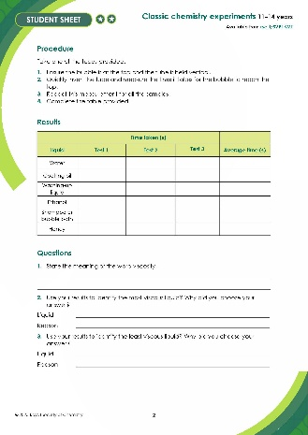 | 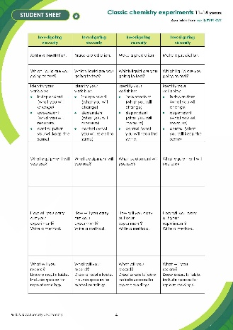 | 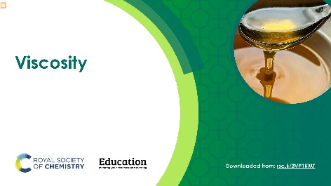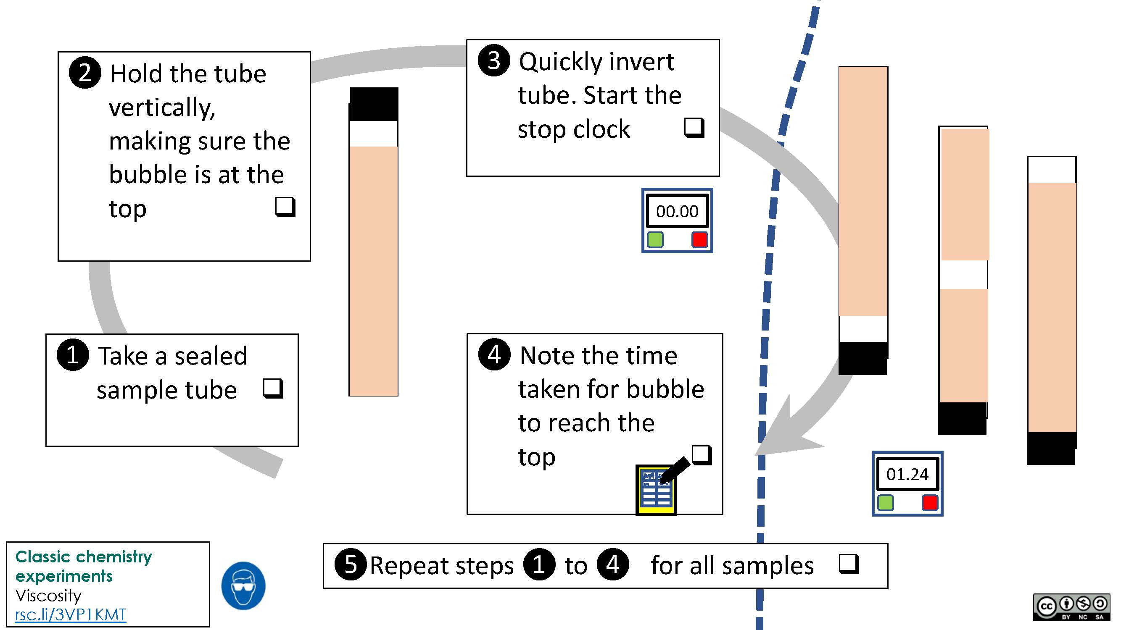
Standard student sheet: a written method, equipment list and diagram followed by questions with free-space for written answers. | Scaffolded student sheet: follow-up questions have more support including fill-in-the-gap style questions and a structure strip for longer written answers. | Presentation: lesson slides including starter activities, written method, integrated instructions and follow-up questions

Learning objectives
- Compare the viscosity of different liquids by making careful observations.
- Apply your understanding of particles to explain your observations.
- Design an experiment.

Learners will meet objectives 1 and 2 as they carry out the experiment, complete a results table and answer questions 1−3 on the student worksheet.

Learners will meet objective 3 by correctly answering questions 4−6 on the student worksheet.

Learners will meet objective 4 by answering questions 7 and 8 on the student worksheet.

Introduction

Provide learners with a set of identical tubes each containing a different liquid and instruct them to measure the time taken for a bubble to rise through the liquid. This is used to compare the viscosity of the liquids.

Scaffolding

There are two versions of the student worksheet:
- Level 1 ()offers additional scaffolding and support, such as fill-in-the gap style questions and a structure strip to help design an experiment;
- Level 2 () has similar questions but with free text answers.

Integrated instructions are included in the presentation.

Teaching notes

Start this lesson by finding out what learners already know about viscosity. Use the images provided on slide 3 of the presentation or pour a couple of different liquids into a beaker to promote discussion and make sure learners understand the term.

Ask learners to carry out the practical in small groups of two or three. Encourage learners to carry out repeat experiments and calculate the mean time for each liquid. For results to be repeatable, remind learners to time each liquid using a consistent method – e.g. measure the time from inversion until the ‘bubble first hits the top’. Remind learners how to work out the average time, if necessary.

Technician notes

Read our standard health and safety guidance and carry out a risk assessment before running any live practical: rsc.li/4oFZoih

Equipment (per group)

Apparatus
- Stopwatch
- Sealed tubes of different liquids

Chemicals

Choose from:
- Water
- Cooking oil
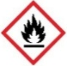
- Washing up liquid
- Ethanol (DANGER: highly flammable liquid and vapour)
- Shampoo or bubble bath
- Honey

Safety equipment
- Eye protection: safety glasses to EN166F

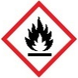
Safety and hazards
- Ethanol is flammable, ensure no naked flames or other sources of ignition
(see CLEAPSS Hazcard HC040a/SSERC)

Answers
- Level 1 and level 2 sheets

Viscosity is a measure of how difficult it is for a liquid to flow. Liquids with a higher viscosity appear to be ‘thicker’ or more ‘gloopy’ than those with a low viscosity.

- Level 1 and level 2 sheets

Liquid – it depends on the liquids used but is most likely to be the honey or shampoo.

Reason – the bubble took the longest time to rise through the liquid.

- Level 1 and level 2 sheets

Liquid − it depends on the liquids used but is most likely to be the ethanol.

Reason – the bubble took the shortest time to rise through the liquid.

- Level 2 sheet
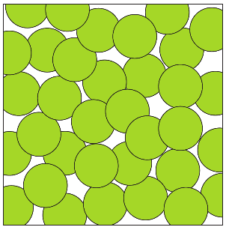
Level 1 sheet

C

- Level 1 and level 2 sheets

The particles slide over each other.
They flow from the bottle into the frying pan.

- Level 1 and level 2 sheets

Water is less viscous than bubble bath because there are less forces of attraction between the water molecules than those between the bubble bath particles. This makes it easier for the water molecules to flow than it is for the bubble bath particles.

- Level 1 and level 2 sheets

The viscosity will decrease. As the particles in the liquid gain more kinetic energy, it will be easier to overcome the forces of attraction between the particles.

- See structure strip

Answers
Investigating viscosity | Suggested answer/points to include
Write down a prediction. | I predict that the viscosity of a liquid will decrease as the temperature increases.
What liquid are you going to test? | Any of the liquids used in the previous experiment could be used.
Identify your variables:  - independent (what you will change)  - dependent (what you will measure)  - control (what you will keep the same) | Independent variable – temperature.  Dependent variable – time taken for the bubble to travel through the liquid.  Control variable – volume of liquid and bubble.
What equipment will you use?  Draw a diagram. | - Stopwatch  - Sealed tubes of chosen liquid  - Thermometer  - Water bath large enough to hold sealed tube  - Kettle to heat water
How will you carry out your experiment?  Write a method. | - Make a water bath by filling a tub with hot water from the kettle.  - Place the sealed tube in the water bath and record the temperature.  - Remove the sealed tube from the water bath and ensure the bubble is at the top and the tube is held vertical.  - Quickly invert the tube and measure the time it takes for the bubble to reach the top.  - Do at least two repeat readings.  - Replace the sealed tube in the water bath, add some cool water and record the temperature.  - Repeat steps 3−5 until you have readings at 5 different temperatures.
What will you record?  Draw a results table.  Include spaces for repeat readings.
  Temperature (ºC) | Time (s)
  Temperature (ºC) | Test 1 | Test 2 | Test 3

