Condensation polymerisation: teacher guidance
This resource forms part of the Review my learning series from the Royal Society of Chemistry. The worksheets assess learner’s understanding of content from common 11–14 and 14–16 curriculums. They can be used to identify knowledge gaps and misconceptions once that part of the curriculum has been taught.
The Condensation polymerisation worksheets cover the following topics:
- the differences between additional polymerisation and condensation polymerisation
- the functional groups of monomers used to make condensation polymers
- equations for reactions to produce polyesters using block diagrams
- equations for reactions to produce polyesters using structural formulas
- the equation for the reaction to produce nylon using block diagrams.
If learners successfully answer questions on these topics, they can attempt the extension questions. This requires learners to describe the experimental procedure of the nylon rope trick and to complete the equation for the reaction to produce Nylon 6,6 using structural formulas.
Scaffolding
Level 1 () is a scaffolded worksheet which supports learners in a variety of ways, such as selecting words from a word bank, providing answer options to choose from or completed examples. Level 2 () is a partially scaffolded worksheet with a reduced level of support, such as partially completed sentences or a wider range of answer options to select from. Level 3 () is an unscaffolded worksheet in which most of the tasks involve answering questions with a minimum of prompts.
Metacognition
The ‘What do I understand?’ page is common to all levels of worksheet and can be used both to identify areas needing whole class attention and as an indicator for learners to help guide their revision.
Below you will find model answers for each level and guidance on learners’ misconceptions. Learners can use the model answers to self- or peer assess.
When to use
The worksheets can be used in a variety of ways:
- to assess learners’ knowledge at the beginning or end of a period of teaching. Match the level of the worksheet to the support needs of the learners,
- to assess knowledge during a period of teaching and once learners have completed the relevant section of the specification,
- as part of revision,
- as a refresher exercise for teachers or non-subject specialists.
There is also scope for the level of the worksheets used to be increased as learners progress through their curriculum.
Further support
For more resources to support teaching of this topic and address any misconceptions identified, go to rsc.li/49Wgm4v.
Answers

Condensation polymerisation: knowledge check
- (Level 1, 2 and 3)
carboxylic acid functional group the rest of the molecule alcohol functional group
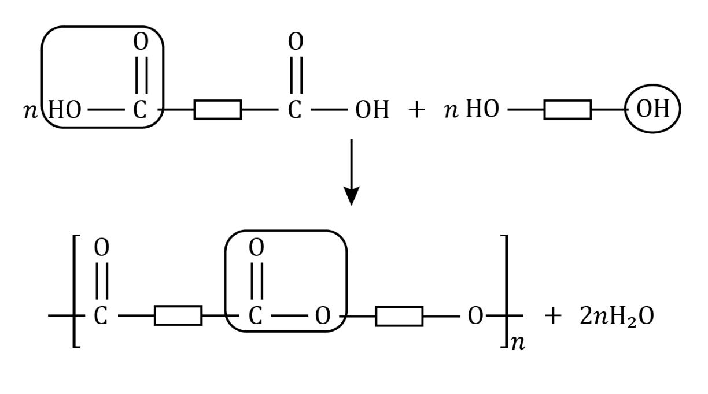
diol
a dicarboxylic acid

a polyester
ester functional group a large number
Guidance: Learners often forget that the equation needs two molecules of water, since one is produced from both ends of the monomers. Remind learners that they should always include the continuation bonds.

- (Level 1)
 | Addition polymerisation | Condensation polymerisation
The monomers contain double carbon covalent bonds. | ✔
The monomers only contain one functional group. | ✔
The monomers contain two functional groups. |  | ✔
Only one product is formed in the polymerisation process. | ✔
Two products are formed in the polymerisation process. |  | ✔
(Level 2 and 3)
 | Addition polymerisation | Condensation polymerisation | Both
The monomers contain double carbon covalent bonds. | ✔
The monomers used are small covalent molecules. |  |  | ✔
The monomers only contain one functional group. | ✔
The monomers contain two functional groups. |  | ✔
Only one product is formed in the polymerisation process. | ✔
Two products are formed in the polymerisation process. |  | ✔
The polymers formed are large covalent molecules. |  |  | ✔
Guidance: Learners often forget that both addition and condensation polymers are large covalent molecules. The monomers used to make them are small covalent molecules.

- (Level 1, 2 and 3)
Type of polymer produced from  $HOOC-CH_{2}-CH_{2}-COOH$ and $HO-CH_{2}-CH_{2}-OH$. | Polyester
The small molecule produced as well as the polymer. | Water
Type of monomer including two carboxylic acid functional groups. | dicarboxylic acid
Type of monomer including two alcohol groups. | diol
The short-form representation of  $HOOC-CH_{2}-CH_{2}-COOH$. | HOOC– –COOH
The short-form representation of $HO-CH_{2}-CH_{2}-OH$. | HO– –OH
Link formed between the two monomers. | ester functional group
Guidance: Many learners will be confused by the full structural formula of monomers. Showing step by step on a whiteboard how blocks are used to simplify the formulas may help. Learners may need prompts to recognise the ester functional group in this context.
- (Level 1, 2 and 3)
dicarboxylic acid; COOH; diamine; $NH_{2}$; polyamide; –CONH–
Guidance: Note that not all 14–16 specifications include polyamides. Amines are probably new to most learners and need explanation. Learners may not recognise that the repeating group of a condensation polymer contains atoms from both monomers.

Condensation polymerisation: test myself
- (Level 1, 2 and 3)
The true statement is B
- (Level 1)
polyester
(Level 2 and 3)
Addition polymers | Condensation polymers
poly(ethene)  poly(chloroethene)  poly(tetrafluoroethene)  poly(propene) | polyester  polyamide
Guidance: Learners may not recall examples of addition polymers and that the ‘ene’ suffix appears in their names.
- (Level 1, 2 and 3)

$HO-CH_{2}-CH_{2}-OH$ $HOOC-CH_{2}-COOH$
Guidance: Remind learners to think about the functional groups needed to make a condensation polymer.
- (Level 1, 2 and 3)
C/They have two functional groups.
Guidance: Learners may be confused because dicarboxylic acids contain double C=O bonds. Nylon can be used as an example to show that double bonds are not present in all monomers used to make condensation polymers.
- (Level 1, 2 and 3)
B/a molecule with two COOH groups
Guidance: Learners are probably familiar with the functional group of carboxylic acids. Reminding learners that ‘di’ means two should help.
- (Level 1, 2 and 3)
polyester
Guidance: This is a short section of the polymer in question 1.1. Learners may not recognise different ways of representing the polyester.
- (Level 1, 2 and 3)
amino acids
Guidance: An amino acid molecule has two different functional groups. One type of amino acid, such as glycine, can polymerise to form a polypeptide. The monomer molecules used to make the polyester and nylon have the same functional group at each end of the molecule. This may confuse some learners.

Condensation polymers: feeling confident?
- (Level 1, 2 and 3)
Step | Instruction
1 | C*
2 | E*
3 | A
4 | F
5 | D
6 | B

*The order of step 1 and 2 are interchangeable so C and E can be either way around in the table.
  - Dissolve monomer X in deionised water.
  - Dissolve monomer Y in cyclohexane.
  - Pour about 10 cm³ of monomer X solution into a beaker.
  - Carefully pour about 10 cm³ of monomer Y solution into the beaker so that it forms a layer on top of the aqueous layer.
  - Use tweezers to gently lift the layer of nylon that forms at the interface.
  - Wind the nylon rope around the glass rod and continue to gently lift it out of the beaker.
Guidance: Note, not all 14–16 specifications require polyamides. This experiment, often referred to as the nylon rope trick, is a show piece for many learners and should be quite straight forward. Find teacher and technician notes for running this as a live demonstration in your classroom at rsc.li/3NPe78M.
- (Level 1, 2 and 3)
$nHOOC{(CH_{2})}_{4}COOH$ + $nH_{2}N{(CH_{2})}_{6}NH_{2}$ → ${[CO{(CH_{2})}_{4}CONH{(CH_{2})}_{6}NH]}_{n}$ + $2H_{2}O$
Guidance: Using full structural formulas is difficult for many learners. See guidance for question 1.1 regarding $2H_{2}O$. Many online sources only show $H_{2}O$.

Condensation polymerisation: what do I understand?
Mini-topic | Assessed via:
I can describe the characteristics of a polymer and an example of condensation polymerisation. | 1.3, 1.4. 2.1, 2.2, 2.6, 2.7
I can describe the differences between addition polymerisation and condensation polymerisation. | 1.2
I can describe the monomers used to make condensation polymers and identify their functional groups. | 1.1, 1.3, 1.4, 2.4, 2.5
I understand the equation for the reaction to produce polyester, using block diagrams. | 1.1, 2.6
I understand the equation for the reaction to produce nylon, using block diagrams. | 1.4
Feeling confident? topics | Assessed via:
I can describe a process to make nylon in the laboratory. | 3.1
I can complete equations representing the reaction to produce nylon. | 3.2

