Supercooling and the energetics of freezing

Learning objectives
- Make and record observations.
- Interpret a graph.
- Describe the energy changes that take place during a change of state.

Introduction

Explore what happens when a liquid is supercooled using sodium thiosulfate crystals.

In this experiment, you will melt sodium thiosulfate crystals before cooling them to a state well below the melting point. The sodium thiosulfate will then exist in a metastable supercooled state. The supercooled liquid will freeze rapidly when you add a crystal of sodium thiosulfate or dust particles, or stir it. Add a crystal of the solid to seed the crystallisation process and observe temperature changes throughout.

Equipment

Apparatus
- Eye protection
- Boiling tube (this must be very clean)
- Boiling tube holder
- Stirring thermometer, –10°C to 110°C
(A temperature sensor attached to a computer can be used in place of a thermometer. A continuous plot can then be drawn as the temperature changes occur.)
- Beaker, 100 cm³
- Bunsen burner (or kettle to boil water)
- Tripod and gauze
- Cotton wool, small tuft to fit boiling tube

Chemicals
- sodium thiosulfate pentahydrate, about 20 g

Method
- Half-fill a very clean boiling tube with crystals of sodium thiosulfate pentahydrate.
- Put a tuft of cotton wool in the end of the boiling tube. Then put it in a beaker of hot water (about 50°C) to melt the crystals.
- When all the crystals have melted, remove the cotton wool, put a thermometer in the melted sodium thiosulfate and record the temperature. If the liquid starts to crystallise on inserting the thermometer, reheat in water to melt all the solid.
- Stand the boiling tube in an empty beaker and leave to cool where it won’t be disturbed.
- Observe the temperature at various intervals until the value is in the region of 30−40°C. No crystallisation should have occurred.
- Add a fresh crystal of sodium thiosulfate pentahydrate, observe the rapid crystallisation which occurs, and continue to monitor the temperature at regular intervals. Record your results in the table below.
- Continue to record your results until the temperature has fallen to about 25−30°C.

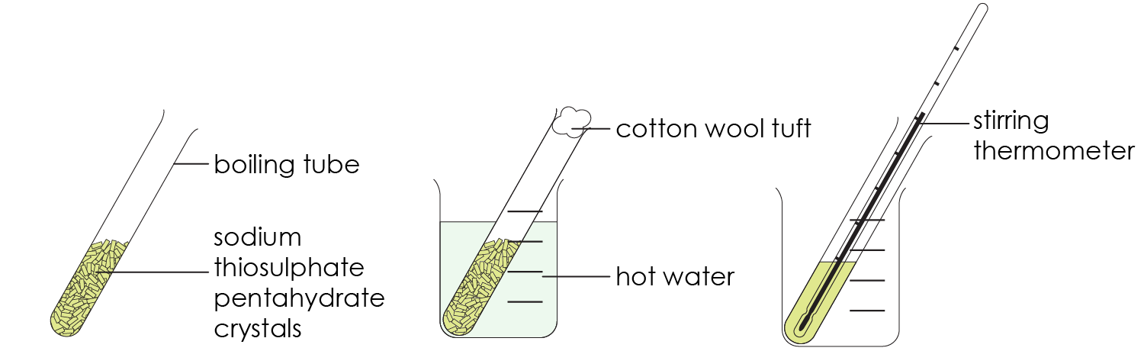

Results table

Questions
- State the meaning of the following key words:
- Freezing

__________________________________________________________________________________

__________________________________________________________________________________
- Supercooled

__________________________________________________________________________________

__________________________________________________________________________________
- Exothermic

__________________________________________________________________________________

__________________________________________________________________________________
- Cystallisation

__________________________________________________________________________________

__________________________________________________________________________________
- Plot a graph of temperature (y-axis) against time (x-axis) using your results.


- Label the parts of the graph that show:
- the melting point of sodium thiosulfate is 48°C
- sodium thiosulfate as a liquid
- sodium thiosulfate as a supercooled liquid
- sodium thiosulfate as a solid

- Describe what happened to the shape of the graph when a crystal of fresh sodium thiosulfate was added to the liquid. Suggest a reason for your answer.

__________________________________________________________________________________

__________________________________________________________________________________

__________________________________________________________________________________

__________________________________________________________________________________

- When a substance changes state from a solid to liquid, an exothermic reaction takes place.

Use your experimental results and ideas about particle theory to explain this statement. Include particle diagrams to support your answer.

__________________ __________________

__________________________________________________________________________________

__________________________________________________________________________________

__________________________________________________________________________________

__________________________________________________________________________________

__________________________________________________________________________________

__________________________________________________________________________________

__________________________________________________________________________________

__________________________________________________________________________________

__________________________________________________________________________________

