Carbon capture from seawater

Introduction

Scientists work to understand the world around us and what they find out often ends up in the news. The work of scientists impacts our lives all the time, so it is very useful to be able to understand science writing. Read the science news story below and answer the questions.

Carbon capture from seawater

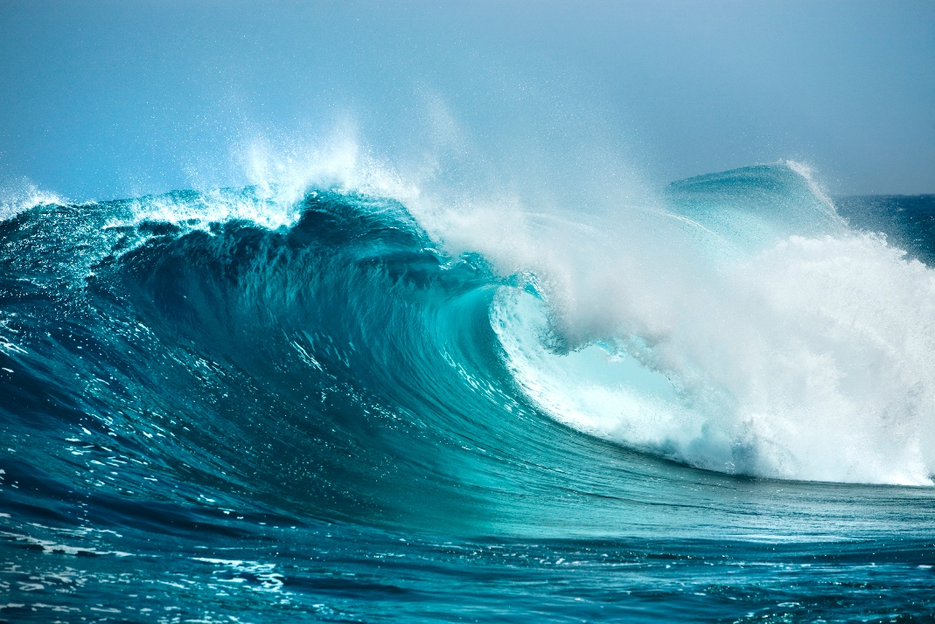

© Shutterstock

Oceans are large carbon sinks with much higher concentrations of carbon dioxide than in air. Researchers are using electrochemical cells to change the pH of seawater and convert dissolved bicarbonate ions into carbon dioxide that can then be collected. The water is then returned to its original pH before it is released back into the ocean.

Releasing carbon dioxide from ocean water can free up this seawater to capture more carbon dioxide from the atmosphere. The carbon dioxide is stored and can then be used to produce fuels and materials. The carbon dioxide can also be stored underground in small air pockets in rocks.

Questions
- Describe two human activities that can increase carbon dioxide levels in the atmosphere.
- Explain why scientists want to store carbon dioxide rather than releasing it back into the atmosphere.
- In your own words write down the meaning of the following scientific words from the news story. Use the glossary that accompanies this worksheet to help you.
- Dissolved
- Fuel
- Carbon sink

Now that you have defined these words, use these words in a sentence. Think of when you have come across these words before and use your prior knowledge of these words to help you write.

Use the scale below to rate how much using the glossary is helping you understand the science in the news story.

1 2 3 4 5 6 7 8 9 10

Not helping → Really helping

- (a) Get two different colour pencils. Circle any scientific words in colour one.
- Using colour two, circle five to ten words that communicate the key message in the news story.

Use the scale below to rate how much circling words is helping you to understand the news story.

1 2 3 4 5 6 7 8 9 10

Not helping → Really helping

Use the scale below to rate how confident you feel explaining the news story to the person next to you. Think of something else you could do when reading the text to help you understand the news story. Share it with the person next to you.

1 2 3 4 5 6 7 8 9 10

Not helping → Really helping

- Write down one thing you have learnt from reading this science news story.
- Write your own summary of the news story for the other learners in your class. Use the prompts below.
- What have the scientists discovered? Try to write this in just one sentence. (Findings)
- What was the problem they were trying to solve? (Context)
- Why does their discovery matter? (Relevance/application)
- Think about who it matters to and what impact it could have for them. (Impact)

Take it further

Scientists publish their findings in research articles. These are then written about by writers and journalists for different audiences. Research articles and other types of science writing can be very technical but they will mostly always cover the four prompts in question 6.
- Read the news story called Using seawater to reduce our carbon footprint (available to download from: rsc.li/4391bCT). This is based on the same research, but it is written for a different audience than the text at the top of this worksheet. Highlight the parts of the articles that link to each of the bullet points in different colours:
- What have the scientists discovered? (Findings)
- What was the problem they were trying to solve? (Context)
- Why does their discovery matter? (Relevance/application)
- Think about who it matters to and what impact it could have for them. (Impact)
- How is this science writing different from the science writing at the top of this worksheet? Write down your answers.

- Imagine you are a professional science writer. Explain how you would write about this research for:
- a post on social media;
- a magazine article aimed at adults who work in the chemistry industry;
- a report for school that gets published on the school website for other learners to read, including learners who are younger than you.

Hint: In each case, think about your audience (in other words, who will read it) and what they might want and need from the writing. This will help you answer the question.

Glossary
Unfamiliar word | What it means
Atmosphere | the mixture of gases around the earth
Bicarbonate ions | a charged particle made up of hydrogen, carbon and oxygen atoms
Carbon dioxide (CO₂) | a gas made of one carbon atom and two oxygen atoms. It is made when a fuel is burned
Carbon sink | anything that absorbs more carbon from the atmosphere than it releases
Concentration | the amount of solute present in a known volume of solution
Dissolve | when a solute is added to a solvent and the solute breaks into much smaller particles and spreads out
Electrochemical cell | something that uses chemical reactions to make electricity
Fuel | a substance that can transfer useful energy as heat when it is burned
pH | a scale used to measure the acidity or alkalinity of an aqueous solution where below 7 is acidic, above 7 is alkaline and exactly 7 is neutral

Definition of atmosphere from Cambridge Dictionary, www.dictionary.cambridge.org/, © Cambridge University Press. Accessed May 2025. Used with permission. All other definitions © Royal Society of Chemistry.

