Extracting lithium using string

Introduction

Scientists work to understand the world around us and what they find out often ends up in the news. The work of scientists impacts our lives all the time, so it is very useful to be able to understand science writing. Read the science news story below and answer the questions.

Extracting lithium using string

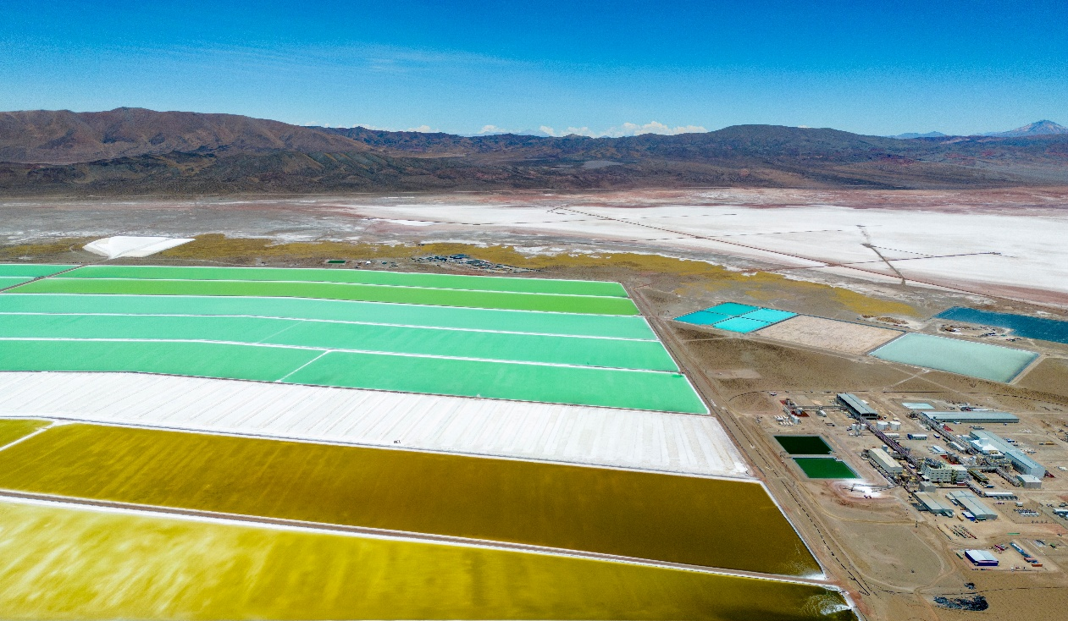

Aerial view of lithium evaporation ponds in Argentina © Shutterstock

Lithium mining demands a lot of energy, chemicals, land and time. It typically involves pumping brine from underground sources to form surface pools. Water is left to evaporate for up to 18 months to allow lithium salts to form and crystallise. However, this method is known to contaminate ecosystems.

Scientists have developed a new crystallisation technique that uses specially designed strings to draw up the brine solution. The water then evaporates from the strings’ surface and leaves behind lithium and sodium crystals. This new method takes around 20 days, so is much faster and saves a lot of water compared to the traditional method.

Questions
- Why are scientists looking for a new method of extracting lithium from seawater?
- In your own words, explain the new method scientists have developed for extracting lithium.
- Get two different coloured pens or pencils. Circle any scientific words in colour one. You will need the second colour later.
- In your own words, write down the meaning of the following scientific words from the news story. Use the glossary that accompanies this worksheet to help you.
- Evaporate
- Crystallise
- Contaminate

Now that you have defined these words, use these words in a sentence. Think of when you have come across these words before and use your prior knowledge of these words to help you write.

Use the scale below to rate how much using the glossary is helping you understand the science in the news story.

1 2 3 4 5 6 7 8 9 10

Not helping → Really helping

- Reread the news story. What do you think is the most important point of this news story? Share it with the person next to you. Using your second coloured pen or pencil, circle five to ten words that communicate that important point in the news story.

Use the scale below to rate how much circling words is helping you to understand the news story.

1 2 3 4 5 6 7 8 9 10

Not helping → Really helping

- Write down one new thing you have learnt from reading this science news story.

Use the scale below to rate how confident you would feel explaining the news story to the person next to you. Think of something else you can do when reading the text to help you understand the story and share it with the person next to you.

1 2 3 4 5 6 7 8 9 10

Not helping → Really helping

- Write your own summary of the news story for the other learners in your class. Use the prompts below.
- What have the scientists discovered? Try to write this in just one sentence. (Findings)
- What was the problem they were trying to solve? (Context)
- Why does their discovery matter? (Relevance/application)
- Think about who it matters to and what impact it could have for them. (Impact)
- The story you’ve just read is about extracting lithium from water. We can do a similar process in the science classroom. Write a method describing how you separate salt from seawater in a science classroom.

Take it further

Scientists publish their findings in research articles. These are then written about by writers and journalists for different audiences. Research articles and other types of science writing can be very technical but they will mostly always cover the four prompts in question 7.

- Read the news story called A fast-track crystallisation technique (available to download from: rsc.li/3EJf8PW). This is based on the same research, but it is written for a different audience than the text at the top of this worksheet. Highlight the parts of the articles that link to each of the bullet points in different colours:
- What have the scientists discovered? (Findings)
- What was the problem they were trying to solve? (Context)
- Why does their discovery matter? (Relevance/application)
- Think about who it matters to and what impact it could have for them. (Impact)
- What differences do you notice between the research article A fast-track crystallisation technique and the science news story at the top of this worksheet? Identify the differences and compare the news story with the research article in your answer.

- Imagine you are a professional science writer. Choose one of the options below and write a text about this research for:
- a post on social media;
- a magazine article aimed at adults who work in the chemistry industry;
- a report for school that gets published on the school website for other learners to read, including learners who are younger than you.

In each case, think about your audience (in other words, who will read it). Consider what they might want and need from the text. Make sure to leave space around your text so you can annotate it, explaining the decisions you have made for your audience. Consider the following and answer these prompts in your annotations:
- Did you include a photo, image or diagram? Did you include more than one? Why?
- Is your text long or short? Why?
- How much detail did you include in your text?
- Did you simplify or explain scientific language? Why or why not?

Glossary
Unfamiliar word | What it means
Brine | water with salt in it
Chemical | any basic substance that is used in or produced by a reaction involving changes to atoms or molecules
Contaminate | to make something less pure or make it poisonous
Crystal | a piece of a solid that has formed in a regular shape
Crystallise | the verb form of crystallisation, the method of separation used to get crystals of a solid by very slowly evaporating the solvent from a solution
Crystallisation | a method of separation used to get crystals of a solid by very slowly evaporating the solvent from a solution
Ecosystem | all the living things in an area and the way they affect each other and the environment
Extract | to remove or take out something
Energy | the ability of a system to do work
Evaporate | a method of separation used to form solids by heating to remove the solvent from a solution
Lithium | a group 1 metal with the symbol Li
Mining | the industry or activity of removing substances from the ground by digging
Salt | a compound such as sodium sulfate, produced when an acid is neutralised by a base or reacts with a metal
Sodium | a group 1 metal with the symbol Na
Technique | a way of doing an activity that needs skill

Definitions of brine, chemical, contaminate, ecosystem, extract, mining, technique from Cambridge Dictionary, www.dictionary.cambridge.org/, © Cambridge University Press. Accessed February - May 2025. Used with permission.

